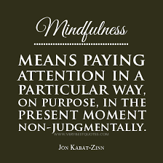
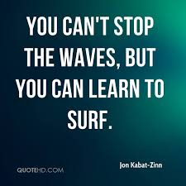

Further learning:
You tube: Jon Kabat - Zinn Body Scan, Meditations and The Seven Attitudinal Foundations of Mindfulness
Mark Williams – various meditations
Reading: Mindfulness – Mark Williams. 8 week course guide with exercises and CD. Highly recommended.
Full Catastrophe Living – JKZ (a bit heavy but very comprehensive).
The Power of Now – Eckhart Tolle – (concise and practical). Popular course book.
Mindfulness/Meditation/Relaxation Apps:
List of 2021’s top apps according to Independent Newspaper. Please see https://www.independent.co.uk/extras/indybest/gadgets-tech/phones-accessories/best-mindfulness-apps-a8217931.html For further details on each of these.(Prices are approximate)
Calm – top favourite £30.00 but well worth the money for its diversity.
Escape - £30
Headspace - £10 – also very popular, tried and tested.
My life Meditation - £10
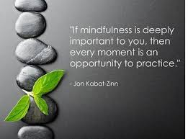
10% Happier - £13
Aura - £12
Buddhify - £5

