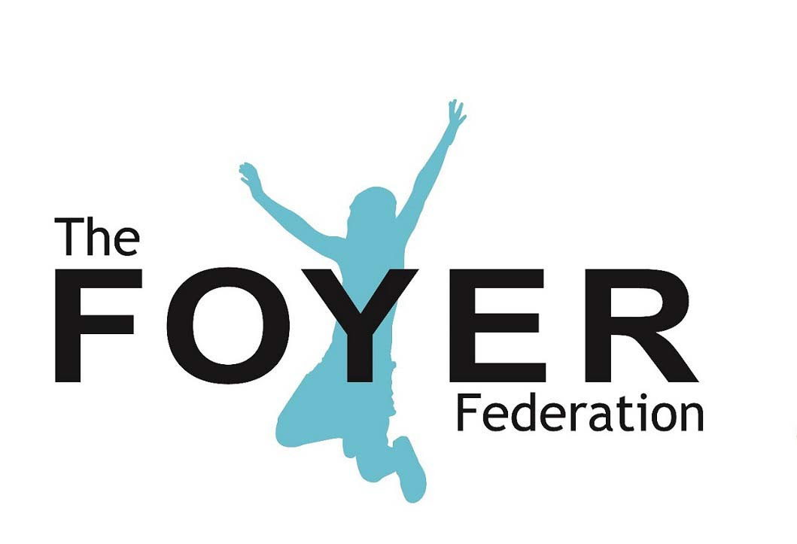

NETWORK TRUSTEE

About the Role

The role of a member of The Foyer Federation Board is to govern its work, help it achieve its charitable objectives and meet its legal requirements. Board members are both Directors of the Company Limited by Guarantee and Trustees of the Charity. Network Trustees are Trustees in their own right, but also represent the voice of the Federation’s Members on the Board, bringing their operational perspective and a view on how to develop the Board’s strategic direction, membership offer and services.

Main duties:

- To participate in regular reviews of the strategy, core values, aims and objectives of The Foyer Federation.

- To ensure that the organisation of the Federation is such that the charitable objects can be achieved.

- To ensure that the Federation meets its legal obligations.

- To monitor the financial strength of the Federation, ensuring its long term sustainability and approving annual budgets.

- To review and approve the Federation’s policies.

- To ensure that all published reports adequately reflect the services and financial condition of the organisation.

- To assist in the recruitment and induction of new members of the Board of Management

- To attend meetings of the full Board and any relevant sub-committees or working groups.

About the person

A Network Trustee will be:

- An experienced staff member within one of our member Foyers
- Committed to the aims and values of the Foyer Federation
- Prepared to work with relevant staff members to develop a more detailed knowledge about one or more aspects of the Federation’s activity and champion it within and beyond the Board.
- Prepared to visit at least one Foyer each year and to attend other events, as appropriate.
- A confident communicator, able to hold courageous conversations, when necessary
- Inquisitive and interested in the aspirations and needs of the wider network of Foyers and how to increase positive outcomes for Foyer young people.
- An Advantaged Thinker who supports the strategic vision of the Foyer Federation
- Able to analyse risks and opportunities, and take a balanced approach to both.
- Able to work as part of a team and willing to take collective responsibility for the governance of our charity
- Willing to train and develop within the role

A Network Trustee will have:

- An understanding of the practice and policy context in which the foyer Federation is working.
- An understanding of social exclusion.
- Empathy with and understanding of young people who experience difficulties as they are becoming adults.
- The ability to work at a strategic and visionary level whilst understanding the detail and complexities of delivery, and the influencing skills needed to bring staff and stakeholders along with plans.
- Sound, independent judgement and the ability to think creatively

Accountability
As a member of the Board, you will be accountable for your actions and decisions to different people at different times including the Foyer Federation’s members, service users, funders and key external stakeholders, including the Charity Commission. Your primary responsibility, however, is to act in the interests of the Charity/Company itself.

Time commitment
A Network Trustee must:
- Seek the permission of their employer/parent organisation to undertake the commitments required by the role
- Be able to commit time to Board and sub-committee meetings (the Board convenes a minimum of 6 times a year)
- Commit to a tenure of 3 years. This can be extended for a further 3 years, subject to fellow Trustees voting on whether to elect them for a second term of three years*
- Prepare for meetings by reading agendas, papers and minutes
- Engage with requests relating to the development of good governance from the Chair, Company Secretary and Chief Executive on an ad hoc basis

*Before submitting a self-nomination, prospective Network Trustees should note that their tenure as a Trustee is subject to remaining in the employment of a Foyer.

Before nomination, candidates should also look at the regulation relating to those ineligible to serve as a Trustee. This can be found here:
https://www.gov.uk/guidance/automatic-disqualification-rule-changes-guidance-for-charities

