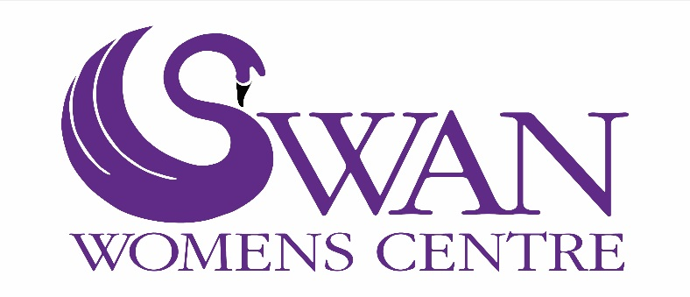
11th September 2018
Annual General Meeting

Chief Executive Report
for the year Ended 31 March 2018

Introduction
SWAN Womens Centre has been in existence since 1992. Though it has changed considerably since its inception, there are key beliefs that we still maintain such as our belief that women benefit from gender specific approaches to health and wellbeing services.
Our Vision is
A society that is inclusive and non-stigmatising of women who experience mental health conditions.

Our Mission is
To empower and support women who experience anxiety, depression, stress and/or isolation according to their individual needs in a holistic way.
Public Benefit
We are ideally located, in the heart of a socially deprived community with easy access, for all, on foot or travelling by public transport.
Our charitable activities focus on the provision of health and wellbeing support for women, who have experienced or are experiencing anxiety, depression, stress or poor mental health, or, those women who have become socially excluded as a result of factors such as unemployment, financial hardship, ill health (physical or mental), youth or ageing.
Our purpose is to support women to improve their sense of wellbeing and help them overcome such difficulties through the various services that we offer, thus ensuring their successful integration into society.

Staffing
Employees
SWAN employs the following staff.
- Chief Executive - 35 Hours
- Counselling Co-ordinator - 35 Hours
- Befriending Co-ordinator – 25 hours
- Reception Co-ordinator – 16 hours
- Counsellor – 14 hours
- Outreach Counsellor – 14 hours
- Stats/Admin – 10 hours
- Support Group Facilitator – 7 hours
- Therapeutic Allotment Facilitators – 14 hours

Volunteers

- We have 26 Volunteer Counsellors. They provide 58 hours of counselling per week. 3016 hours per year.
- We have 12 Reception Volunteers. They provide 45 hours of support on a weekly basis. 2340 hours per year
- We have 2 social media and website Volunteers. Who between them provide 10 hours of support a week. 520 hours per year.
- We have 11 Volunteer Befrienders. Who between them provide 22 hours of support per week. 1144 hours per year.
- We have 1 allotment Volunteer. Who provides 7 hours of support per week. 364 hours per year.
- We have 2 Volunteers who lead on crafts and activities on a weekly basis. They provide 6 hours craft group activities. They provide 312 hours per year.
- We have 7 Trustee Volunteers. Who meet 6 weekly for Trustee meetings and give approximately 150 hours per year to benefit the work of SWAN.

- Total volunteering hours per week: 148 hours

- Total volunteering hours per year: 7846 hours

The total contribution from volunteers to SWAN Womens Centre, if we paid only minimum wage, would be £61,434.18 per year.

Services
Counselling and Listening Service
Our reputation has enabled us to recruit and retain 12 qualified Volunteer Counsellors as well as offer placements to 14 Counsellors in training. We employ 2 additional Counsellors who provide counselling as well as co-ordinatation of the service.
During 2017-2018 year, SWAN delivered 2280 counselling sessions to 190 women in Sefton.
Out Reach Services
The outreach service works with women who cannot access community based services due to severe anxiety, agoraphobia or emotional problems and who often do not get any support from statutory services because they do not fit the criteria of severe mental illness. It aims to help them gain confidence and develop their individual potential to integrate into their local communities.
The Outreach Service has supported 12 women this year and carried out 187 support sessions with women.
Therapeutic Allotment Project
We have an allotment based in Litherland. The allotment project is aimed at women who are isolated, may be experiencing anxiety and/or depression or have a history of mental health conditions.
The allotment is in a quiet and peaceful environment where women can learn how to grow food organically, become physically active, build networks of support and talk to other women who may be experiencing some of the same issues. The women plant a wide range of vegetables and tend them throughout the year. The produce is shared between the women as well as being brought back to the centre to be used for cooking, making soup, jams and chutneys. The project is delivered by 2 qualified Counsellors who have knowledge and experience of land management and allotments.
During the year over 18 women have accessed the Therapeutic Allotment project.

Emotional Well- being Support Group

For women who experience anxiety, stress, depression or other mental health problems. We provide two support groups. One operates in the daytime and the other in the evening. This ensures that women who cannot attend during the day have the opportunity to attend later .The groups are facilitated by a qualified Counsellor. The issues that are focused on during the sessions, respond to the needs and wishes of the group members.

During 2017 - 2018 we provided 88 support sessions to 28 women.

Befriending Service
We also introduced a new service to SWAN in 2018. We received funding from the Steve Morgan Foundation to provide a Befriending Service to women in Sefton who are isolated and/or lonely due to their health. While we will report this in full next year, we can tell you that the befriending service has trained 11 individuals and who are now providing a service to 10 women.
Apart from the services above we also provide a range of services aimed at increasing emotional well-being.
These include:
Courses
Educational, creative and exercise courses have been provided for women over the last year. 106 women have attended one or more of the groups below.
Activities included:
- Creative Writing Group
- Mosaic class
- Confidence Building
- Yoga
- Knitting and Sewing group
- Reading group
- Jigsaw group
- Mindfulness
- Relaxation and rebalancing group.

Weekly support groups
During the year 211 women accessed the groups below.
- Peer Support group
- Drop in - Coffee and Support group

Complementary Therapies
We have a range of therapies/ treatments that woman can access.

In 2017 - 2018, 307 women accessed 1299 treatments.

These included:
- Acupuncture,
- Full Body Massage,
- Facial Massage,
- Indian Head Massage,
- Reiki,
- Reflexology
- Hypnotherapy
- Thai Massage.

Fundraising activities
Our fundraising activities this year included:
- Selling of jams and chutneys
- Selling produce from the allotment
- Selling SWAN merchandise i.e. Poetry books written by the Creative Writing Group
- Christmas Raffle

Donations
We have had a number of donations through our website this year. We have had a couple of large donations (over £1000) as well as a regular donor setting up a monthly Direct Debit.
We have also received some large donations from:
- Eleanor Rathbone Foundation
- Oliver Stanley Foundation
- Crosby Soroptimists
- Union of Catholic Mothers

Principal funding sources
SWAN received funding from a number of grant making trusts and foundations in 2017-2018. The charity's principal funding sources were:
- Southport and Formby Clinical Commissioning Group,
- South Sefton Clinical Commissioning Group
- Sefton Council.
- Dong Energy
- Ground Work - TESCO
- Steve Morgan Foundation

Feedback from those who use the services

“I didn’t know places like this existed. I feel you all understand what I am going through and listening to you all sharing about yourselves makes me realise that I am not the only one coping with this depression and anxiety and all the ways that it affects my life.”
“Without your support, I don’t think I would have had the confidence to apply for the job or believed that I could get my-self together again”
For the Future

This year we have already introduced a young women’s group for 14 – 18 year olds. We provide both our counselling experience as well as activities that promote young people talking about their emotions. This is a pilot programme so we will provide some feedback from the programme next year.

