Using drones to survey wild Bornean orangutan (Pongo pygmaeus) populations in Central Kalimantan, Indonesia

Cameron Goodhead
cam.goodhead@gmail.com
University of Exeter

Supervisors: Dr Kim Hockings¹, Dr Helen Morrogh-Bernard¹
International Collaborator: Dr Hendrik Segah²

¹University of Exeter
²Universitas Palangka Raya

Awarded a PSGB grant in 2020*

*Research was delayed by two years due to the COVID-19 Pandemic

Introduction

Determining population trends and distributions is a crucial aspect of primate conservation (Plumptre, Sterling and Buckland 2013). The Bornean orangutan (Pongo pygmaeus) is listed as Critically Endangered by the IUCN (Ancrenaz et al. 2016), with populations suffering severe declines over the last few decades (Voigt et al. 2018). Current methods for estimating orangutan populations usually rely on counts of ‘nests’ that orangutans build daily to enhance comfort when resting (Prasetyo et al. 2009, Kuhl et al. 2008). Typically, nests are surveyed from the ground and this is time-consuming and physically demanding due to the challenging terrain found in orangutan habitats. As a result, it takes considerable time and resources to complete surveys and thus many areas are not regularly surveyed (Utami-Atmoko et al. 2017).

New drone technology has the potential to be used for nest surveys instead, as many orangutan nests are built near the canopy (Cheyne et al. 2013) and can be detected from the air (Ancrenaz et al. 2004). Recent research in Sumatra, Sabah, and Gunung Palung have trialled drones for orangutan nest surveys and found variable detection rates (Wich et al. 2015, Milne et al. 2021, Barrow 2022). However, all found a significant correlation between aerial nest surveys and ground nest surveys, indicating potential future use for population estimates. In this research, I trialled drone nest surveys in a new study site in Central Kalimantan, the Sebangau National Park. The Sebangau National Park is thought to hold the largest protected orangutan population in Borneo and is comprised primarily of tropical peat swamp habitat (Utami-Atmoko et al. 2017, Husson et al. 2018). The aims of this research were to determine nest detection rates using drones, factors that affect detection and the method’s suitability for population estimates in the region.

Methods
Seven transects (total length 10.2km) were surveyed in the Laboratorium Hutan Gambut (LAHG) in the Sebangau National Park, Central Kalimantan, Borneo. Transects varied between 1-2km in length with a minimum distance of 200m between separate transects. Each transect was first surveyed from the ground, with a team comprising of two or three experienced nest surveyors. For each nest that was spotted, a GPS coordinate was marked using a Garmin 64x GPS directly below the nest. Features of the nest were also recorded including height of the tree, height of the nest, age of the nest, perpendicular distance from the transect, position of the nest and canopy cover above the nest.

After each ground survey, a flight plan for the transect was created in DroneDeploy (https://www.dronedeploy.com) and a DJI Mavic Pro 2 drone was piloted to complete surveys over the respective transect. The drone was flown at an above-ground altitude of 100m (approximately 82m above the average canopy height), and took photos every 30m along the transect, resulting in ~33 photos per km surveyed.

Each photo was imported into Adobe Photoshop (Adobe Inc. 2019) and overlayed with a 3x3 rectangular grid. Appropriate adjustments to brightness and colour were made for each photo. Each photo was analysed for orangutan nests, with each image taking approximately three minutes to search fully. If a nest was detected, it was circled in red if the surveyor was 100% certain it was a nest, and circled in pink if the surveyor was <100% certain it was a nest. Previous and subsequent photos were checked to verify each nest was unique and not recorded in multiple photos.

Adapting the framework from Milne et al. (2021), the GPS coordinates of the centre of each photo was extracted using Exiftool (Harvey 2016). The distance (in terms of pixels) of the nest from the centre of the image, the bearing of the nest from the centre of the image using the ‘bear’ function from the ‘Fossil’ package, and the distance each pixel corresponds to (Ground Sampling Distance) were all calculated. From this, a GPS position for each nest was created using the ‘destPoint’ function from the ‘geosphere’ package in RStudio (R Core Team 2022).

The estimated GPS position for each aerial nest was then imported into QGIS (QGIS Development Team, 2009), alongside the GPX position of each nest from the ground surveys. A 7m buffer was added around each ground nest to account for the estimated error in the handheld GPS, and a 5m buffer was added around each aerial nest to account for error in the ground sampling distance. If there was an overlap in buffers between a ground and aerial nest, it was counted as a matched nest.

A binomial generalized linear mixed model was then created to investigate the factors that affected the detection of all matched nests using the ‘glmmTMB’ package in RStudio, with transect identity added as a random effect. The ‘dredge’ function from the ‘MuMIn’ package was used to create 80 models, which were ranked by AIC. The optimal model was used to predict probabilities of detection for each nest in the dataset using the ‘ggpredict’ function from the “ggiraphExtra” package.

Results

A total of 348 orangutan nests were recorded across 10.2km of ground surveys. Of these nests, 60 were matched with nests spotted on the drone surveys (17.2%). A further 33 nests were spotted on the drone surveys with 100% certainty but did not match a nest found on the ground surveys. Thus, overall, the drone surveys spotted 26.7% of the number of nests spotted on the ground surveys.

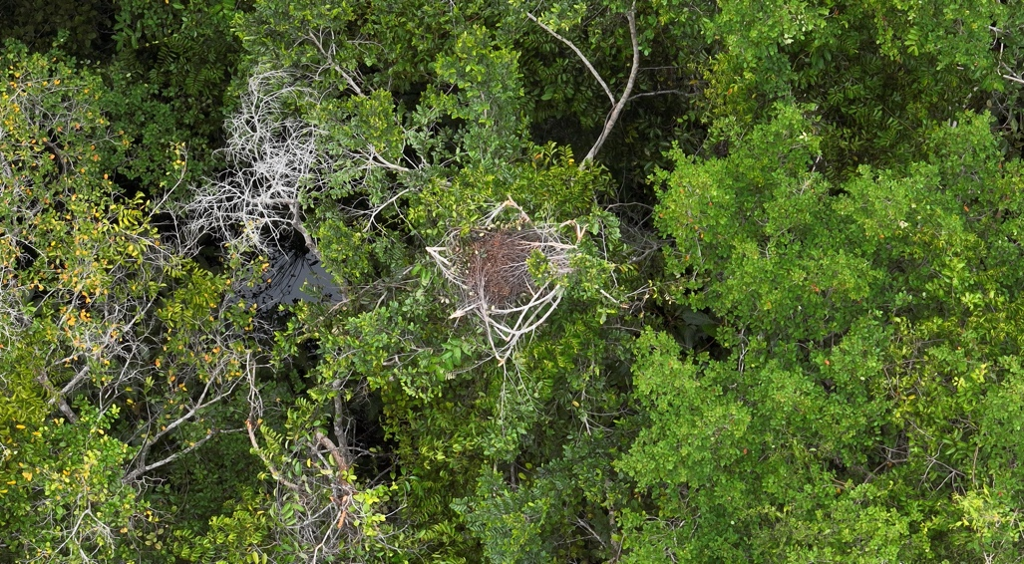
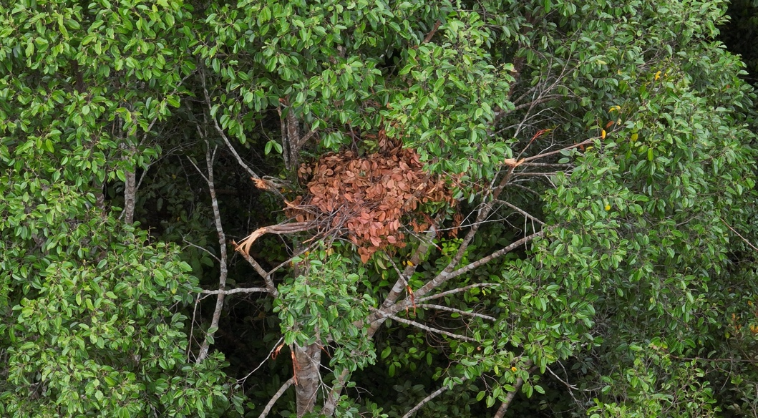
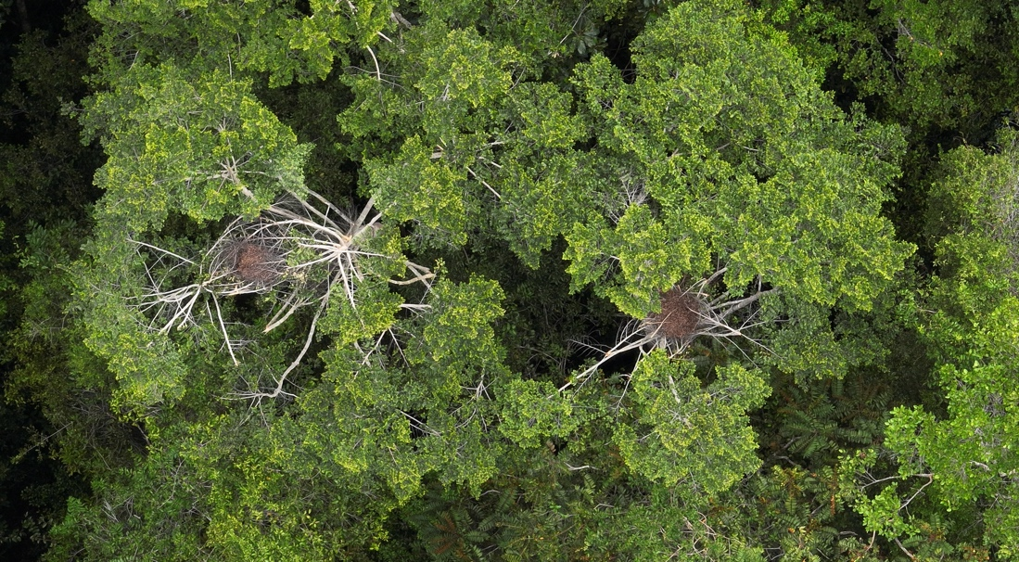
Figure 1. Close-up photos of orangutan nests detected by the drone.

However, the total number of nests spotted per 500m segment of each ground transect was not significantly positively correlated with nests spotted with 100% certainty from aerial nest counts of the same transect segments (Spearman’s rank correlation, r₍₁₈₎ = 0.42, p = 0.06, Figure. 2).

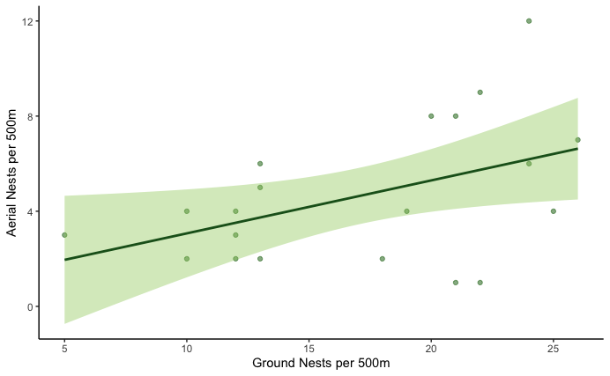
Figure 2. The number of ground nests and the number of aerial nests identified for each 500m transect section.

The highest performing GLMM included only the nest age, the canopy cover above the nest and the height of the nest as predictors of nest detection. Nests of medium ages were significantly more likely to be detected than old nests (class ‘E’) (LRT, 𝜒² = 5.86, p = 0.015, Figure 3). Out of 14 fresh nests (class ‘A’), none was detected on drone surveys.

Canopy cover above the nest was a strong predictor of the likelihood of nests being detected, with nests with <50% canopy cover above them being significantly more likely to be detected (LRT, 𝜒² = 33.0, p < 0.001, Figure. 4).

Nest height had a moderate positive effect on nest detection, with odds of detection increasing in taller nests (LRT, 𝜒²= 5.29, p = 0.02, Figure. 5). Tree height, relative height of the nest within the tree and position of the nest were not included in the optimal model as they weren’t strong predictors or significant.

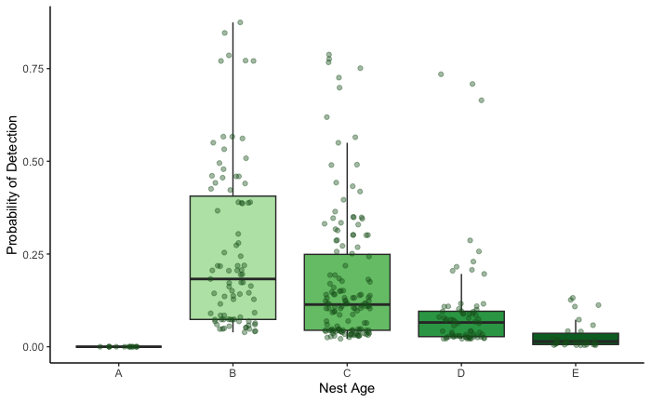
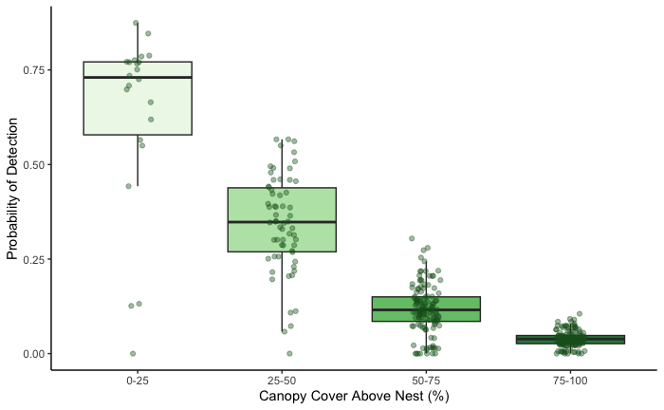
Figure 3. The predicted probability of detecting different age classes of nest on drone nest surveys (Note that due to an insufficient number of A detections, probability of detecting A is 0.).
Figure 4. The predicted probabilities of detecting a nest with different levels of canopy cover above the nest on drone nest surveys.
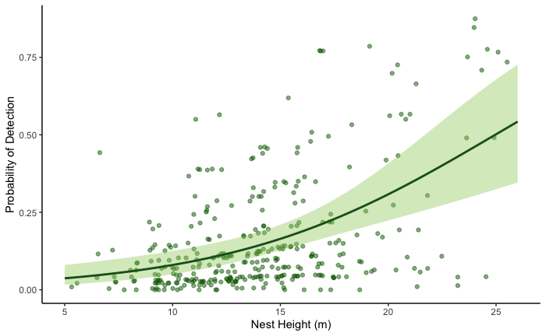
Figure 5. The predicted probability of detecting a nest built at different heights on drone nest surveys.

Discussion

The detection rate of nests by drone surveys in this research (26.7%) was higher than estimates produced by Wich et al. (2015) and Barrow (2022), who produced detection rates of 17% and 9% respectively. However, the estimate is lower than results in Milne et al. (2021), who found no significant difference between nest counts from both methods. The variability in detection rates in studies is of concern for the future of drone nest surveys, as it indicates that detection rates are likely to be highly habitat-specific, and potentially site-specific. There is also the possibility that detection rates may differ due to differences in technology used, such as using drones with better quality cameras, or using different survey methodology, as both affect the ground sampling distance (distance per pixel), which has been shown to have a significant effect on nest detection rates (Wich et al. 2023).

The lack of significant correlation found in this study is of further concern. It indicates that even if it is possible to get site-specific detection rates, the variation between transects will result in large confidence intervals, and thus unreliable population estimates. This will render it considerably difficult to detect population changes in areas. However, all previous research has found significant correlations between ground and drone nest surveys, and seeing as the correlation is extremely close to significance in this research, it may be due to insufficient sample size that this result has not been reproduced. Further research should be completed at different sampling locations to determine the validity of the relationship and any factors that affect detection rates.

This research backs up research by van Andel et al. (2015), Wich et al. (2015) and Barrow (2022) that found canopy cover to be a strong predictor of nest detection. In this research, I found nest age and nest height to be significant predictors of nest detection. Anecdotal observations also indicated that tree species may influence nest detection and it is recommended that future research take this into account when analysing detection rates.

In this research, the drone surveys spotted many additional nests that were not picked up by the ground survey teams. Previous research has also indicated that line transects may underestimate nest counts (van Schaik et al. 2005). In addition, the nests that are most likely to be missed from the ground surveys may be more likely to detect on the aerial surveys, as nests in the canopy can be harder to spot. Drone surveys may complement ground surveys and assist with acquiring more accurate nest counts in areas.

In addition to the variation in the results between transects, there are also significant methodological issues with drone surveys that need to be resolved before they can be used more reliably. Flying drones in forest environments is extremely difficult, as the tall vegetation often obstructs the signal and restricts line of sight between the pilot and the drone, limiting surveys to areas only close to the take-off zone. In addition, whilst the flights themselves can be completed in a matter of minutes, analysing the data can take significant amounts of time.

Future work will aim to increase the number of transects completed, in different locations and habitats to further analyse the detection rates. In addition, I aim to investigate the reliability of nest observers for aerial imagery and determine the agreement between different individuals for photos.

Conclusion
In this research, I produced an overall aerial nest detection rate of 26.7% in comparison with the ground surveys. The variation between transects within the same site, as well as in previous research indicated that the reliability of drones for population surveys is still questionable. Whilst there may be potential in drones for population monitoring of orangutans, there are still significant barriers and knowledge gaps that need improving before they can be used successfully.

Funding
The research grant awarded by the Primate Society of Great Britain was used for local field staff salaries.

References

Adobe Inc., 2019. Adobe Photoshop, Available at: https://www.adobe.com/products/photoshop.html.

Ancrenaz, M., Gimenez, O., Ambu, L., Ancrenaz, K., Andau, P., Goossens, B., Payne, J., Sawang, A., Tuuga, A. and Lackman-Ancrenaz, I., 2005. Aerial surveys give new estimates for orangutans in Sabah, Malaysia. PLoS Biology, 3(1): e3.
Ancrenaz, M., Gumal, M., Marshall, A.J., Meijaard, E., Wich , S.A. and Husson, S. 2016. Pongo pygmaeus. The IUCN Red List of Threatened Species 2016:
Barrow, B. 2022. Assessing the distribution of Southwest Bornean orangutans (Pongo pygmaeus wurmbii) in Gunung Palung National Park, West Kalimantan (Borneo), Indonesia, with a comparison of traditional and drone methods for long-term population monitoring. MRes Thesis, Oxford Brookes University, Oxford.
Cheyne, S.M., Rowland, D., Höing, A. and Husson, S.J., 2013. How orang-utans choose where to sleep: comparison of nest site variables. Asian Primates Journal, 3(1), pp.13-17.
Harvey, P. 2016. Exiftool. Kingston, Ontario, Canada. https://exiftool/org.
Husson, S.J., Limin, S.H., Boyd, N.S., Brousseau, J.J., Collier, S., Cheyne, S.M., D'Arcy, L.J., Dow, R.A. and Schreven, S., 2018. Biodiversity of the Sebangau tropical peat swamp forest, Indonesian Borneo. Mires and Peat, 22, pp.1-50.
Kühl, H.S., Maisels, F., Ancrenaz, M. and Williamson, E.A., 2008 Best practice guidelines for the surveys and monitoring of great ape populations. Gland, Switzerland: IUCN SSC Primate Specialist Group (PSG). 32 pp.
Milne, S., Martin, J.G., Reynolds, G., Vairappan, C.S., Slade, E.M., Brodie, J.F., Wich, S.A., Williamson, N. and Burslem, D.F., 2021. Drivers of Bornean orangutan distribution across a multiple-use tropical landscape. Remote Sensing, 13(3), p.458.
Plumptre, A.J., Sterling, E.J. and Buckland, S.T., 2013. Primate census and survey techniques. Primate Ecology and Conservation: A handbook of techniques, pp.10-26.
Prasetyo, D., Ancrenaz, M., Morrogh-Bernard, H.C., Utami Atmoko, S.S., Wich, S.A. and van Schaik, C.P., 2009. Nest building in orangutans. Orangutans: Geographical Variation in Behavioral Ecology, Oxford University Press, Oxford, pp.269-277.
QGIS Development Team, 2009. QGIS Geographic Information System
R Core Team, 2022. R: A language and environment for statistical computing. R Foundation for Statistical Computing, Vienna, Austria. URL https://www.R-project.org/.
Utami-Atmoko, S., Traylor-Holzer, K., Rifqi, M.A., Siregar, P.G., Achmad, B., Priadjati, A., Husson, S., Wich, S., Hadisiswoyo, P., Saputra, F. and Campbell-Smith, G., 2017. Orangutan population and habitat viability assessment: final report. IUCN/SSC Conservation Breeding Specialist Group, Apple Valley, MN

Van Andel, A.C., Wich, S.A., Boesch, C., Koh, L.P., Robbins, M.M., Kelly, J. and Kuehl, H.S., 2015. Locating chimpanzee nests and identifying fruiting trees with an unmanned aerial vehicle. American Journal of Primatology, 77(10), pp.1122-1134.

van Schaik, C.P., Wich, S.A., Utami, S.S. and Odom, K., 2005. A simple alternative to line transects of nests for estimating orangutan densities. Primates, 46, pp.249-254

Voigt, M., Wich, S.A., Ancrenaz, M., Meijaard, E., Abram, N., Banes, G.L., Campbell-Smith, G., d’Arcy, L.J., Delgado, R.A., Erman, A. and Gaveau, D., 2018. Global demand for natural resources eliminated more than 100,000 Bornean orangutans. Current Biology, 28(5), pp.761-769.

Wich, S., Dellatore, D., Houghton, M., Ardi, R. and Koh, L.P., 2015. A preliminary assessment of using conservation drones for Sumatran orang-utan (Pongo abelii) distribution and density. Journal of Unmanned Vehicle Systems, 4(1), pp.45-52.

Wich, S.A., Bonnin, N., Hutschenreiter, A., Piel, A.K., Chitayat, A., Stewart, F.A., Pintea, L. and Kerby, J.T., 2023. Using drones to determine chimpanzee absences at the edge of their distribution in Western Tanzania. Remote Sensing, 15(8), 2019.

