FINAL REPORT TO THE PRIMATE SOCIETY OF GREAT BRITAIN AND BORN FREE FOUNDATION-CONSERVATION GRANT

INTERGRATED COMMUNITY CONSERVATION PROJECT FOR MANDRILLS AND OTHER PRIMATE SPECIES TO SAFEGUARD THE BIODIVERSITY OF THE CAMPO MA'AN NATIONAL PARK (PNCM)
Hervé NGUNTE TEKOU ¹
tekoungunte@gmail.com
Awarded a grant by BFF through PSGB in 2022
Worked in collaboration with: Cloreil MBONJO EBOA^{1,} Prospère KEU JEUNEMI¹, Frédéric Mike NSIM EBA²
- Association pour la Promotion d’un Environnement Vert (APEV); Campo Ma'an National Park (PNCM)
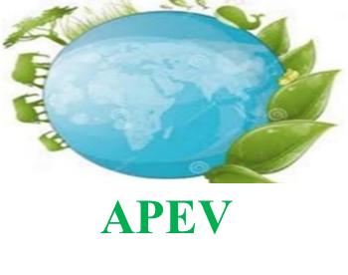
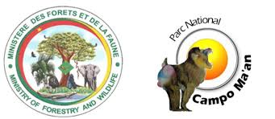

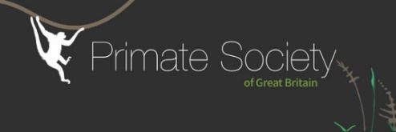

EXECUTIVE SUMMARY
LOCATION OF THE PROJET
The project took place in the Ocean Department, South Cameroon Region, and particularly in three Bagiély Pygmy indigenous communities (Nyamabandé Nkol-Melen and Nkongo) of the Niété District and three local communities (Afan-Essokyé, Koadjap, Mintom) of the Arrondissement of Campo around the National Park of Campo-Ma'an (PNCM). This park is an S-shape, covers an area of ​​264,064 ha and extends between latitude 2°10' and 2°45' North and longitude 9° 50' and 10° 48' East. Among the mammal species in the park, some species are threatened (23 on the IUCN Red List). Several of these emblematic species are particularly abundant, such as the mandrill (Mandrillus sphinx): the PNCM being the only site benefiting from protection and abounding in the habitats of this species; gorillas (Gorilla gorilla) and chimpanzees (Pan troglodytes), the African elephant (Loxodonta Africana cyclotis) and the giant pangolin (Manis gigantean).

The implementation of this project aimed to involve local communities and local development actors for the conservation and safeguarding of the mandrill in the ecosystem of the Campo Ma’an National Park.
Presentation of the project approach
A participatory and consultative methodological approach has been adopted on certain number of articulations around certain axes for the success of the activities:
- Contact with local administrative, traditional and sectoral authorities to introduce them to the project, the project team and the objectives;
- Visit of the various initiatives of existing micro-projects within the communities;
- Meeting with the Bagiely and Bantu communities and explanation of the objectives of the mission and gathering their opinions on the project;
- Explanation of the project, the objective and the expected results;
- Collect information on mandrill habitat from local communities.
The communities pre-identified during field trips are mostly Bagiély and Bantu Pygmy ethnic groups who do not actually benefit from capacity building support for the development of existing income-generating activities, strong awareness and environmental education for the conservation of mandrills and other endangered primate species of the PNCM.

In addition, some of the pre-identified villages carry out mostly agricultural, livestock, fishing and handicraft activities, and seek technical, material and financial support for the development of their activities in order to be resilient to COVID-19.
Prior to the visits to the local communities of Campo and Niété, the APEV technical team held a meeting with the warden of the Campo Ma'an National Park (PNCM) and his team, and the head of the conservation sector of Niété for guided discussions on the implementation of project activities within the beneficiary communities.

RESULTS
During this project from June 01, 2022 to December 31, 2022, the activities carried out to achieve the objective. The results obtained within the framework of the project are among others: 1,500 members of six local communities and Bagyeli pygmies sensitized and educated on the conservation of mandrills and other endangered primates of the Park; one environmental education session on the conservation of the mandrill conducted with 500 students from the public schools of Campo; ten young people trained in the domestication of Non-Timber Forest Products (wild mango); five Eco-guards reinforced in capacity on the monitoring of mandrills, four radio programmes produced and popularized with 22 communities directly affected by the project around the Park; one documentary film on the impact of the poaching of primates projected with the pupils of the primary school of Campo. For the next deadline for further support, it is planned, among other things, to : plant trees in the degraded areas of the community forests of the residents of the Park, continue to raise community awareness and set up a habituation system for the mandrills to promote eco-tourism and local development.
At the end of this project, the lessons learned lead us to formulate challenges that will have to be addressed in the future for an added value of the project. These are :
- Set up a habituation project for the mandrills of the Campo Ma'an National Park to promote ecotourism within the communities bordering the park;
- Carry out patrols with members of the local communities and the eco-guards of the park to identify the residential areas and an inventory of the mandrills of the Campo Ma'an National Park;
- Restore the degraded areas of community forests and the habitats of mandrills which are undergoing very heavy deforestation around the park.
The implementation of our activities faced difficulties, in particular:
-The heavy rainfall during the implementation of the activities negatively impacted the deployment of the technical team in the field;
-The poor condition of the road between Kribi-Campo and Kribi- Niété, coupled with the presence of multiple quagmires made access difficult in some communities.
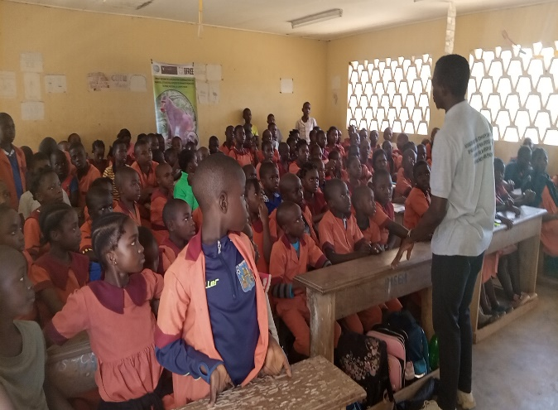
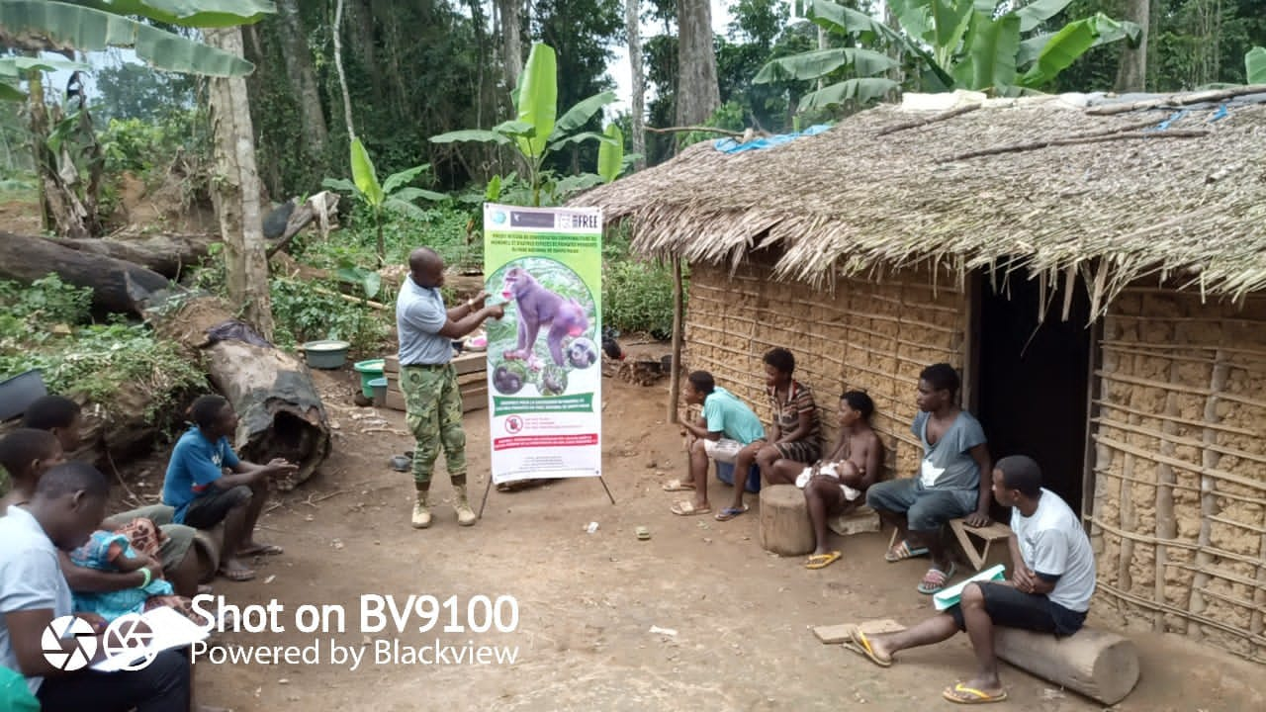
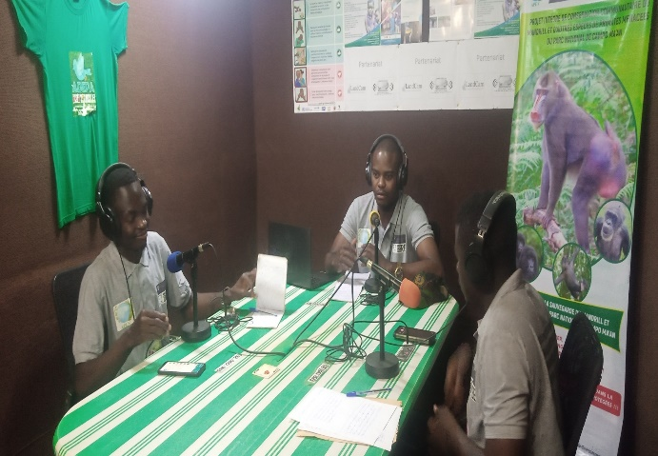

Pictures: Environmental education at Campo public school, Radio programme and local communities

ACKNOWLEDGEMENTS
We would like to thank Born Free Foundation (BFF) and the Primate Society of Great Britain (PSGB) for sponsoring this project. APEV also thanks all the local communities bordering the Campo Ma'an National Park for their listening and receptivity to the project; as well as the administrative authorities who participated for their close collaboration.

