Increasing Access to Human-Primate Interactions Research using Webinars
Sian Waters
IUCN Primate Specialist Group Section for Human-Primate Interactions
psg.hpi@gmail.com

Awarded a PSGB Conservation Grant 2021
With others, I organised four webinars to increase awareness of human-primate interaction issues which directly influence primate conservation. These involved a total of 18 speakers, the majority being young range country primatologists. While most of the topics dealt with conservation issues, our first webinar discussed the ethics of habituating primates to people for research and alternatives to habituation. The second webinar featured primate conservationists from four different projects talking about their professional experiences. The Urban Human-Primate Coexistence webinar speakers discussed problems of how human-primate interactions in urban settings are often framed negatively in media reports in many different countries, with more positive interactions failing to attract extensive media attention; they made suggestions about how best to counteract this. Our final webinar illustrated the considerable conservation benefits of involving the public in our scientific and awareness work and hopefully encouraged other primate conservationists to set up such initiatives.
Each webinar was recorded and made accessible to the public via our website (https://human-primate-interactions.org/webinars/) and linked via social media. The live webinars had a mean of 37 participants. The number of times each video has been viewed on our website as at December 31st 2021 can be found in the information for each webinar below. Those attending live proved to be very engaged in the topics, which led to interesting and illuminating discussions of each issue for the organisers, speakers and attendees. Many thanks to all our speakers and co-organisers and to Andrea Dempsey for her assistance with the technology. We are grateful to PSGB and anonymous donors for supporting these webinars.
To Habituate or not to Habituate: Ethics and Alternatives 13th July 2021
Organisers - Malene Friis Hansen and Sian Waters

Dr Christine Ampumuza (Uganda) - Animal ethics in primate research, and tourism: Lessons from a relational perspective on mountain gorilla habituation at Bwindi, Uganda.
KT Hanson (USA) - Rethinking Habituation: Insights and Implications
Dr Eva Gazagne (France) - Habituation to human observers: Process, pros, cons, and alternative monitoring methods in primatology fieldwork.
Dr Mimi Arandjelovic (Czech Republic) - Non-invasive methods for studying wild animal populations

Total views per video = 386

Conservation on the Ground: National and Grassroots Experiences 19th August 2021
Organisers - Liana Chua and Siân Waters

Angela Maldonado (Colombia) - Fundación Entropika: Primate Conservation at the Colombia- Peruvian Border
Gladys Kalema-Zikusoka (Uganda) - Conservation Through Public Health
Seheno Corduant-Andriantsaralaza (Madagascar) - Conservation on the Ground in a Time of Crisis: Perspectives from Madagascar
Fransisca Ariantiningsih (Indonesia) - Addressing Human-Orangutan Conflict in Northern Sumatra
Total views per video = 246
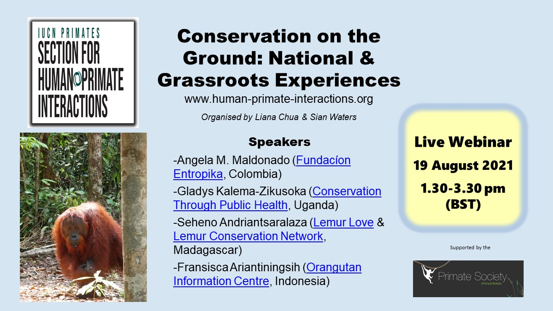
Urban Human-Primate Coexistence 7th September 2021
Organisers - Wendi Prameswari and Malene Friis Hansen
Andrew King (Wales) - Extreme Behavioural Flexibility by Chacma Baboons Using Urban Spaces
Sabrina Jabbar (Singapore) - Human - Macaque Integrated Approaches for a City in Nature.

Sharmini Julita Paramasiwam (Malaysia) - Embracing Community-based Conservation to Manage Human Monkey Interaction in Urban Areas

Anindya “Rana” Sinha (India) - Why We Must Return to the Monkeys: Macaque–Human Ethnographies of Urban India
Total views per video =178
Community Science for Conservation 9th December 2021
Organisers – Sian Waters and Denise Spaan

Andie Ang (Singapore) - Citizen science programme for critically endangered primates: a case study from Singapore
Jo Leen Yap (Malaysia) - Langur Project Penang: Let's Bridge to Coexist.
Denise Spaan & Montse Franquesa Soler (Mexico) - Collective actions to conserve Mexico's urban primates: promoting citizen science through social media
Nancia Raoelinjanakolona (Madagascar) - Setting up a citizen science project in Madagascar
Marcello Nery (Brazil): The Monkey's Web - Connecting Science and the Citizen
Total views per video = 52 (video accessible on our website for less than a month).

