Wildlife tourism and conservation: an interdisciplinary evaluation of gorilla ecotourism in Dzanga-Sangha, Central African Republic

Kathryn Shutt

k.a.shutt@durham.ac.uk

Department of Anthropology
Durham University
Dawson Building,
South Road,
Durham, DH1 3LE

Awarded a PSGB Conservation Grant in February 2010
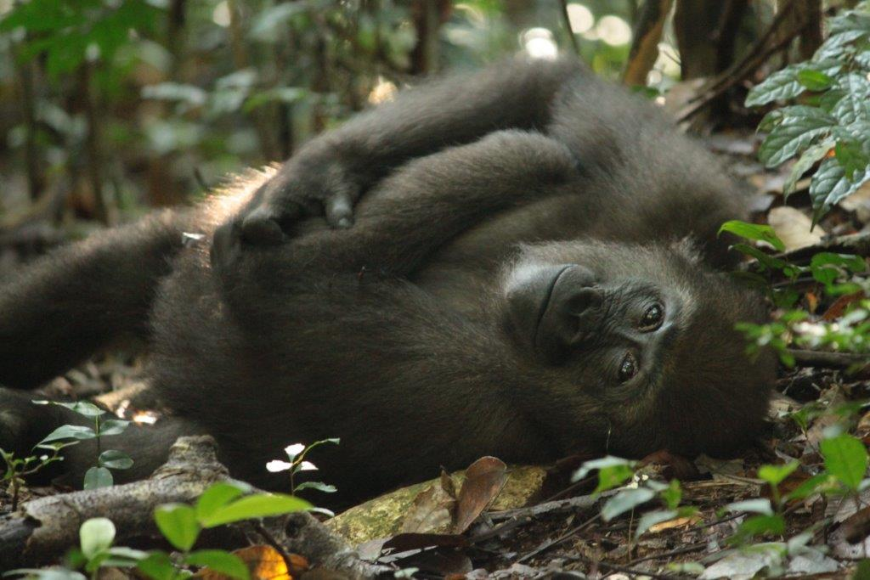
Wildlife tourism is proliferating worldwide and has the potential to raise revenue for conservation as well as public awareness of conservation issues. However, concerns are growing about the potentially negative influence of such tourism on the wildlife involved. An absence of scientific information means that the potential costs of tourism are unidentified, tourism management strategies are not informed by scientific studies, and the ethics of habituating animals to humans remain relatively unexplored, though much discussed. This combination of ecological and anthropological research questions necessitates a bio-social approach. In this thesis I adopt an interdisciplinary approach to explore the factors that influence human-animal interactions and incorporate them into conservation biology. I use the Dzangha-Sangha Gorilla Habituation and Ecotourism Project in the Central African Republic as a case study. First, I explore the context of wildlife tourism and why people watch gorillas in the wild, their reactions to and behaviours during their gorilla encounters and the effect these encounters have on the visitors. People are drawn to gorillas because gorillas are human-like and tourists seek close encounters which are rare and authentic. Photography is a key motivation for tourists to visit gorillas but also a major cause of disturbance. Next, I detail a series of experiments I conducted to validate methods for measuring physiological stress in the western lowland gorilla. Using these methods, I then address the question of whether gorillas incur stress as a result of habituation and ecotourism activities, comparing faecal glucocorticoid metabolite levels (FGCMs) in four gorilla groups at different stages of habituation. Two (and possibly all three) of the human-contacted groups had significantly higher levels of FGCMs than unhabituated gorillas, and the group undergoing habituation had the highest FGCMs, suggesting that the process of habituation is perceived as a threat by gorillas, and that habituation reduces this response over time. FGCMs in habituated groups were significantly associated with increasing frequency of violation of the 7 m distance rule by observers and with a medical intervention but not with other measures of human pressure, suggesting that some elements of human-gorilla contact still elicit a GC response in habituated gorillas. I then demonstrate a positive association between FGCMs and parasite infection that may reflect hormonal suppression of the immune system in gorillas with higher FGCM levels, or, stimulation of the HPA axis as a result of increased parasite infection. Finally, I explore socio-cultural, epidemiological and management aspects of human interactions with gorillas in order to identify how and why visitors break regulations and the subsequent risk of human-gorilla disease transmission. Socio-cultural and emotive factors motivate people to get close to gorillas. Epidemiological factors interact with socio-cultural and emotive drivers to create a variable profile of disease risk presented by each person during their interactions with gorillas. The outcomes of this interdisciplinary risk assessment will inform policy makers as to how they may better protect gorillas, and other animals, from the potential negative effects of human disturbance resulting from habituation, tourism and research activities. The implications of this study will help to maximize the potential for such projects to be beneficial, low-impact and sustainable conservation solutions.

