LEARNING &
WELLBEING PACK
Hello!
As Providence Row @The Dellow is currently closed due to the Coronavirus, we want you to know that Learning and Wellbeing very much continues. We, like you, are currently staying at home to help stop the spread of coronavirus (known more specifically as COVID-19).
The flowers in this design were made by a member of our Women’s Only Art, Craft and Photography Group

We have put together these packs to help you stay connected to your own learning and wellbeing while staying at home. We encourage those who have already participated in the groups and activities to think about the time and effort you have put into the sessions that you have attended. Was there a project or piece of work that you’ve been working on recently? How could you continue this now? How have you been looking after yourself? We’ve got some pages here for you if you’re not sure where to start.

We would love to hear from you about your experiences and how this time of isolation is affecting you. And if you haven’t been to any of the groups at Providence Row, we’d love to hear how you find this pack. We're here if you'd like to get in touch to tell us how you are, if you need any support or about the work that you're doing. Our contact details are below.

Of course, we will keep you updated on when Providence Row reopens and Learning and Training activities start again.
USEFUL TELEPHONe NUMBERS

Samaritans
116 123
When things are difficult, whatever kind of distress you’re feeling, talk to someone here for free, confidentially, 24/7

NATIONAL DOMESTIC ABUSE HELPLINE
0808 2000 247
A free, confidential service for people experiencing Domestic Abuse, 24/7, available in different languages.

Stay in touch,
Monday – Friday 9am – 5pm
Alex ☏ 07776590709 apalmer@providencerow.org.uk
Sarah ☏ 07990004246 shalsey@providencerow.org.uk

Monday, Thursday, Friday 9am – 5pm
Chris ☏ 07741143898 cbardo@providencerow.org.uk

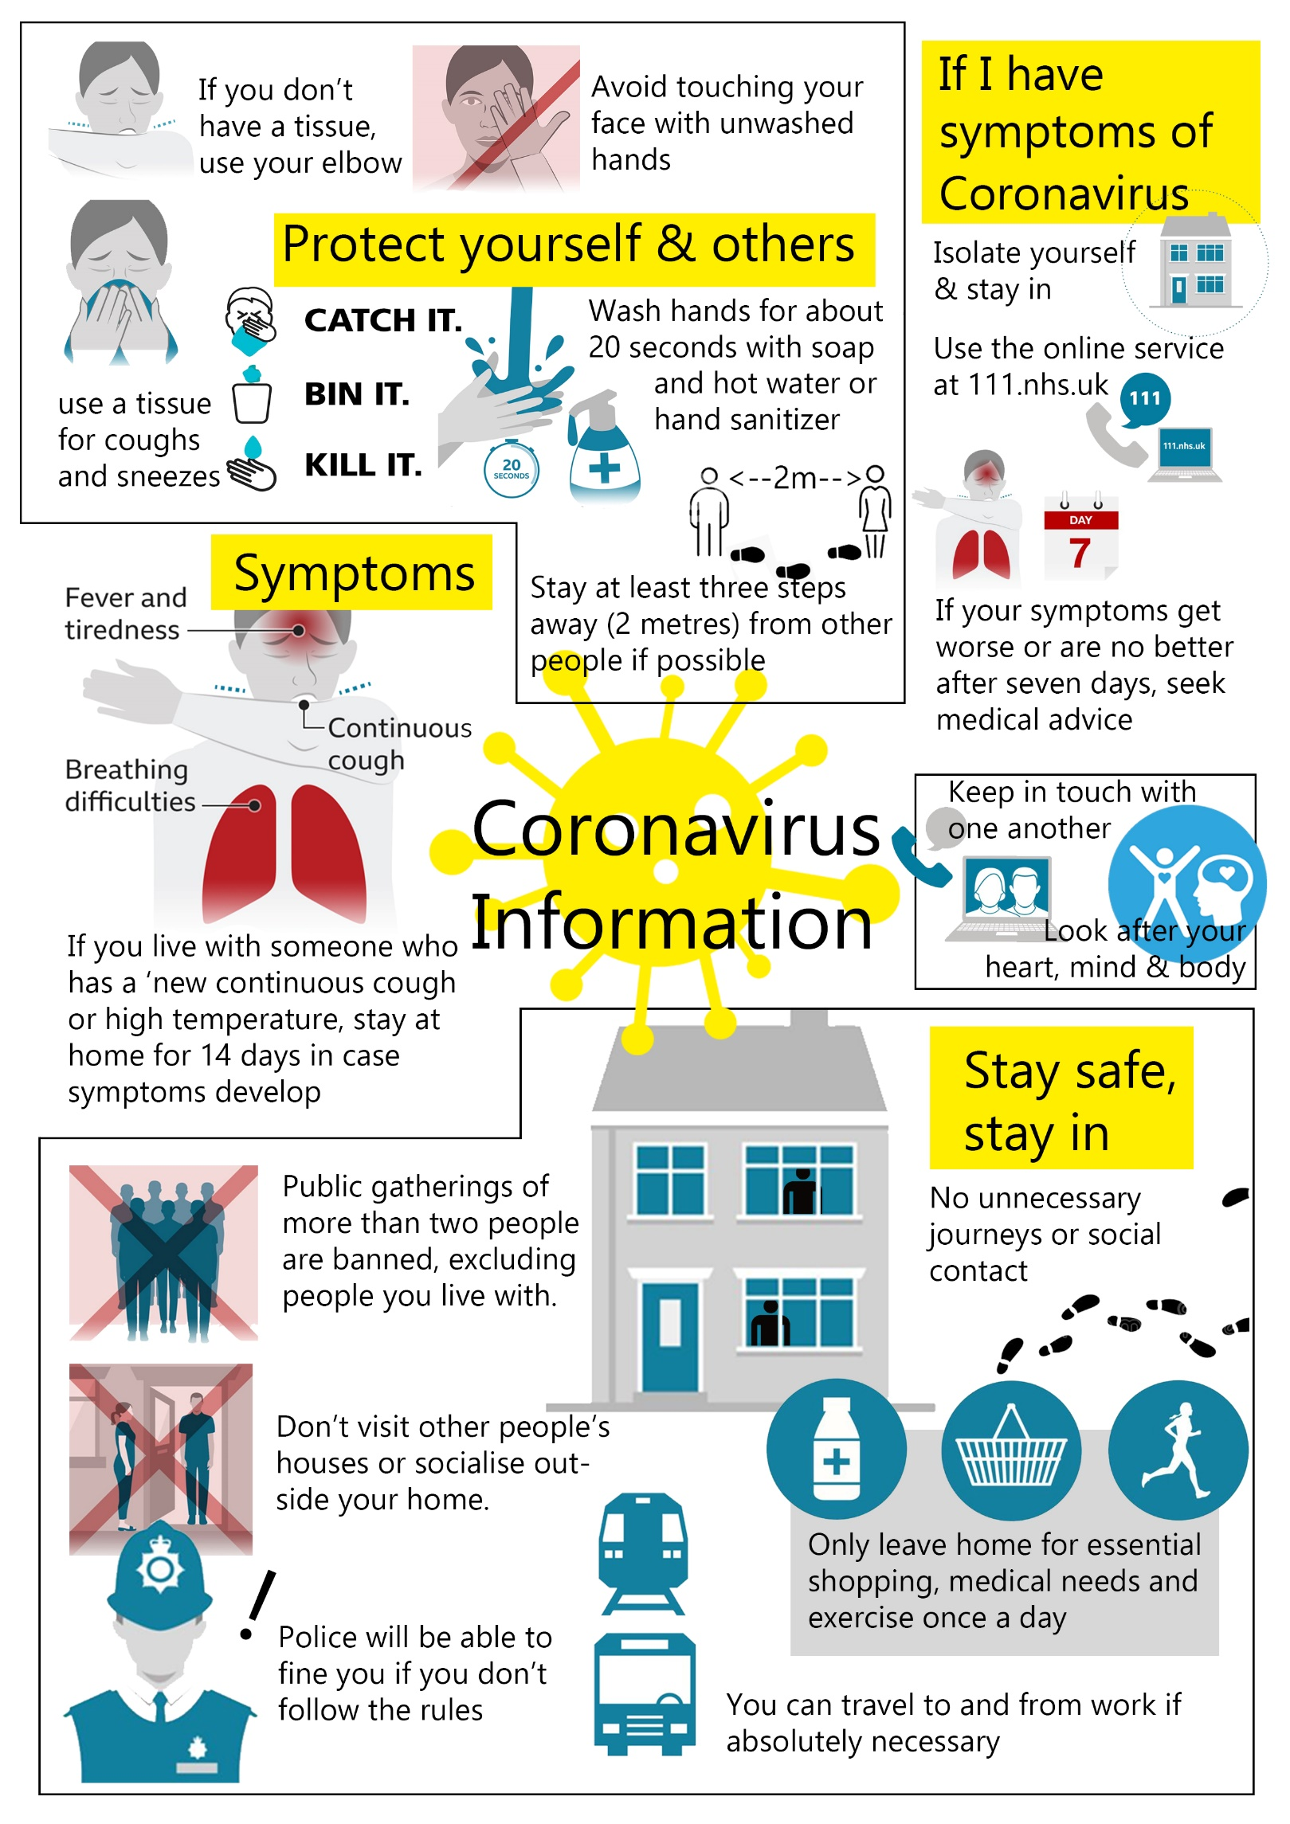
STAYING CONNECTED DURING ISOLATION
We would LOVE to hear from you, about your experiences of isolation, though we appreciate that your options to connect to us may be limited.
Connecting with others
Is there a friend that you haven’t heard from in a while? Reaching out to others by phone/email could really help both them and you.
Connecting with yourself
During this time of enforced isolation, it is a perfect time to connect with ourselves. Too often there is far too much going on to stop and concentrate on us.
Keeping a journal.
Writing down your thoughts on a daily/weekly basis. This can be an excellent tool to help us process and deal with this time of isolation. Getting things out of our heads and down on paper can be excellent therapy. This can also be done in drawing form, or any other way that you want. Also, it will be a great way to keep a written history of this unique time in our lives. Looking back over the next few years will be fascinating.

Example – “Tuesday 24^{th March 2020}. First day of isolation and it feels weird. I looked out the window and the street was empty. I felt quite scared and went back to bed until lunchtime. My friend John called me and told me how weird he was finding it. We had a good laugh about the last time we met and how he had fallen over running for the bus. Made myself my favourite lunch. Beans on toast!!!!

Getting Creative (focusing on the process, not the product)
One exercise is to take a blank piece of paper and just start drawing, without thinking about what it is you are doing. To allow yourself to go with it rather than think about.
Naming your feelings
Another way to connect to yourself is by naming how you’re feeling at a particular moment. It may fear, anger or another emotion that you are experiencing. Write about it. How does it feel? Does it have a colour? Does it have a shape or sound?
Are there other ways you could connect with other or with yourself? Let us know your ideas!!
Connecting with us at Providence Row
Call, text, whatsapp, email – talk to us, send us a message or even a video
Sometimes it can be difficult to be left with ourselves or to work on personal projects without anyone to talk about them. If things are feeling difficult, it could be important to talk to us. Please give us a call. We would love to talk it through with you. Remember, we are isolating too, so we would also love to hear your ideas and suggestions on dealing with staying at home during coronavirus

Monday – Friday 9am – 5pm
Alex ☏ 07776590709 apalmer@providencerow.org.uk
Sarah ☏ 07990004246 shalsey@providencerow.org.uk

Monday, Thursday, Friday 9am – 5pm
Chris ☏ 07741143898 cbardo@providencerow.org.uk
Keeping fit
Government guidelines state that currently we can go out for exercise once a day, but that doesn’t mean that we can’t exercise at home, even if we have limited mobility.

PLEASE TAKE CARE WHEN COMPLETING THESE EXERCISES AND TAKE REGULAR BREAKS. IF YOU FEEL UNWELL, PLEASE STOP.

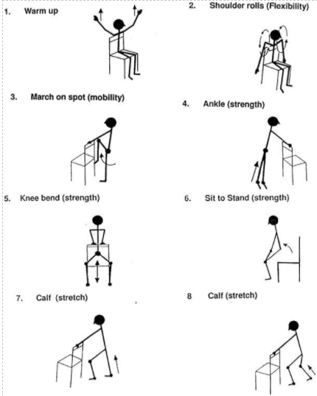
Exercises taken from http://exercisesforseniorshozomehi.blogspot.com/2017/03/chair-exercises-for-seniors-handout.html
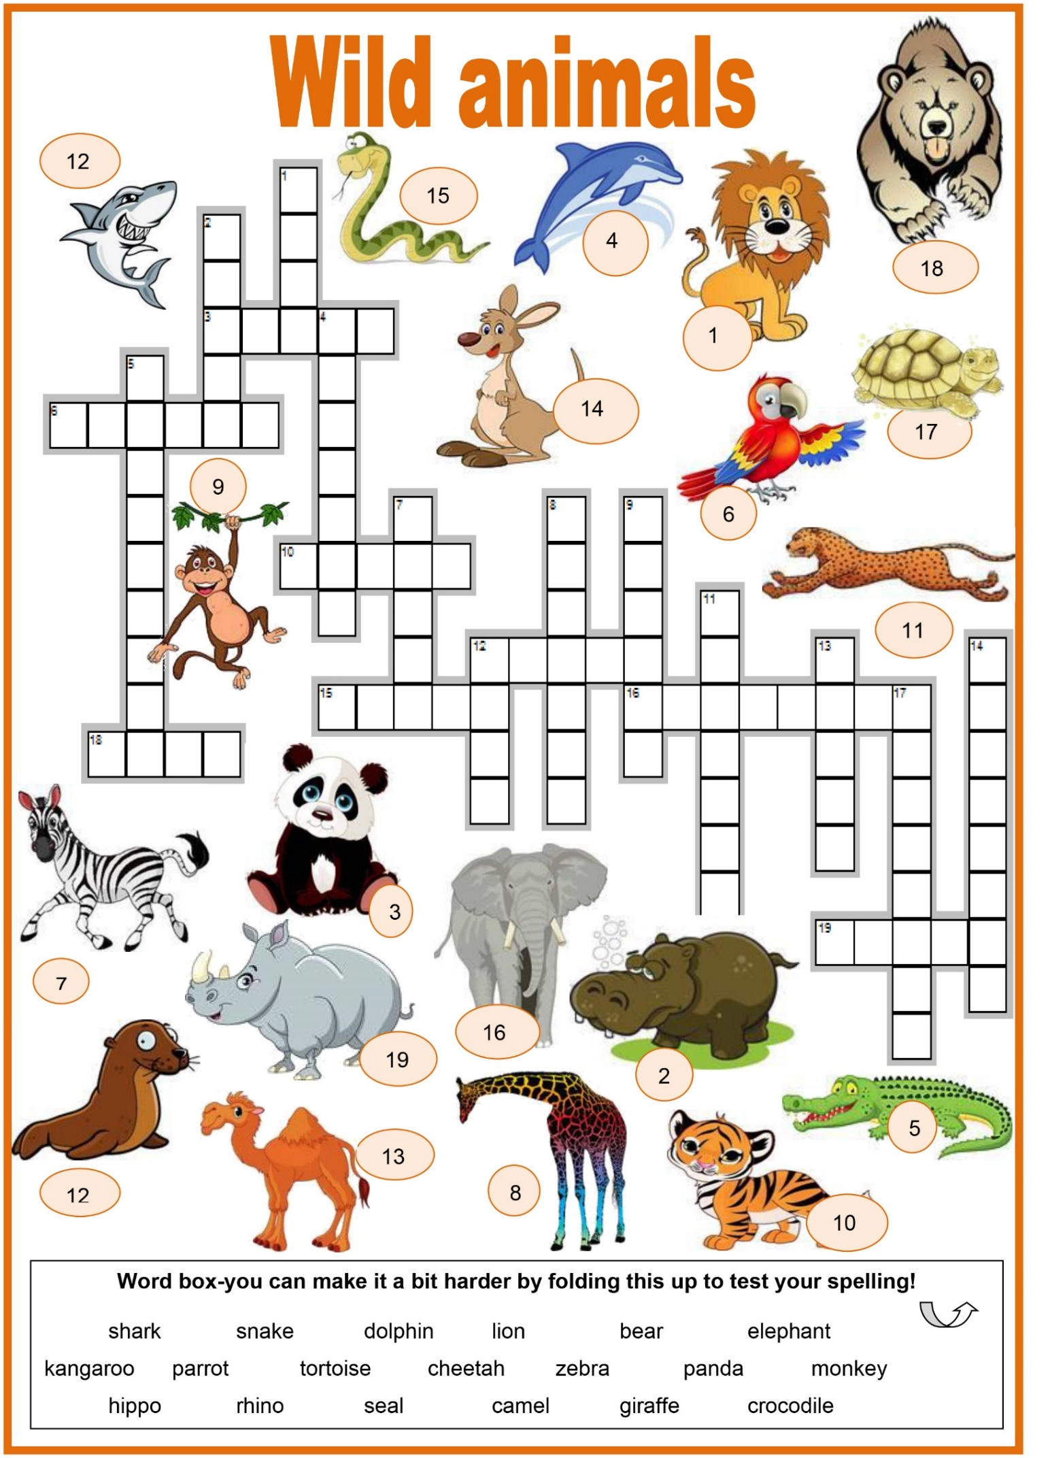
Crossword (adapted) by silvialefevre at https://en.islcollective.com/
