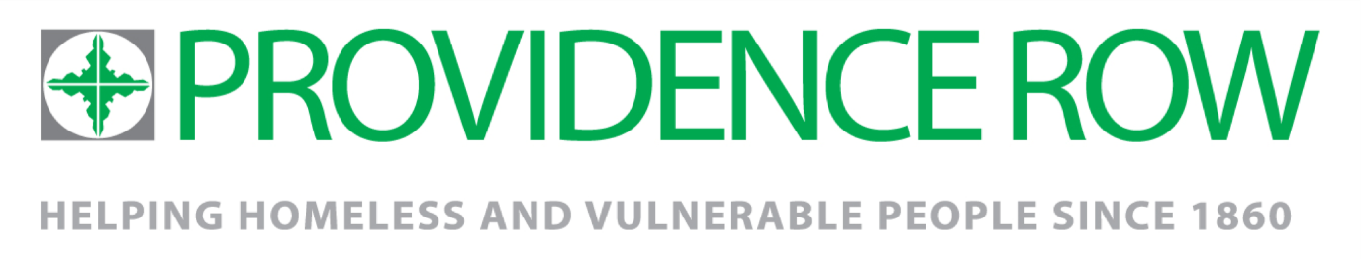
Substance Use Outreach Worker
August 2019

Job title: Substance Misuse Outreach Worker | Team: RESET Outreach and Referral Service
Accountable to: Senior Referral Adviser | Line managing: Peers and Volunteers
Salary: £25,000  Pension: following successful completion of 6 month probationary period (5% employer contribution conditional on min. 3% employee contribution) | Hours: 35 hrs a week/including some evening/weekend/early morning.
Disclosure: Enhanced | Contract: Permanent

Tackling the root causes of homelessness in London
For homeless people, or those at risk of homelessness, finding employment and housing opportunities can feel like an uphill battle, even more so if they’re affected by physical, mental health or substance misuse issues. Providence Row works with more than 1800 homeless and vulnerably housed people a year in East London, offering an integrated service of crisis support, advice, recovery and learning and training programmes. Our aim is to ensure that people who are so often excluded from mainstream services gain the support and opportunities they need to create a safe, healthy and sustainable life away from the streets. Central to our work are our core values of Compassion, Respect, Inclusiveness, Empowerment and Justice. These inform the content, style and delivery of all our services.
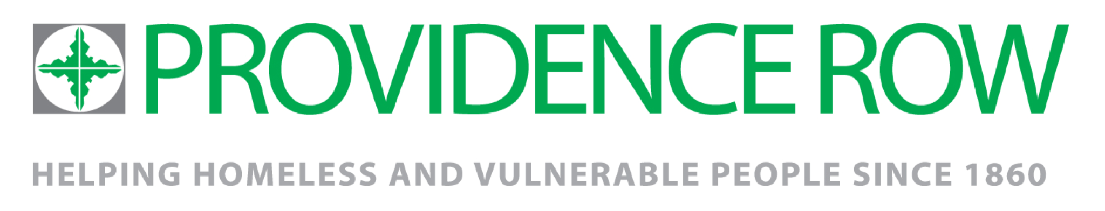

RESET Outreach and Referral Service
Providence Row has been successful in winning the new Reset Outreach & Referral Service contract. Having successfully delivered the contract for 3 years Providence Row is now building on its success with engagement and minimising harms through outreach work in the vibrant yet complex Borough of Tower Hamlets.

The Service is based at the central hub delivered by Providence Row and is commissioned by Tower Hamlets Drug and Alcohol Action Team (DAAT). The service works seamlessly with Reset Treatment and Reset Recovery Support Services providing residents of Tower Hamlets with the drug and alcohol support they need.

The Outreach team includes a needle exchange provision and onsite support at the hub. The team works alongside other Outreach provisions within the Borough and partnership work is key.

The service is delivered through a “strengths based” approach. This means that all staff involved in the delivery of the service must work with, rather than for clients to address their situation. This approach taken by Providence Row recognises that clients are people with problems, not problem people. The service will engage clients in the development, delivery and evaluation of the work, working with a team of peer mentors with lived experience of substance misuse.

The ideal candidate
Passionate about providing quality Outreach support to some of the most vulnerable women and men and excluded people across communities in East London, you have the drive and track record to make positive lasting changes in people’s lives. You have considerable experience of substance misuse working in a fast paced environment dealing with the resulting client needs. You are an excellent communicator and can create positive working relationships with a wide range of people. You are active, able to work independently and as part of a team and experienced in dynamic risk assessment. You are creative, innovative, driven and well organised.

The Role
The role will involve;
- Delivering a range of outreach support to individuals with chaotic drug/alcohol use.
- Providing support to encourage people from hard to reach groups and hidden populations into treatment services, including those not willing or able to access structured treatment interventions.
- Providing targeted harm reduction advice and information to individuals around the risks associated with drug or alcohol use and supporting people to improve their situation.
- Providing support to individuals to access treatment and recovery support services.
- Signposting to other support services where an individual with problematic drug and/or alcohol use does not engage with the service or whose support needs are not limited to drug and alcohol use.
- Promoting the full range of support available for varying levels of drug and alcohol use.
- Providing outreach to local communities to better support treatment naïve service users to prepare for treatment, delivering awareness training and group work to community groups and external agencies.

Key Responsibilities:

Client support
- Provide harm-minimisation advice and information to clients who are not yet willing to address their substance use and work with this resistance through motivational interviewing techniques.
- Provide information and advice on treatment and support services within the borough, including signposting clients to a wider network of support services, and where appropriate advocating on their behalf.
- Provide support to clients willing to address their alcohol and substance use through 1:1 support, group facilitation and presentations.
- Provide varied support to clients to facilitate engagement through a strengths based and personalised approach.

Promote of Reset services
- Participate in the Needle Exchange rota, using the service as an engagement tool and to build rapport.
- Encourage treatment resistant clients to use the low threshold services provided at the central hub to maintain engagement.
- Actively promote the services offered at the central hub to a wide range of organisations to encourage referrals into the service, and to highlight people of concern to the service.
- Participate in the production of the Referral Service promotional materials.
- Take on networking responsibilities to ensure the service is well informed, up to date and promoted.

Partnership
- Foster supporting partnerships with Reset colleagues at Providence Row, treatment and recovery support.
- Participate in the team rota to deliver the service to a high standard.
- Develop partnership work with other agencies and communities in the borough to better identify signs of substance use.
- Deliver 1:1 support, group work and training to other professionals.
- Act as a first point of contact for relevant agencies and organisations who provide specialist support to communities; Women, LGBTQ, Faith, BME groups, particularly those most represented in LBTH – Bangladeshi and Somali, Families, Young Adults.
- Actively seek out and forge links with agencies and communities with a view to expanding networks and exploring partnership working.

Admin and Other Duties
- Record all client contact, service delivery and outcomes based on the contracts Key Performance Indicators to a high standard, using Inform database.
- Complete paperwork such as shift reports, assessments, referrals and short treatment episodes.
- Provide summary reports to the Borough Drug and Alcohol Outreach Lead on performance and outcomes to be provided to the commissioners.
- Ensure all work carried out is in line with all policies and procedures relevant to the role.
- Support and promote service user involvement to enhance service delivery, and provide support to the Peer Mentor/Volunteer Manager.
- Participate in the production and implementation of the Referral Service Team Plan and resulting personal objectives.
- Take on occasional tasks as agreed with the Borough Drug and Alcohol Outreach Lead.
- Work in accordance with the Charity's values, policies & procedures.

Person specification
Knowledge and Experience
Experience of working in an Outreach environment including street outreach | Essential
Experience of working with vulnerable people with complex needs | Essential
Experience of current Children and Adult safeguarding legislation | Essential
Experience of working with individuals who are actively engaged in substance use | Essential
Experience of solution focused 1:1 work and use of psycho-social approaches | Essential
Knowledge of substance misuse issues and relevant services in the area | Essential
Good IT skills, including databases to log and manage information and use of mobile and remote technology to communicate | Essential
Strong commitment to the importance of monitoring and evaluating all work completed | Essential
Experience of running group work and training for clients and professionals | Desirable
Experience of engaging clients in designing, delivering and evaluating services | Desirable
A good understanding of the local community, cultural diversity and the need to adapt services in order to enable equality of access to services. | Desirable
Experience of managing volunteers including those with low or no support needs and volunteers with lived experience of substance misuse. | Desirable
Attributes
Strong organisational and recording skills | Essential
The ability to work with a wide range of people from a diverse community | Essential
The ability to work in partnership, including compromise and collaboration | Essential
Able to work unsociable hours such as early mornings and late evenings | Essential
Flexible and with a “can do” attitude | Essential
Able to work to the Providence Row core values | Essential

