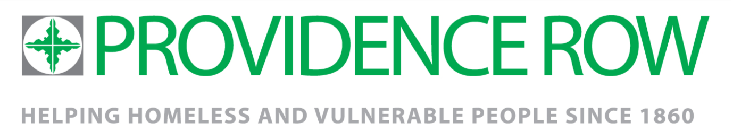
Reset Outreach and Referral Service –Community Engagement Worker

Salary: £27,000
Duration: Full Time 35 hrs per week. Permanent contract.
Reset Outreach and Referral Service
This role sits within the Reset Outreach & Referral Service, which is based at and delivered by Providence Row. The service is commissioned by Tower Hamlets Drug and Alcohol Action Team (DAAT) to work seamlessly with Reset Treatment and Recovery Support Services in providing residents of Tower Hamlets with the drug and alcohol support they need.
The role involves building relationships with marginalised and hard-to-reach communities in Tower Hamlets. You will identify places of interest where people who might have various practices of drug and alcohol use can be found and where ongoing relationships can be built. This service is a vital first point of access to support and engage people who use drugs to address their needs.

The ideal candidate
You have knowledge of substance use or experience working in a fast-paced environment dealing with a variety of needs, but you do not need to be a senior established substance misuse professional. Your experience can be paid of volunteer and lived experience of using substances is equally valued. You should be eager to engage with people through providing a low threshold, non-coercive service and be understanding of how other factors such as language barriers and cultural norms surrounding substance use can impact a person’s access to services. You will live out Providence Row’s values in your approach to your work, as well as abide by the principles of harm reduction as specified by the organization Harm Reduction Coalition (HRC).

You are an excellent communicator and can create positive working relationships with a wide range of people. You are active, able to work independently and as part of a team, and experienced in carrying assessing risk in varying situations. You are creative, innovative, driven, and well organised.

For an application pack, please visit our website at www.providencerow.org.uk/jobs
The deadline for applications is midnight 23rd September 2021
Interviews will take place on the Week Commencing 27th September 2021

Providence Row is a charitable company limited by guarantee registered in England and Wales; company number 07452798 registered charity number 1140192.

