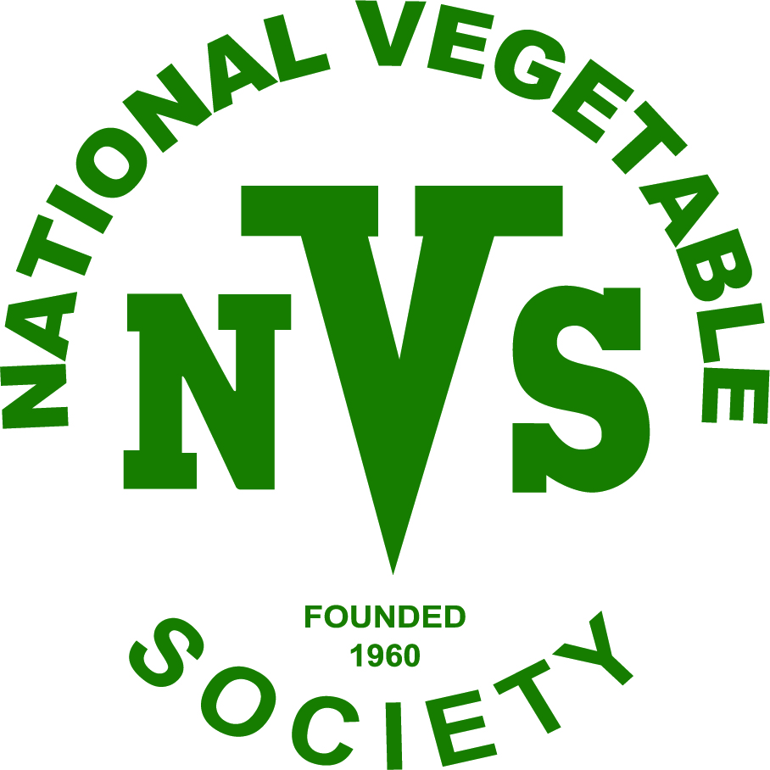

West Midlands District Association

Meetings are held at Fairfield Village Hall. B61 9LZ

Opening at 7.30 pm for 8.00 pm start

There are talks by experienced Vegetable growers, presentations by Specialists on particular aspects associated with vegetable growing.

There are leaflet growing guides on specific vegetables and books available for purchase.

We have products available for sale such as Rock Dust, including small trial packs. Occasionally other products are available.

There are quality plants and produce for sale during the year as appropriate and at our Meeting in May we have a Bring and Buy Sale.

The meetings Planned for 2022:

Thursday 24 February General Meeting (including AGM) and a vegetable related talk details to be confirmed.

Thursday 26 May February Talk / Presentation to be finalised and followed by the Bring and Buy Sale

Thursday 25 August Annual Show and a short evening talk yet to be arranged.

Thursday 24 November Evening Talk followed by Presentation of Prizes.

The National Vegetable

Society

Charities Registration No. 1088979
West Midlands District Association

ANNUAL SHOW
Thursday 26 August 2021

8.00 pm
Fairfield Village Hall
Stourbridge Road Fairfield
Bromsgrove B61 9LZ
Organised by Roy James

National Vegetable Society

West Midlands District Association (DA)

ANNUAL SHOW 2021

Show Schedule.
To be held at Fairfield Village Hall at DA meeting on Thursday 26th August.
STAGING: Planned 7.00 to 7.55 p.m. maybe extended for safety / social distancing.
JUDGING: to commence 8.00 p.m. maybe later if staging is delayed.
JUDGE: GRAHAM LINK FNVS

CLASS 1. Potatoes – £10 Prize Money Sponsored by ALBERT WALKER.
One dish of 3 White AND One dish of 3 Coloured – one named variety of each.

CLASS 2. Carrots –£10 Prize Money Sponsored by WMDA.
One dish of 3 – Stump Rooted. Tops trimmed to 75mm.
Variety to be named.

CLASS 3. Beetroot – £10 Prize Money Sponsored by PETER WALDRON.
One dish of 3. Red Globe approx. 60-75 mm diameter. Tops trimmed to 75mm.
Variety to be named.

CLASS 4. Onions – £10 Prize Money Sponsored by RICHARD SPIERS.
One dish of 3. 250 gm or under. Variety to be named.

CLASS 5. Tomatoes – Medium – £10 Prize Money Sponsored by IVAN PERRINS.
One dish of 3. Size should be approx. 60mm in diameter. Variety to be named.

CLASS 6. Turnips - variety OREGON F1 – £10 Prize Money Sponsored by WMDA.
Seeds Supplied and Sponsored by Medwyn’s of Anglesey.
One dish of 3 roots from seeds supplied by Medwyn’s through the DA are eligible.
Clear skinned shapely ball roots with small single taproot and foliage trimmed to approx. 20 mm.

CLASS 7. Collection of 4 dishes of Vegetables – £20 Prize Money
Sponsored by PETER CHAMBERLAIN.
From: Potatoes (3) one variety, Carrots Stump Rooted (3), Beetroot Red Globe (3),
Tomatoes Medium (3), Onions (3) 250 gm or under, Runner Beans (6) with stalks.
All vegetables to be named and displayed as detailed in Classes 1 - 5.

CLASS 8. French Beans – £10 Prize Money Sponsored by GRAHAM LINK FNVS.
One dish of 6 with stalks. Variety to be named.

CLASS 9. A Collection of Salad Vegetables - £10 Prize Money
Sponsored by ROY JAMES.
Any number of vegetables with a minimum of 4 varieties to be selected from Celery, Chives, Cucumber, Fennel, Kohl Rabi, Lettuce, Radish, Salad Potatoes, Spring Onion, Sweet Pepper, Tomato (Cherry) and displayed in a CLEAN STANDARD SEED TRAY.
Parsley may be used for presentation.

NOVICE CLASS 10. - £10 Prize Money Sponsored by WMDA.
ONE entry chosen from Classes 1 to 9.
Please note: Novices may also enter the other Classes.

NON MEMBERS / VISITORS CLASS – BEECHCROFT Nurseries & Garden Centre have kindly sponsored this Class with Vouchers to the Value of £25. The Prize Money is Sponsored by ROY JAMES and GRAHAM LINK FNVS. 1st Prize £10 Voucher+£5
2nd £5 Voucher+£5 3rd £5 Voucher+£3 4th £5 Voucher+£2 5th £3 6th £2

One Dish of any single variety of vegetable(s) grown by Exhibitor.
Dish/Cloth will be provided and assistance/guidance will be given by an experienced member, if requested.
ALL EXHIBITORS have FREE ENTRY to both the Show and the Prize Presentation Evening on 25 November including any associated Evening Talk.

Vegetables to be kept fresh with WATER ONLY.

BEST IN SHOW - to be awarded a TROPHY sponsored by the MIDLAND BRANCH.
BEST SINGLE DISH OF POTATOES IN SHOW - £5 Prize Sponsored by WMDA
Where there is £10 Sponsored Prize Money it will be shared £5, £3, £2.
For Class 7 the £20 Sponsored Prize Money will be shared £10, £6, £4.
For the Non Members/Visitors Class – Prize Money as indicated above.

It would be appreciated that Exhibitors who do not wish to take home leave these for auction at the end of the evening.

ENTRY FORM – MEMBERS CLOSING DATE - Friday 20 August
NON MEMBERS / VISITORS – may enter on evening of Show

Name: ………………………………………………………… Membership No. ……………………………..

Classes Entered: ………………………………………………………………………………………………………
Exhibitor Cards will be available and issued before Staging.
Entries by email or telephone
Tel: Roy James 01527 831508
email: roy_ james2 @ sky.com (preferred)

