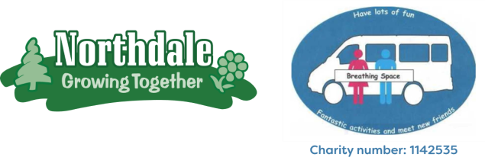
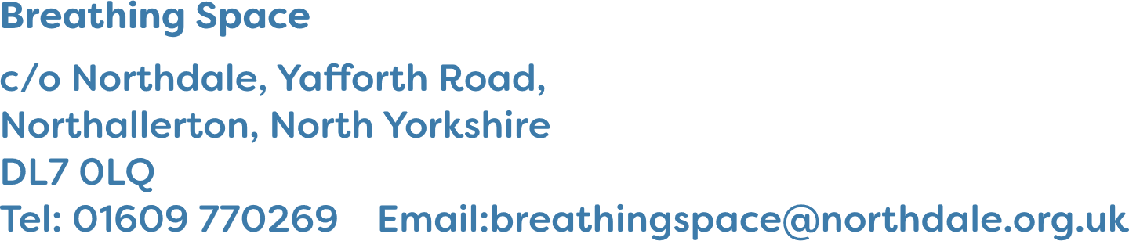
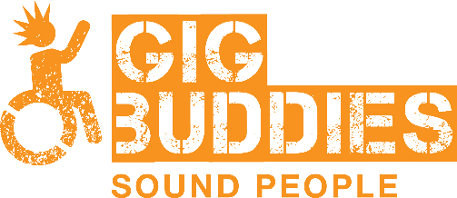

What is Gig Buddies Northdale?
Gig Buddies is a way you can make a new friend who you can go out with.

Your buddy will be matched with you carefully.

We listen to what your interests and hobbies are and match you with a volunteer who likes similar things.
Your shared interests and hobbies can be anything!

Watching a football match, live music, going to the cinema or going for a country walk.

Gig Buddies is free to join. It is for anyone who is a Breathing Space member or Northdale trainee.
Northdale are running Gig Buddies because they want to stop people with learning disabilities feeling lonely.

