TEN WORD TALES EASTER SPECIALS
The Guava Palava
by The Story Spinner

CHAPTER 4
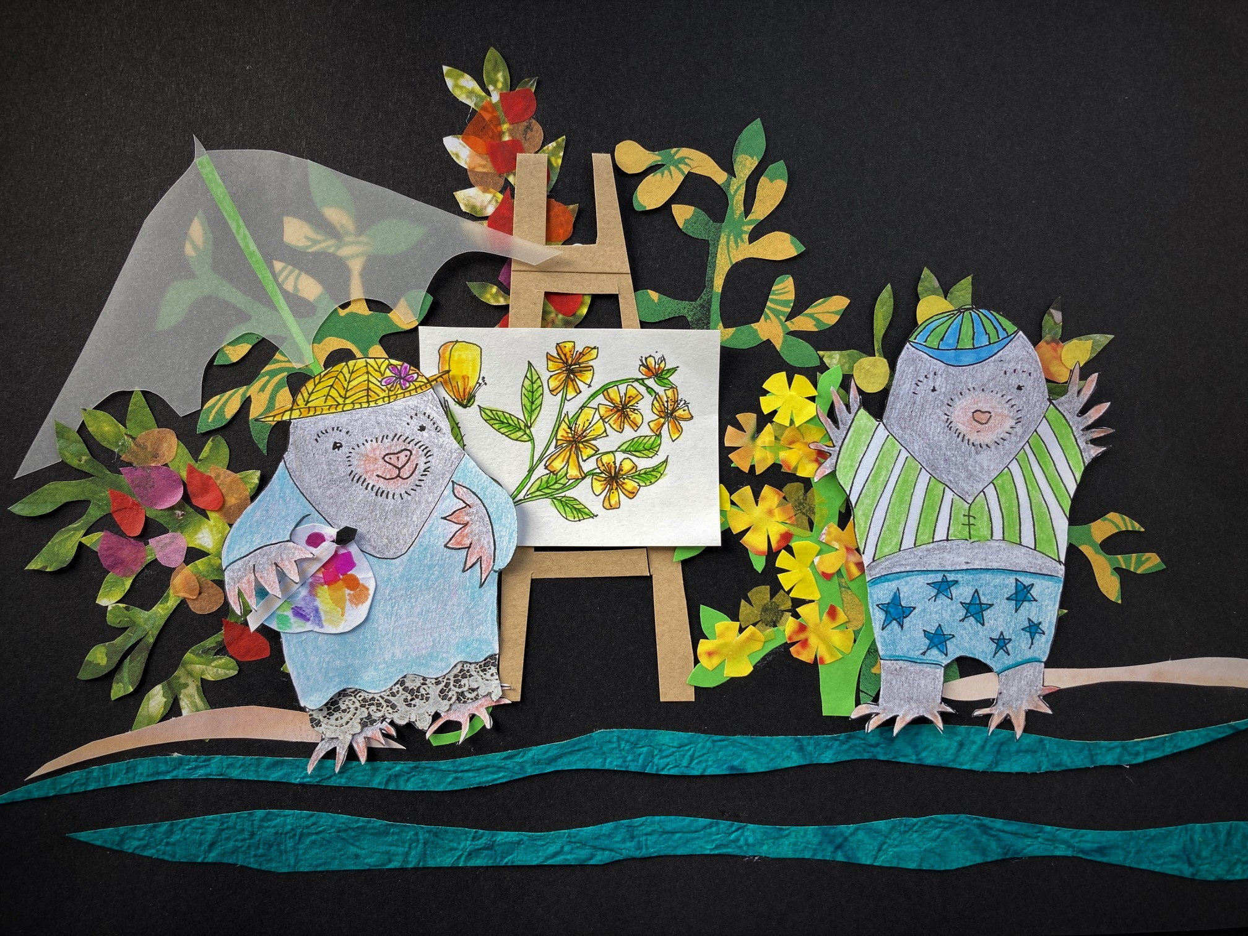

Over breakfast the scientists, who had heard Nick’s yells as he talked to Mick, asked what had happened. They were very sympathetic. Some of them had experienced attacks by rivals.

“I remember when someone tried to steal the micro-mandarins I was growing on my balcony,” said a girl called Sarah.

“I remember when someone stole my research on growing dragon-fruit in the dark with only one hour of leaf-filtered sunlight every day,” said an old professor.

Nick spent the day with the scientists. Sarah was taking samples of rock within a kilometre radius of the new guava trees. The professor was noting the light-and-shade conditions the guavas seemed to prefer. Nick enjoyed learning about the new species while Norma painted them, sheltered by a huge umbrella.

“I wish I’d been a scientist,” Nick sighed later over dinner, “but I’m not clever enough.”

“You are a scientist!” said Sarah and the professor at once. They said he was the perfect scientist as he spent his whole life observing and growing fruit. Nick went quite pink with pleasure.

Norma laughed as she tucked into the delicious dessert of tropical trifle. “I tell him this all the time. Perhaps he’ll believe you, though he never believes me. You’re scientists. I’m just his wife.”

The scientists insisted Norma was a scientist too, observing and recording flowers. “We sent for you to come from London to do our pictures because you’re the best,” said the professor.
“The best in the world,” said Sarah.

The Moles went to bed early again.

“It’s a mystery why they think we’re so good,” said Nick. “Obviously you are, but ...”

“Obviously you are,” said Norma. They fell asleep to the sound of the waves close by and an owl hooting.

They had a wonderful time with the scientists. They were all firm friends by the end of the trip. Nick was given some cuttings and seed samples of the new guava for himself and the responsibility of delivering cuttings and seeds to Kew Gardens when they got back to London.

“Find an expert called Ken,” said the professor.

“I’ve met him,” said Nick.

Sarah drove them to the airport.

Watch out for Chapter 5 tomorrow!

