Tips for Learn to Love to Read reading volunteers

This is a second online reading scheme for you to use for your virtual reading session. It is particularly good when you want to find books that focus on specific phonics phases or individual sounds – especially useful if your child is very much at the early stages of learning to read. It is also helpful to have two different schemes to access in case one of the websites has issues one week!

Logging in
Log in at: https://ebooks.collinsopenpage.com with the username and password supplied by L2L2R.

User guide
Read through the Collins Big Cat ebook Libraries Parents’ Guide, a two-page PDF. This is aimed at parents supporting their children at home, but it gives a good general overview of how to navigate the Big Cat ebooks bookshelf.

Tips for volunteers

Finding books
As you are a reading volunteer rather than a parent, you have been allocated all 352 books available, all of which will appear on your bookshelf. To select books of the right level for you child, enter the book band colour into the search field. You can also sort the bookshelf by books most recently read, A-Z and Z-A. Click on your chosen book cover to open it.
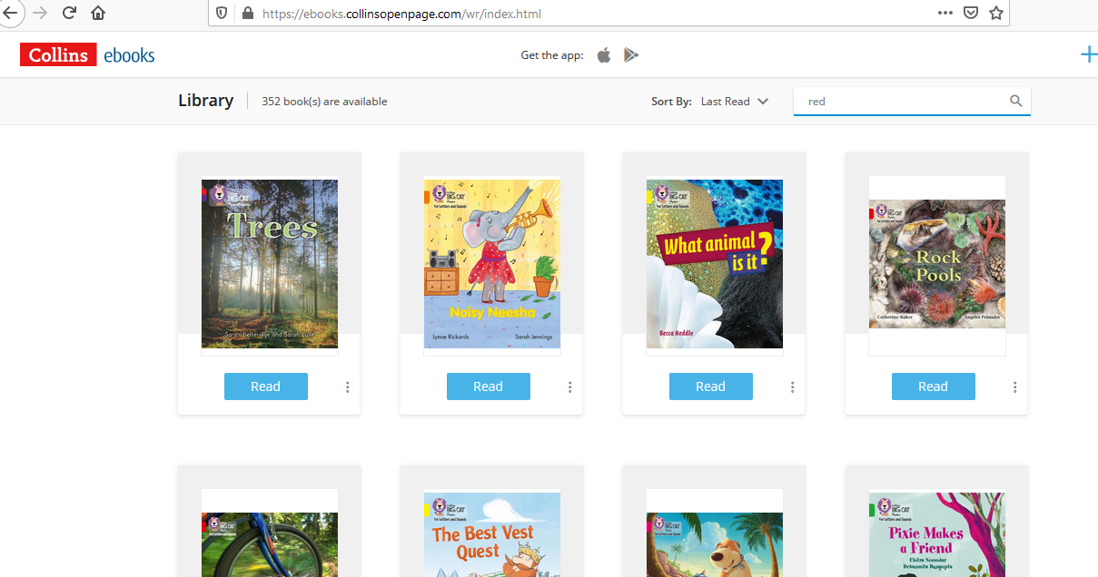

Zoom tip
Unlike Rising Stars, Big Cat does not open a new window when you open a new book. Therefore when you are sharing your screen in Zoom, you should not have to share again when you open a new book. The child should automatically see it on the screen.

Returning to the bookshelf
When you have finished the book and you want to return to the bookshelf, click on the red library button.

Annotating books
If you want to annotate the book – underlining and/or highlighting words for example, we suggest you use the Zoom annotation tools (NB if you are screen sharing using an iPad you will not have access to the Zoom annotation tools).

Bookmarks
You can add a bookmark to any page by clicking on the bookmark icon on the top left or right-hand corner of the page.
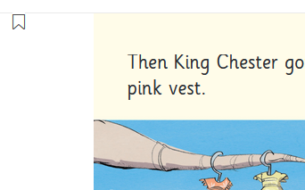

Activities for understanding and comprehension
You will find suggestions and ideas for discussion and helping comprehension on the front and back inside covers of the books.

Tablet users
If you are using a tablet, you may be prompted to download the app version. You can do this for ease of use, but we suggest you use the desktop version in a browser as when you open a book in the app, it downloads it onto your device which could eventually take up a considerable amount of space on your device.
Any questions please email Matilda@learn2love2read.org.uk.

