L2L2R virtual reading session Zoom tips for volunteers
December 2020

Open your online book library first
Go to https://my.risingstars-uk.com/ and sign in with your personal L2L2R account. Choose the Rising Stars Reading Planet option, then click on the brown Menu option. Select your library (Rocket Phonics is a good place to start) and then the book band colour suitable for the child you’re reading with.
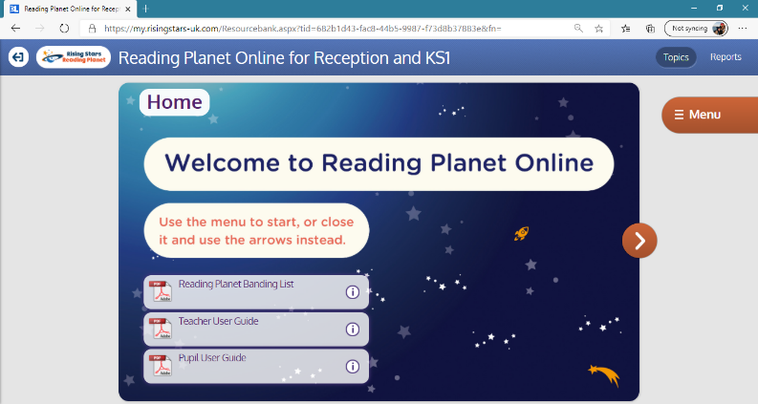
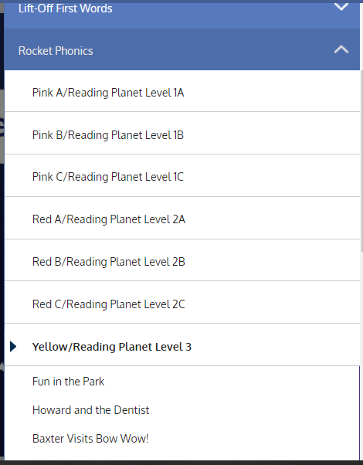
Once you have this ready, you can start Zoom.

Using Zoom
You will need to have the Zoom software or app downloaded on your device. The Zoom app does not have all the functionality of the desktop version and although it is possible to run a virtual reading session on Zoom from a tablet, we strongly recommend you use the PC version to take full advantage of Zoom’s functionality, as the screen sharing functionality in the app is less sophisticated. Please see specific information and instructions about screen sharing on an iPad at the end of this document.

Other things to note:
- Although Zoom works on Macs, Safari does not support screen sharing which you will need to do in order to share online books.
- Screen sharing on Microsoft Edge requires Windows 10 Pro or Enterprise. It is not supported on Windows 10 Home. If you are running Windows 10 Home and need to share your screen, it is recommended you use Chrome or Firefox.
- If you are using an iPad or iPhone, it must be running iOS 11 or higher.
After you have downloaded the Zoom software, sign in using your personal L2L2R account.

Finding your scheduled meeting
Click or tap on ‘Meetings’ at the top of the screen:
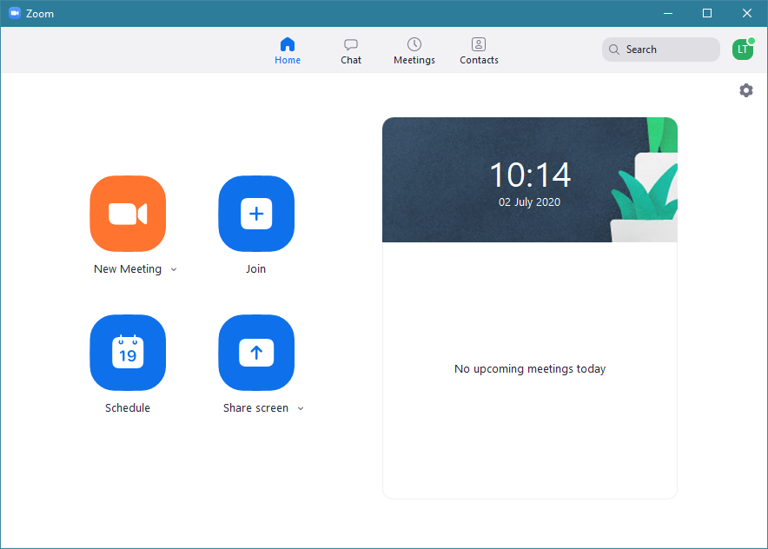

You will see your recurring meetings set up on the left-hand side:
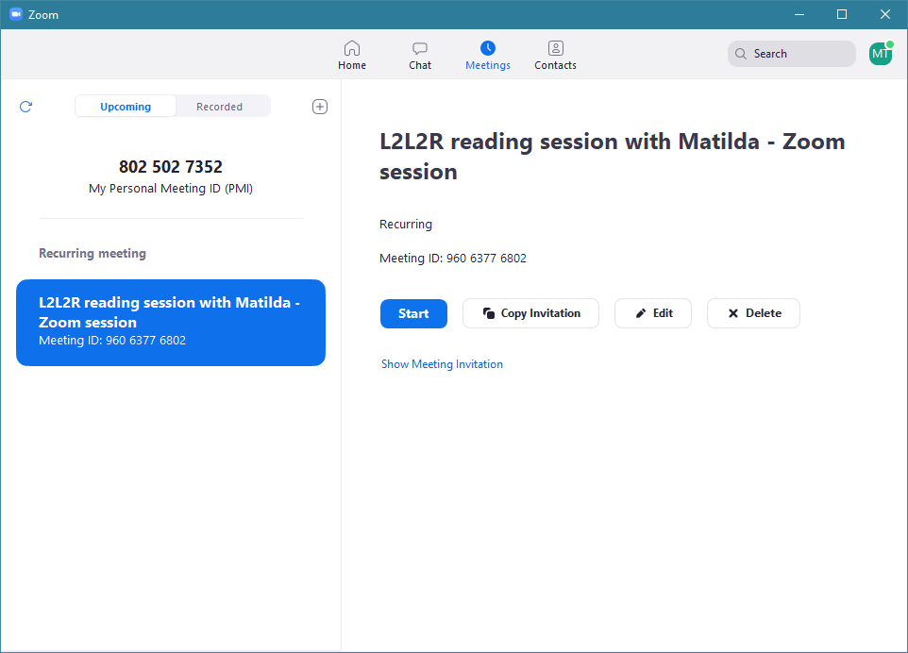

Click on the Start button to launch the meeting.
Once you have started the meeting, make sure the ‘Start Video’ option at the bottom left-hand corner of the screen is switched on and that your microphone is unmuted so the attendees will be able to see and hear you. If either the speaker or video icon appears with a red line through it, you cannot be seen or heard. Click or tap on the icon to unmute and/or start video.
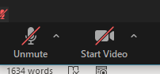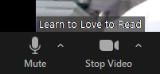

Admitting your participant
All meetings are set up with a waiting room which means that you, the host, have to let people into the meeting when they join. Please only admit the family you are expecting – this is to prevent strangers joining your meeting. Click on Participants on control bar to view who is in the meeting and to admit participants from the waiting room:
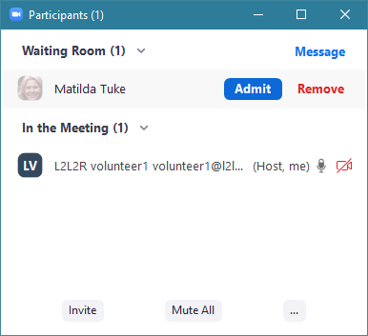

Views in Zoom
Once your participant has joined the Zoom meeting, click on the View button on the top right-hand side of the screen to choose how you want to see your screen.
Grid View gives you a side-by-side view of you and the child. Speaker View will show whoever is speaking in the biggest window. You may prefer the Grid View for your session.
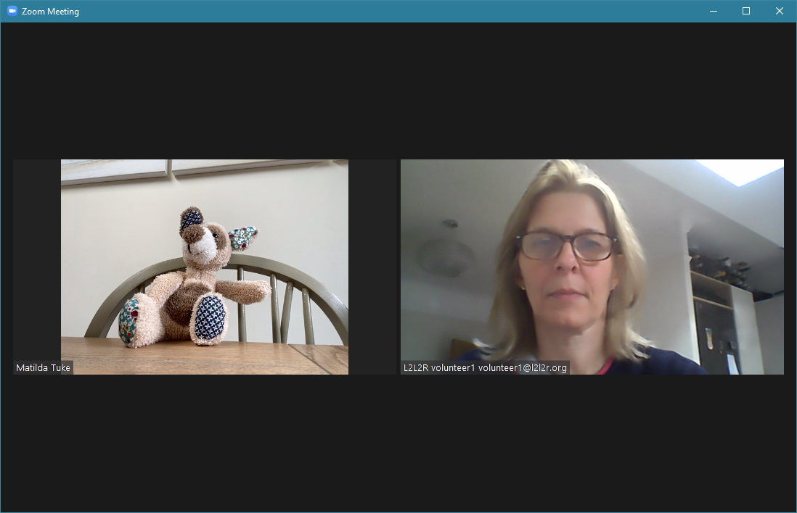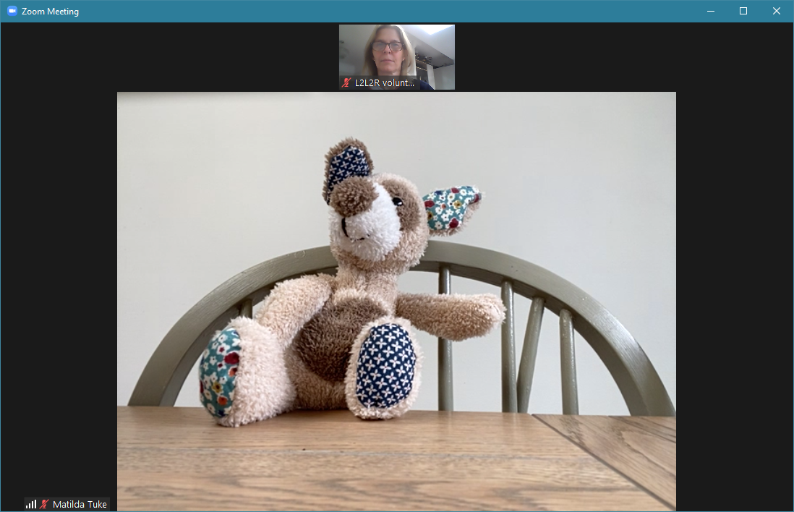
Grid view Speaker view

When you start sharing your screen (click on the green Share Screen icon on the control bar, then select your online book library which you opened beforehand), you should still be able to see you and the child in a floating window on top of your screen share. This can be dragged around the screen if you need to move it.
You may like to let the child choose a book title from the list. Remember that when you open the book, it will open in a new window and you will need to stop and restart resharing or click on ‘new share’ to share the new window so the child can see it.
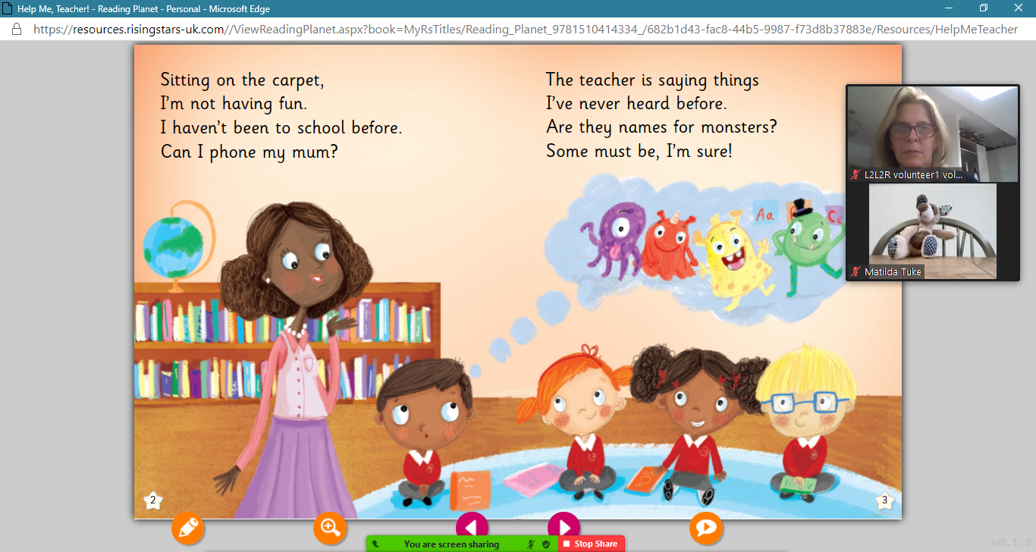
If the parent/carer tells you they cannot see all of the book on your shared screen, ask them to check their View Options which should appear at the top or the bottom of the screen. If they click on Zoom Ratio they can choose from a number of options, one of which should allow them to see the entire shared screen on their device at a size they can read:

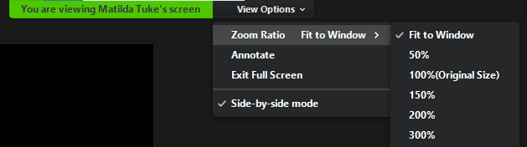

Annotating
Click on Annotate to see the annotation menu bar. You can use this to highlight, circle or underline words.
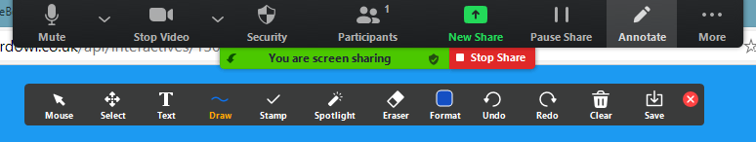

Quizzes
Throughout the books, and at the end, there are opportunities for the child to take an online quiz to help their comprehension. You will see the green cloud symbol on pages where there is a quiz. You can read the questions to the child and complete the answers given to you by the child. Once you have run a few sessions with your child, you might want to give control of the mouse to the child so they can fill in the answers themselves, though you may still need to help them read the questions.

Handing over control of the mouse
On the screen sharing menu, you will see a ‘Remote Control’ option. By clicking or tapping on it, you should be able to give control of the mouse or keyboard to the child. This means that they can use the mouse to complete the quiz. Don’t forget to cancel this once they have finished so you take back control completely. Clicking your mouse on the screen will also temporarily return control to you.
If you don’t see the ‘Remote Control’ option, it may be that the device they’re using doesn’t support this function, so you won’t be able to give them control of the mouse.
If the child is using a tablet to access the Zoom meeting, once you have given control, they will see a message on screen saying ‘Tap here to control xxxxxx’s screen remotely’. Once they tap on the icon underneath, they will see a mouse icon on the screen which they are able to move around with their finger and use as a pointing device. As soon as you move your mouse, the control reverts back to you. Cancel this from the ‘Remote Control’ menu option to stop the child from using the mouse completely.
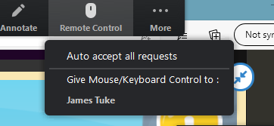

NB you cannot give screen control if you are using the Zoom app as this function is not available.

Screen sharing on an iPad or iPhone
Some set up on your iPad is required before you will be able to share your screen in a Zoom session. Please refer to Zoom’s instructions about how to screen share on an iPad as the app works very differently to sharing on a PC/laptop:
https://support.zoom.us/hc/en-us/articles/115005890803-iOS-Screen-Sharing
NB your Apple device must be running iOS 11 or higher.

Point to be aware of:
- Remember to log in to Rising Stars on your browser before you start your Zoom meeting.
- Once you are screen sharing, you will notice that your camera switches off, so the child will not be able to see you. You will also not be able to see the child. Once you stop sharing, your camera should automatically switch on again and you should be able to see both you and the child. The child will also be able to see you again once you have stopped screen sharing.
- Zoom annotation tools are not available when screen sharing on an iPad, but you can use Rising Stars’ own annotation tools.
- As you are sharing your entire iPad screen when you screen share on an iPad, you will not need to re-share your screen when you open individual books on Rising Stars (like you do on the PC/laptop version of Zoom).
- You cannot give control of the mouse/screen to the child while screen sharing on an iPad as this functionality is not available.

