Shaving cream rain clouds
You will need:
Glass of water (half full)
Shaving foam
Food colouring
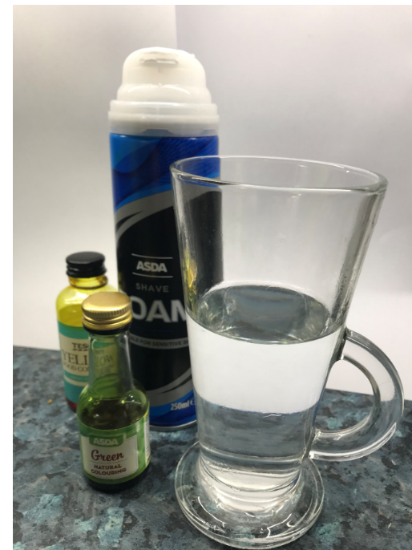
Squirt some shaving foam into your glass
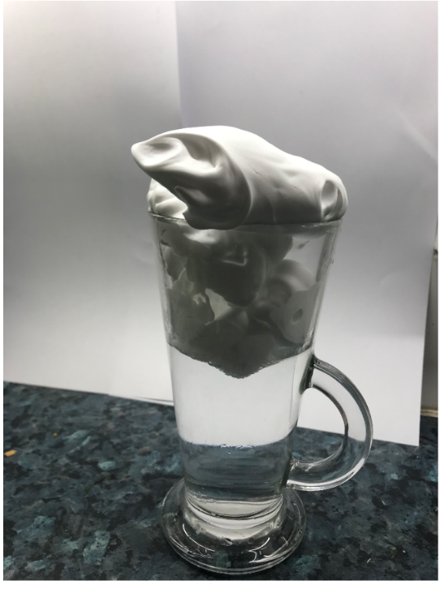

Add food colouring
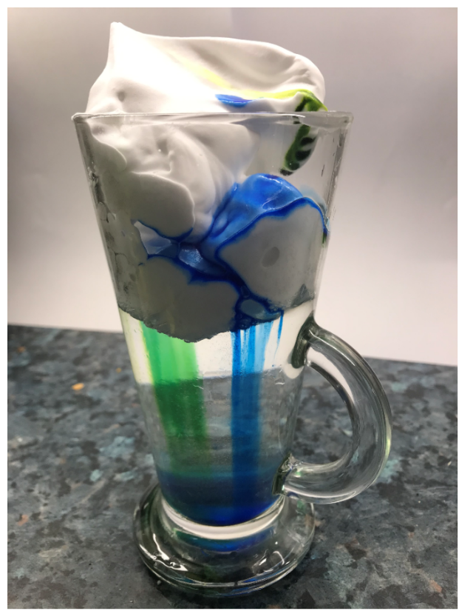
and see what happens next..
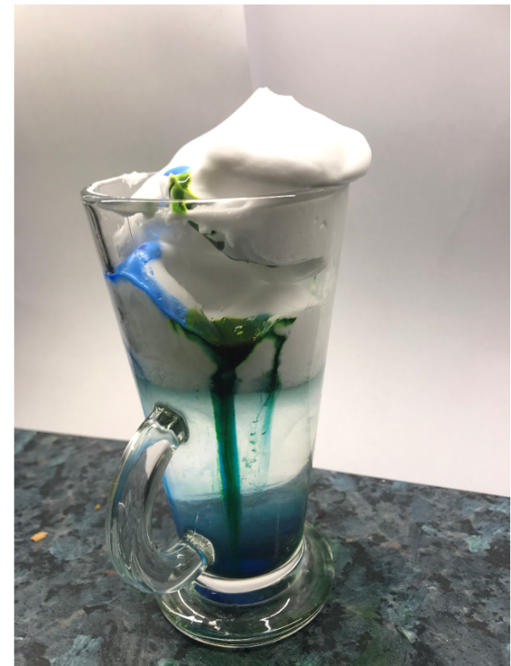
Have fun!

