Dinosaurs in Taste-Safe Mud
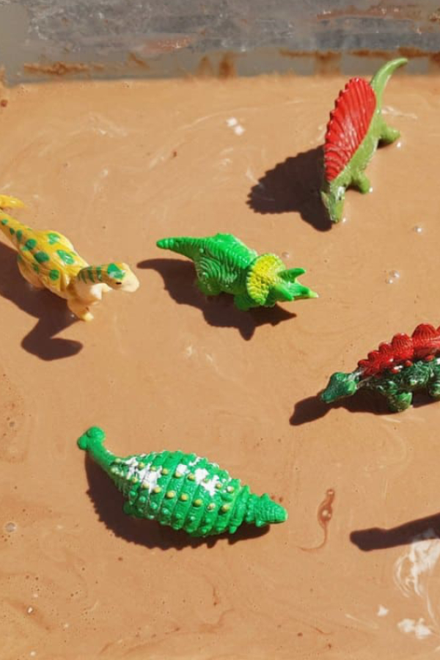
What you need:
- 2 cups of corn starch
- Water
- 1 cup of powdered hot chocolate mix or cocoa powder
- Assorted dinosaur toys
- Container
- Spoon
How you do it:
First, combine the corn flour and the cocoa powder in a bowl. You can choose how firm or how runny you want to make the messy mud by adding small amounts of water to the bowl. The general guideline calls for one cup of water to two cups of cornflour and one cup of cocoa powder, but there’s no rule. You can always firm it up a little bit with some more corn flour if the mixture becomes too runny. Finally, add some toy dinosaurs or farm animals and you’re set for muddy fun.

