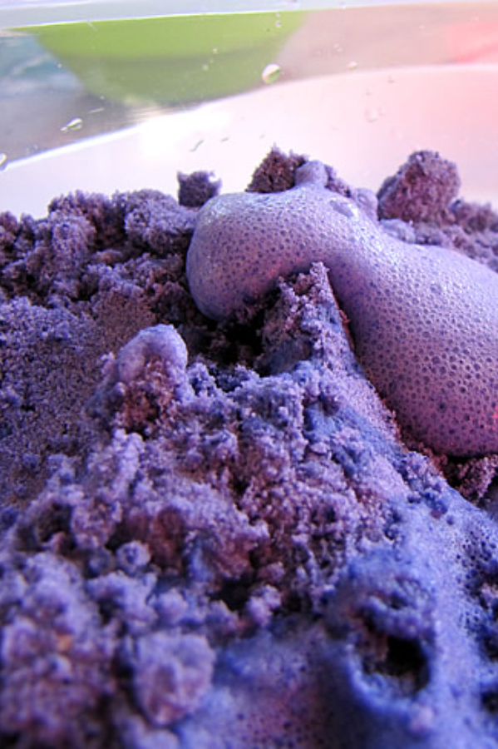
2. Fizzy Cloud Dough Experiment
What you need:
- 1 cup of flour
- 1 cup of baking soda
- 1/4 cup vegetable oil
- Oil-based or powder food colouring
- Vinegar
- A mixing bowl
- A tub for playing in
How you do it:
The method starts by creating sensory play dough (which is also safe for little ones who still put everything into their mouths). Push the play dough into the tub, and let your children explore with moulding and shaping it.
Then, add a bit of vinegar to the dough to bring the fizz out. The little ones will have a wonderful time grabbing the fizzing foam while the older children will have a kick out of adding the baking soda and watching the bubbles form.

