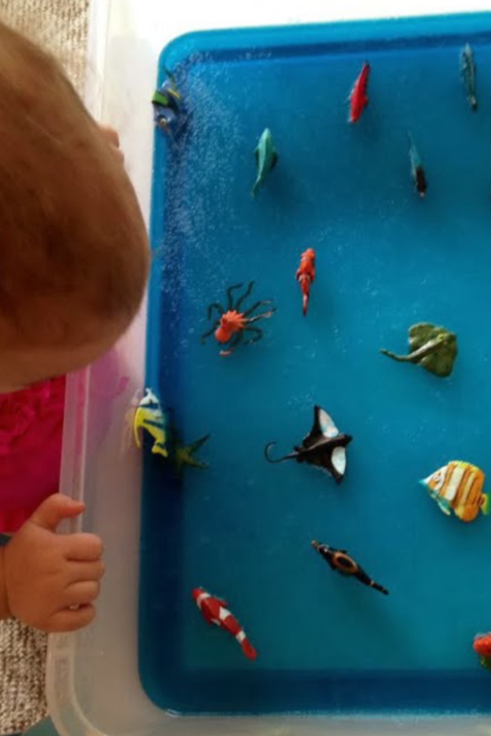
4. Under the Sea Sensory Jelly Adventure
What you need:
- Jelly mix (blue is best)
- Aquatic animal figurines
- A large container
How you do it:
Follow the instructions to make the jelly, but instead of using a glass dish, have the jelly set in the plastic container. After you pour the liquid into the container to set, add all the animals and the underwater creatures.
Once it’s set, let the messy play begin! If the children are very young, you’ll likely experience jelly splatters everywhere. Is this a good indication of how much fun is being had? Absolutely.

