Messy Crafts 5
Fizzy Dough
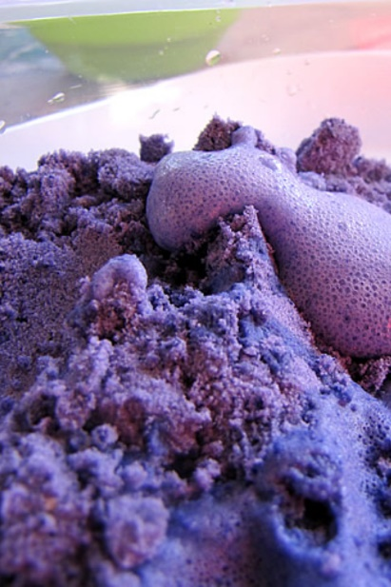
- 1 cup of flour
- 1 cup of baking soda
- 1/4 cup vegetable oil
- Oil-based or powder food colouring
- Vinegar
- A mixing bowl
- A tub for playing in
- Mix all ingredients into bowl except for the vinegar and mix until right consistency.
- Let child play in the tub!
- Then add vinegar to make it fizz!

Balloon Painting
- Balloons
- Child-friendly paint
- Cardboard or large sheets of paper (easel pads, for example)
- Large safety pins
- A funnel
- Start by filling the balloons with paint. You can use a funnel for a cleaner result or enjoy the sensory fun alongside the children and fill the balloons without a funnel.
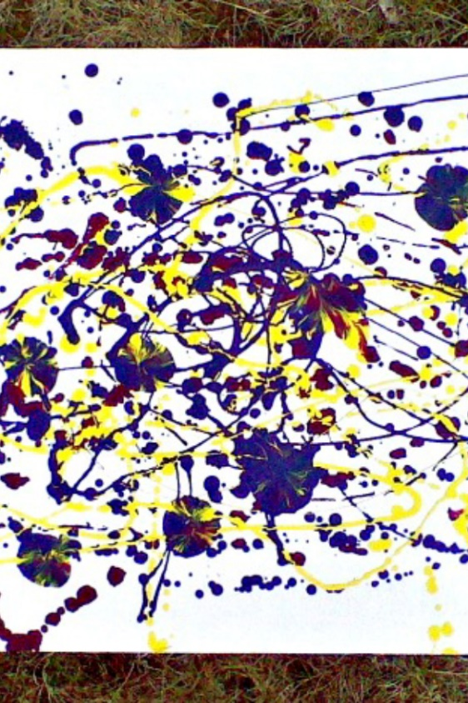
- Close the balloons’ opening at the top with a simple knot and use a safety pin to poke holes in the bottom of the balloon.

- Time to paint!

