Messy Crafts 4
Colourful Spaghetti Worms
- Cooked spaghetti
- Food colouring (different colours)
- Some bowls

- Cook spaghetti and put in separate bowls.
- Add food colouring!
- Mix all the spaghetti together and have fun.
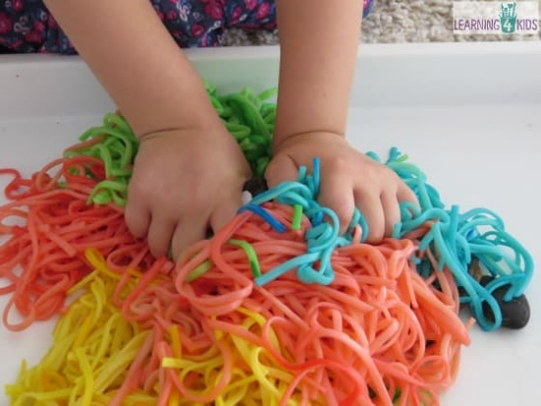

Baking Soda and Vinegar
- Baking soda
- Vinegar
- Spray bottle
- Glitter

- Cover tray with baking soda and glitter!
- Spray with vinegar that is in the spray bottle and watch it bubble.

