Messy Crafts 3
Magic Snow
- Baking Snow
- Unscented Baby Shampoo
- Water
- Liquid water colours/Food colouring
- Citric Acid powder
- Optional plastic snowflakes

- In a large cake pan (or other container), measure out 3 cups of baking soda and use your hands (or your child's hands) to break up any clumps. Measure out 1/4 cup shampoo and add 1-2 drops of food colouring OR 1/8 cup blue liquid watercolours and stir them until combined.

- Add the coloured shampoo to the baking soda and using a spoon or your hands (or your child's hands) mix until completely combined.

- Finally add 5 Tablespoons of water and mix until completely combined. The dough should be crumbly but hold together if compacted.

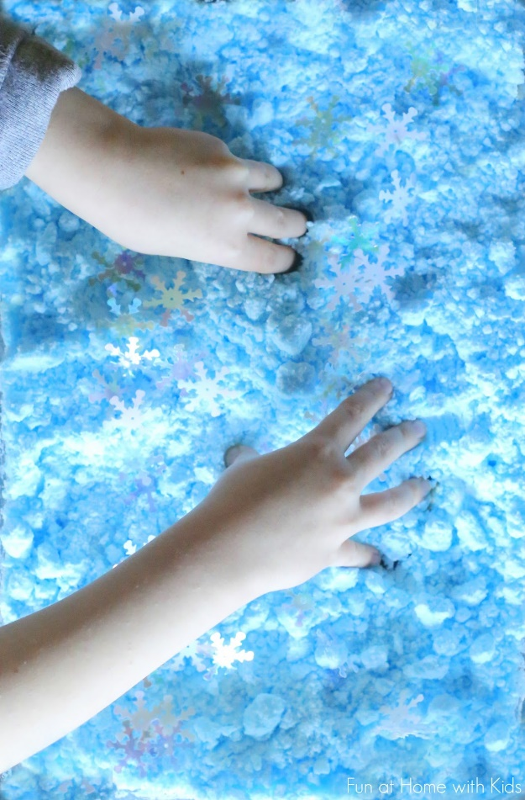
- In this state, you can play with it for quite a while building and sculpting. Once you're ready for it to start puffing, sprinkle 1/4 cup citric acid evenly over the top of the dough and mix it until well combined. It will start puffing up within about a minute and continue for around 1 hour.

