Messy Crafts 2
Edible Slime
- Basil Seeds
- Cornflour
- Food Colouring

- ¼ cup of basil seeds with 16 ounces of cornflour, with food colouring and 2.5 cups of water in a bowl.
- Knead it until you get the right consistency.
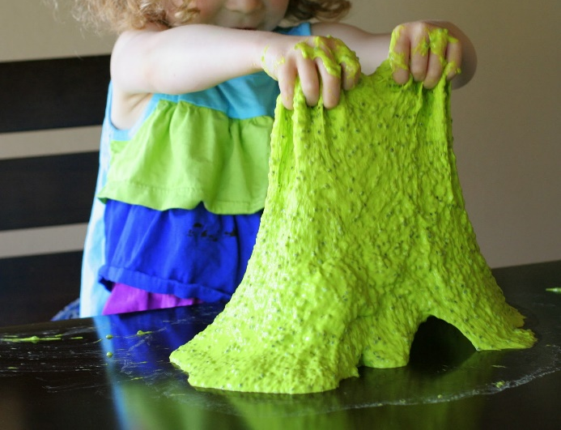

Glowing Water
- this vitamin , or a similar product if this is not available.
- Ziplock bag
- Hammer/rolling pin.

- Put 2 vitamins in the Ziplock bag and crush into a fine powder.
- Put in warm water and add to a bath.
- Have fun (Don’t worry it is perfectly safe to go in eyes or be swallowed).
