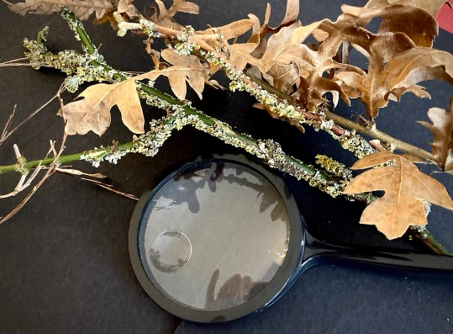**Go for a nature walk and collect different leaves, twigs, stones, and cones. Make nature pictures with your collection when you get home. Why not use a magnifying glass to look more closely at your things.**