Nature Walk Scavenger Hunt

Try collect these things when on your walk:
- Leaves
- Small rock
- A Stick
- A pretty flower

Leaf Prints
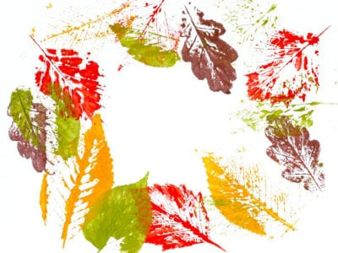
- Paper
- Paint
- Leaves

- Using your leaves, you collected earlier on your walk, and using some paint you can create some lovely leaf prints on a piece of paper.

Rock Painting
- Using some paints, you can do some lovely rock art that you can
keep in your room!

- Some ideas are to paint some characters like the minions or SpongeBob or make a rock themed clock using some twigs as hands.
