Nature Crafts
Button turtle:
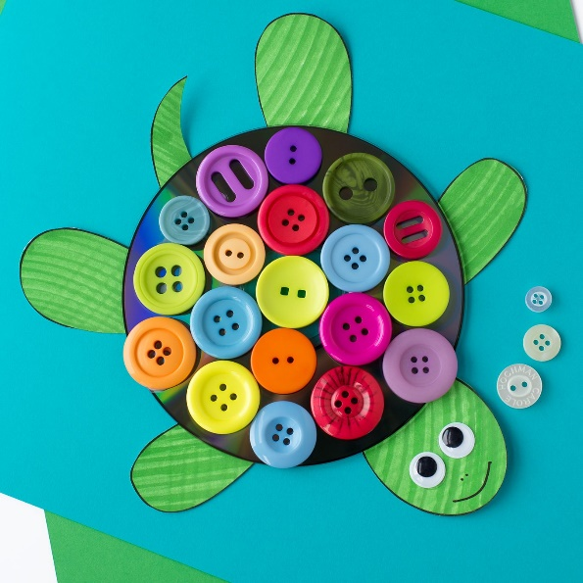
- Buttons
- Cardboard
- Scissors
- Glue
- Paints/markers

- Cut cardboard into turtle shape.
- Decorate with colors.
- Glue buttons onto where the shell would be.
- Have fun!

Bug House:
- Shoe box
- Toilet roll Inners (3)
- Hay
- Sticks
- Grass
- Small bits of food
- Scissors
- dirt

- Put the inners upright in shoebox after cutting arch in the inner
- Fill the different inners with grass, hay, and sticks.
- Scatter some food in the box and fill with grass and some dirt.
- Place outside and see if you get any visitors.

