Nature Crafts
Handprint tree
- Paint brushes
- Paper
- Paint

- Paint the trunk of your tree and a few branches coming off it.
- Then dip your hands in some green paint and go crazy by using your handprints as leaves.

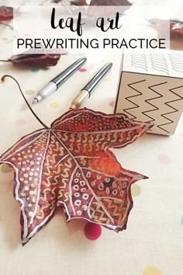
Paint your own leaf!
- Paper
- Scissors
- Paints

- Cut out a leaf shape from paper.
- Then using your paints, you can decorate your leaf in any way you want.

Leaf Monsters
- Leaves
- Paints
- Glue
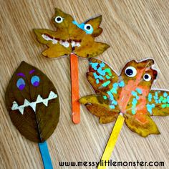
- Googly eyes!
- Popsicle stick

- Decorate the leaf with googly eyes and paint to make them look like monsters.
- Add the popsicle stick to the bottom with glue.
- Have fun!

