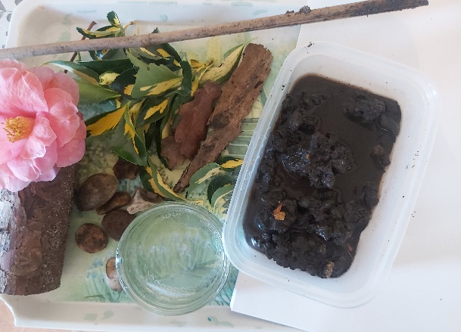
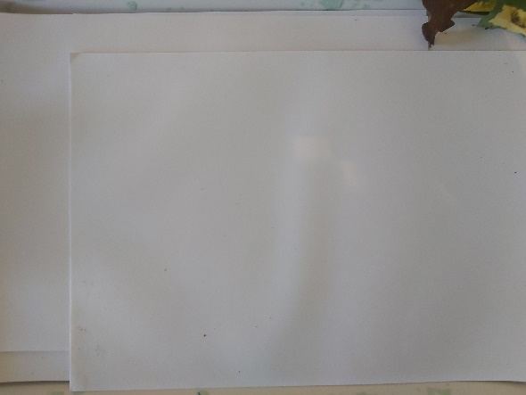
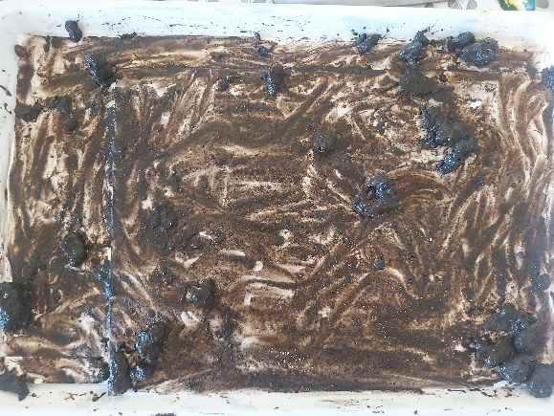
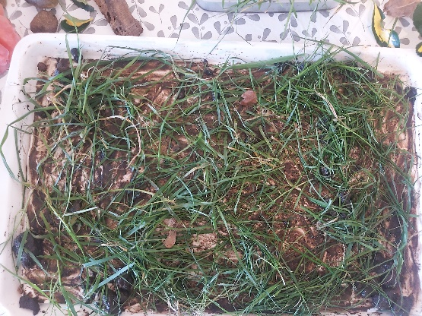
Pop outside and collect any objects that you would like to create you miniature garden!!!
First lay down some paper onto your chosen surface, I choose to lay some paper on a tray.
Take your chosen ground and lay it down , this was messy when using mud!!

In the picture is what I collected and some ideas for you;
Tray
Mud or sand
Pot
Sticks
Leaves
Stones

Create any garden that you would like using any objects or follow these steps and pictures 😊
At this step you can lay down some grass, anything that you have collected and would like to use…
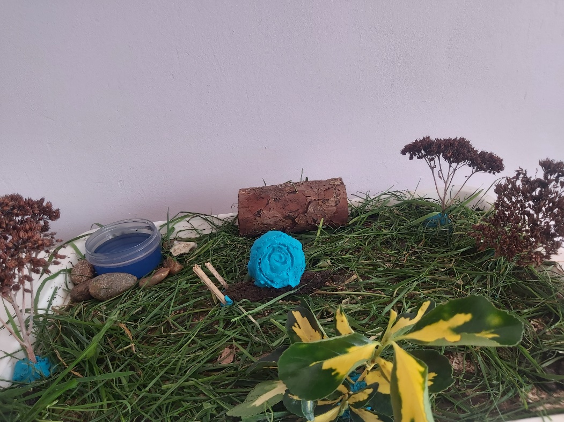
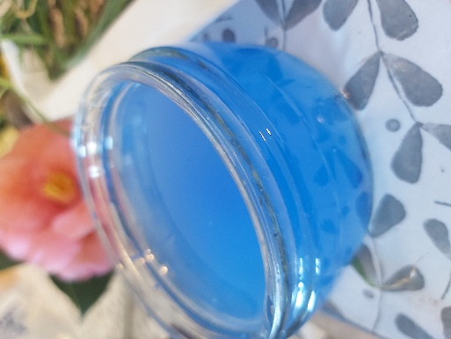
To make a pond, use nay pot of your choice and add some water.
To make it blue ad paint and mix.
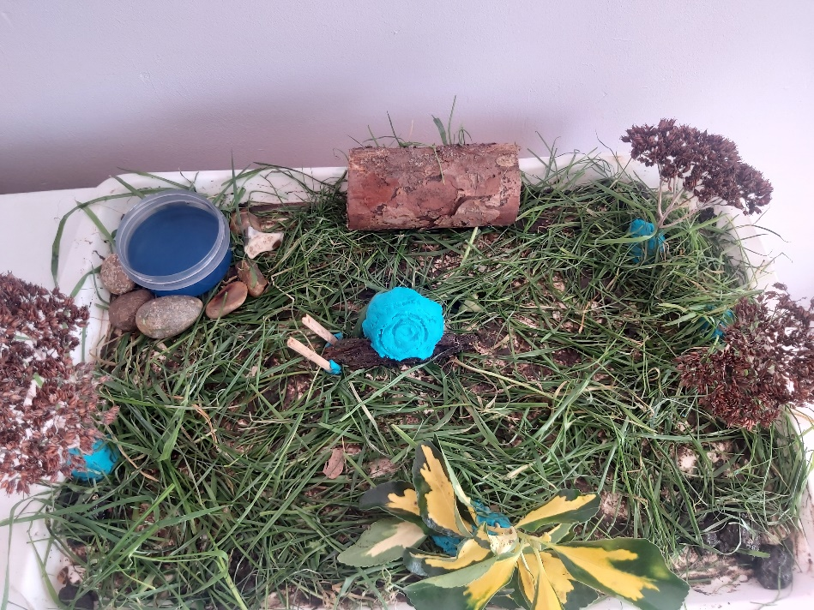
Make bushes out of leaves
Using playdough create a snails shell
Using bark and sticks I made the snails body and head
Some wood/branch for a bench
Some plants for mini trees

Stones to outline you pond

