Nature Crafts

Twig Raft

- Lots of twigs
- String
- Paper or leaf

- Line up your twigs next to each other like this.

- Then using your string loop, it around like this a few times before tying it off

- The mast will be harder to keep in place and will probably fall off but try jam it in gaps between twigs, tie it with some left-over string or use some water-resistant glue if you have any.
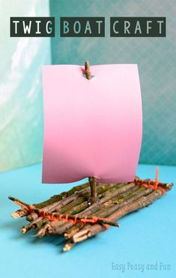
- Then poke 2 holes in the paper or leaf and slide it onto mast.

- Set sail.

Leaf Bracelet or Necklace
- Many leaves
- String

- Poke holes in the centre of the leaves.
- Then using the string, feed the leaves onto the string and tie it up so it fits loosely on your neck or hand.
