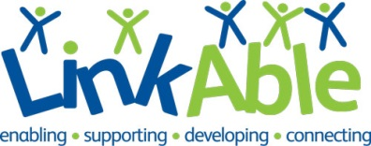
London Marathon 2020 Charity Place Application Form
If you would like apply to run for LinkAble in the 2020 London Marathon, please complete the application form:
First name: |  |  |  |  |  |  |  |  |  | Last name:
D.O.B.: |  |  |  |  |  |  |  |  |  | Gender:
Email:
Address:
Mobile no.:
What is your profession?
Does your employer run a matched funding scheme? |  |  |  |  |  |  |  |  |  |  |  | Y/N/n/a
Running vest size (complimentary):
How did you learn about LinkAble’s marathon place?
Why would you like to run for LinkAble?
Do you have a personal link with LinkAble? |  |  |  |  |  |  |  |  |  | Y/N
If yes, please detail:
Did you enter the race organiser’s ballot? |  |  |  |  |  |  |  |  |  | Y/N
What is your fundraising plan?
In no more than 250 words please tell us why you would be the best person to represent LinkAble at the 2020 VLM

If you are the successful applicant, we will include a free place in the Surrey Half Marathon as part of your training plan. If your application is unsuccessful, and you would be interested in joining Team LinkAble at the Surrey Half Marathon, we are offering free spaces with a minimum fundraising target of £200. Please tick if you would be interested in more information.

Completed application forms should be returned to rhys.parker@linkable.org.uk no later than 12pm Friday 20th December 2019. However, we strongly advise candidates to apply earlier as we reserve the right to close the application process earlier.
If your application is unsuccessful, would you be interested in joining team LinkAble at the Surrey Half Marathon. We are offering free spaces for anyone willing to raise a minimum of £200.
Contacting you. Thank you for providing your contact details to receive information about running for LinkAble in the 2020 Virgin Money London Marathon. We will be in touch in a few weeks to let you know the outcome of your application. If you would like to know more about LinkAble and our other activities via email, please tick the box [ ]. If you wish to stop hearing from us at any time in the future, please email info@linkable.org.uk.
Registered charity: 1119596



