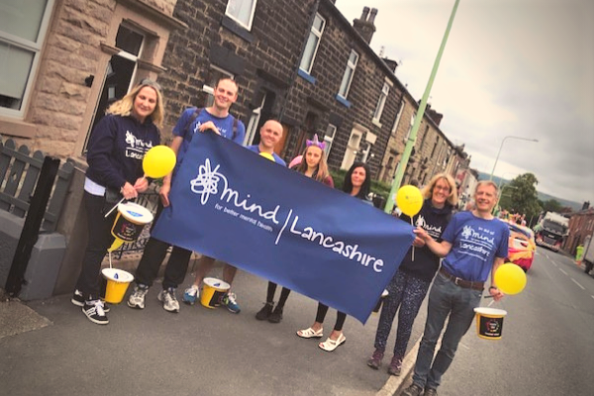
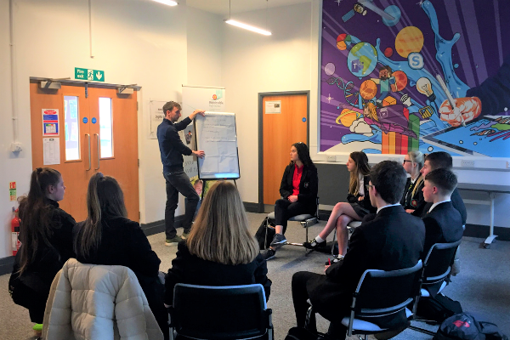
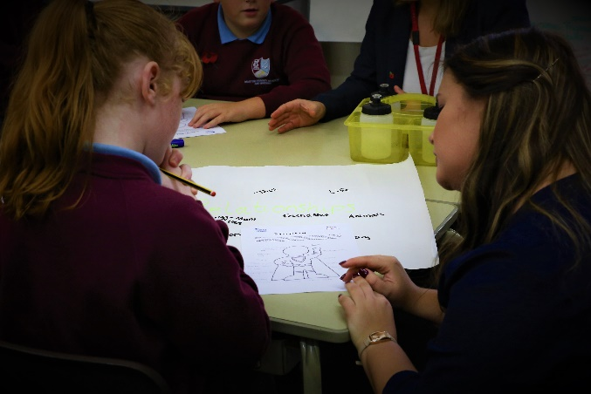
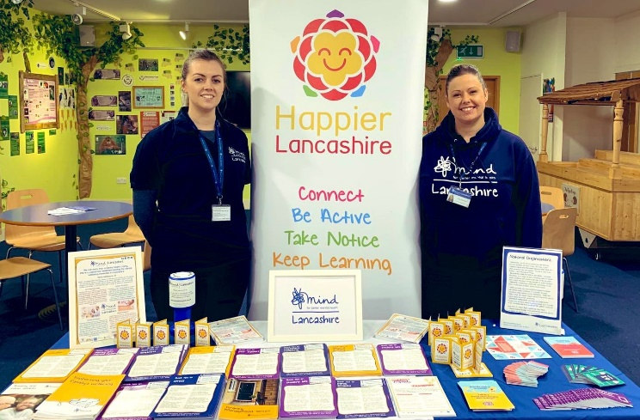
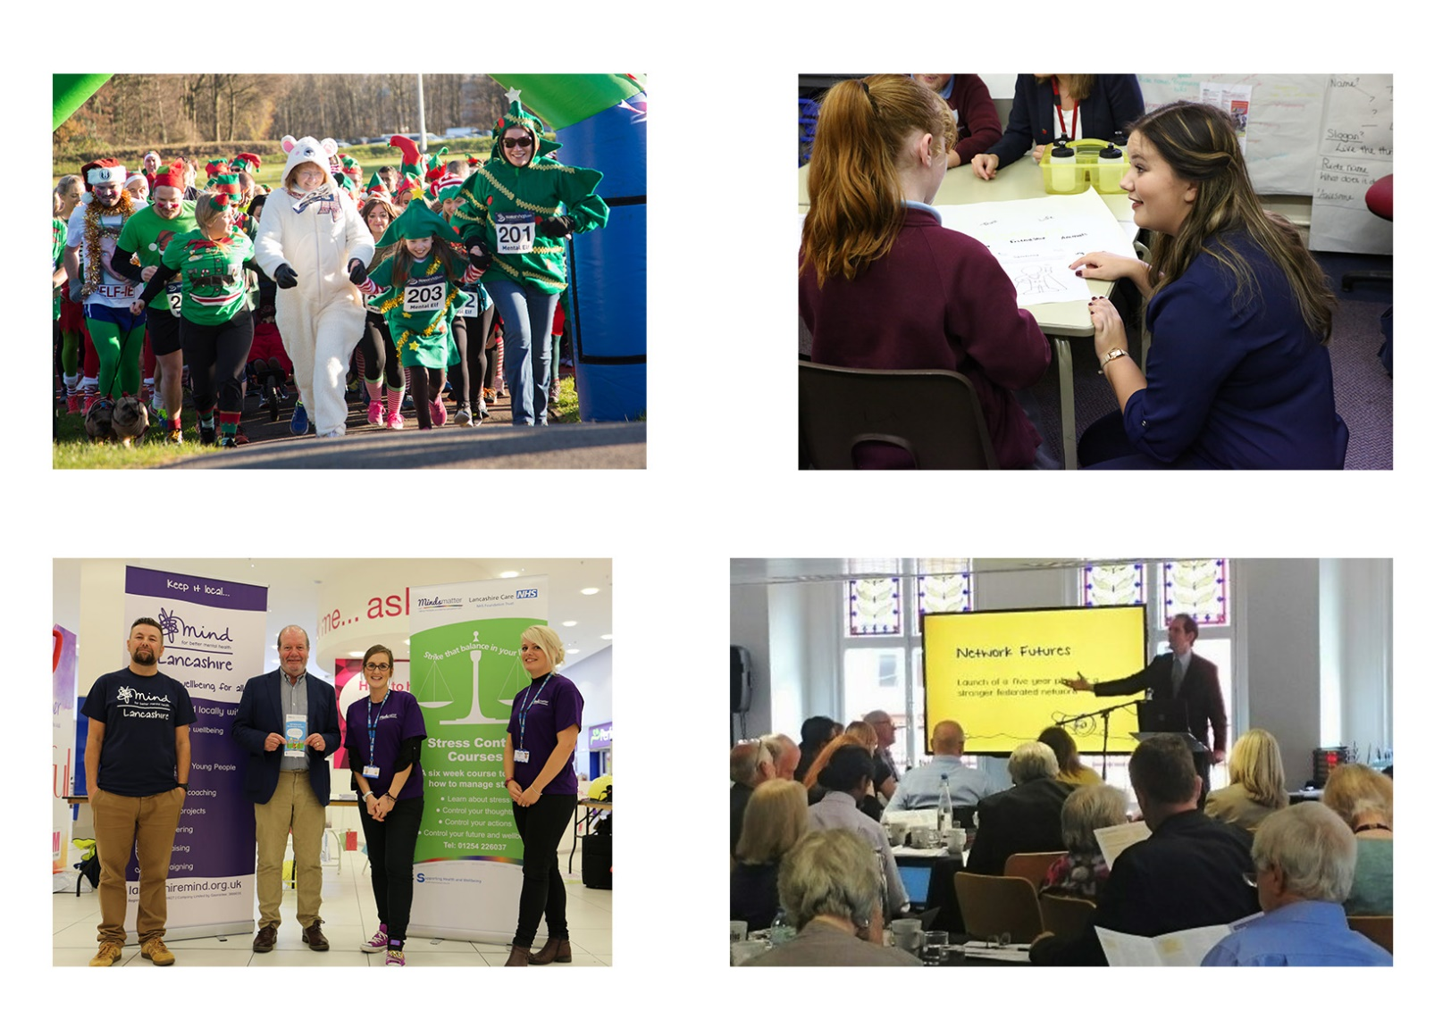
Recruitment Pack
Children and Young People
Project Coordinator
October 2020
Thank you for your interest in working with Lancashire Mind
Who are we?
Our vision is Mental Wellbeing for All. Our work enables people in Lancashire to value and take care of their mental health. Our dedicated team challenge misconceptions about mental health, develop resilience in people from an early age and work with communities to build a happier Lancashire.
We are more than a mental health charity.
We’re a passionate movement leading the wellbeing revolution in Lancashire.

We work in partnership with others to provide support, raise awareness and campaign locally to make mental wellbeing a priority. We believe that prevention is the solution, that everyone can achieve mental wellbeing and that resilience is the key to sustaining it.
With 50% of mental health conditions developing before the age of 14, building resilience from an early age is central to the work we do.
At any one time, 1 in 4 people in Lancashire are living with a mental health condition. The vast majority play an active role in society with a significant proportion in active employment. However, we continue to work to ensure everyone experiencing a mental health condition is treated as an equal by society.
We raise awareness of mental health and wellbeing and the ways in which we can all take steps to improve our wellbeing through our Community Development Services. We work with people to manage and improve their mental health through our Tenancy Management and Wellbeing Coaching services, adopting a joined-up approach with other services.
We work with businesses across Lancashire to provide effective workforce training to improve resilience and mental wellbeing and to reduce the impact of stress and mental health conditions in the workplace.
Everyone who works for Lancashire Mind is fuelled by a passionate belief that achieving mental wellbeing will reduce the occurrences of mental health conditions. Using this passion, we are creating a happier Lancashire by sharing simple steps to improve wellbeing.
Together we can make Lancashire the beacon county for mental wellbeing and ensure everyone experiencing a mental health condition is treated as an equal member of society.
Children and Young People Programmes
Our work with children and young people (CYP) takes place in a variety of settings. We offer a range of programmes suitable for children from school age upwards. These programmes empower children to understand their mental health and take steps to look after and boost their wellbeing.
During the covid-19 lockdown, we adapted our CYP offer for online delivery to enable us to continue providing activities when face-to-face provision is not possible. We are currently doing a mix of virtual and face-to-face delivery.
Wellbeing Challenge is an evidence-based programme that strengthens school communities by providing children and young people with the structure and support to design and implement projects to tackle wellbeing issues that matter to them.
We work with students to empower them with skills to self-care, support the wellbeing of their peers, create resilient schools and reduce the number of children that go on to develop mental health conditions.
Whole School Approach, in partnership with national Mind, delivers a range of interventions within high schools to improve wellbeing across the whole school population, including pupils, staff and parents.
We currently work with eight schools who each have a dedicated action plan designed in collaboration with pupils, staff and parents and based on wellbeing needs identified through surveys and peer feedback.
Bounce Forward is an evidence-based resilience programme delivered in the classroom, offered as a five- or ten-week programme. It was initially developed for children in Year 5 but has since been adapted for EYS, KS1, KS2 and KS3 and we aim to expand the programme across Lancashire.
We have delivered Bounce Forward for all primary schools in Blackpool and are now working with schools in several areas of Lancashire.
Resilient Transition Programme – we have been awarded funding from the Children in Need Next Steps fund to offer a bespoke programme for schools in east Lancashire. The programme combines Bounce Forward and Wellbeing Challenge and will focus on developing resilience, confidence, and skills to support transition into high school.
Happier Lancashire is our universal, one-off workshop that raises awareness of and encourages children to follow the Five Ways to Wellbeing. Happier Lancashire is delivered in all settings, but primarily within primary and high schools.
As well as the above programmes, we offer a wellbeing coach service that targets CYP who are facing barriers to achieving mental wellbeing. A Coach works with individuals over a six-week period to equip them with self-care tools and coping strategies.
We also deliver a range of training, including mental health awareness for parents, carers and professionals who work with CYP.
The role
During the national lockdown, we had to put a lot of our programmes on hold. Now that schools are back in and we can be more flexible with our provision, we want to continue to support our existing cohorts of young people, whilst expanding our reach to others.
Over the next six months we have projects that we need to get back on track and new projects to start so we’re looking to increase the capacity of our team by employing two CYP Project Coordinators.
The Project Coordinators will work alongside our dedicated staff to plan, coordinate, deliver and evaluate our programmes. We need people who are comfortable and confident with both virtual, online delivery and face-to-face delivery. You should have some experience of working with children and/or young people and an understanding of the barriers they face to achieving mental wellbeing.
Ideally, you will have had some experience of working with schools although this is not essential, but it is important that you have a good understanding of safeguarding children and professional boundaries. Some experience of project planning, coordination and delivery is required.
We are looking for people who can work collaboratively and flexibly to cover the full range of programmes delivered by our CYP and Community Development Teams.
These posts are initially temporary to provide the additional capacity we require up to the end of the current school year (end of July 2021) but there is the potential for extension, dependent on future funding.

What people enjoy about working with Lancashire Mind

- Challenging, varied, flexible and innovative work
- Shared passion for mental health and wellbeing
- Rewarding work - making a difference, seeing progression, a sense of achievement
- Feeling valued, listened to and supported by colleagues
- Working with people, the community, a wide range of organisations
- Responsibility, trust, openness and autonomy
- Opportunities to learn
- Meeting new people and being part of a passionate team
- Feeling part of something revolutionary
- Opportunity to work flexibly and achieve a good work/life balance
Organisational perks

- A 35-hour working week (full-time hours), with flexible start and finish times
- The annual holiday entitlement for full-time staff is 25 days, plus 8 bank holidays, with the potential for the days between Christmas and New Year to be gifted to staff based on organisation performance (pro rata for part-time staff)
- Lancashire Mind offer the opportunity for staff to save for their retirement by providing a workplace pension scheme
- Staff are eligible for a company sick pay scheme after completion of a six-month probation
- Emergency time off - we appreciate that there can be difficult times for you and your family; the organisation offers up to five days paid leave (pro rata for part-time staff)
- All members of staff receive regular supervision, giving you protected time to reflect on and plan the work you do
- Lancashire Mind is committed to providing learning and development opportunities
- Workplace wellbeing scheme - provided by staff champions who provide wellbeing chats, organise wellbeing activities and plan social events to support people to maintain and improve their wellbeing
- We strive to be a green organisation and take practical steps to reduce our ecological footprint
- We reimburse the cost of standard eye tests and annual flu jabs
Job description
Job title: CYP Project Coordinator
Hours: part-time, 28 hours per week
Contract: temporary until 31 July 2021 with possibility of extension dependent on funding
Salary: NJC points 14 (£22,462) to 19 (£24,799) (pay award pending)
Responsible to: CYP Project Lead or Community Development Lead
Location: working from home initially due to covid-19 restrictions but usually based in Chorley, with extensive travel across Lancashire

Overview
In collaboration with colleagues and stakeholders, the CYP Project Coordinator will engage and support children and young people (CYP) in Lancashire through delivery of our CYP programmes, across a range of projects. The Coordinator will work with CYP, school staff, parents, stakeholders and the wider community to build relationships and deliver tailored wellbeing activities to CYP through online virtual delivery, as well as face-to-face delivery in schools and community settings.
Main duties and responsibilities
- Coordinate wellbeing projects to meet the needs of CYP, in conjunction with Lancashire Mind colleagues, school staff, CYP and parents
- Plan and deliver Lancashire Mind’s CYP wellbeing programmes for a range of age groups
- Build and maintain relationships with stakeholders, particularly schools
- Co-produce activities with schools, parents and CYP
- Understand and implement key policies and procedures, such as safeguarding and GDPR compliance
- Work with the CYP and Community Development Leads and other Project Coordinators to test, learn from and adapt activities to be delivered in a range of settings and identify opportunities for development
- Capture and analyse quantitative and qualitative data, including feedback from CYP, to feed into monitoring reports and programme evaluation
- Support the CYP and Community Development Leads to monitor quality of delivery and impact of project activities
- Maintain accurate records and input data into spreadsheets and Lancashire Mind’s database
- Attend internal and external meetings, events and training, as and when necessary
- Undertake flexible working hours, including some weekend and evening work and travel across Lancashire
- Abide by Lancashire Mind’s policies and procedures
- Undertake other tasks and duties as deemed appropriate by a Lead or member of the Senior Management Team

Please note: this post is subject to an enhanced Disclosure and Barring Service (DBS) check

Person specification

We only consider inviting to interview people who show that they possess the following qualifications, skills, experiences and personal attributes. When you fill in your application form, use examples from your professional and personal life to illustrate how you fulfil all the criteria required at application stage.

 | Criteria | Assessed at application (A) or interview (I)
Qualifications | - Qualified to degree level in a related area of study or the equivalent, relevant experience | A
Knowledge and experience | - Experience of delivering projects with children and/or young people | A and I
 | - Experience of engaging and working with a diverse range of stakeholders, including coproduction of activities | I
 | - Experience of project planning, coordination, and delivery of project activities | A
 | - Knowledge and understanding of mental health and the barriers that young people face to achieving mental wellbeing | A and I
 | - Knowledge of schools and an understanding of how they operate | A
 | - Knowledge and understanding of safeguarding, professional boundaries, confidentiality and data protection; particularly in relation to children | I
Skills, abilities and competencies | - Ability to communicate effectively with a wide range of people and through a variety of methods | I
 | - Ability to motivate and inspire others, including colleagues and people who use Lancashire Mind services | I
 | - Ability to handle multiple tasks in a fast-paced environment, set priorities and remain calm under pressure | A
 | - Ability to work both independently and in collaboration with others | A
 | - Excellent numeracy, literacy and report writing skills with the ability to maintain accurate records | A
 | - Excellent office IT skills (Microsoft Office 365, including Excel) and the ability to learn new software packages, including video conferencing platforms | Test at interview
Personal attributes | - Resilient and committed to promoting mental wellbeing for all | A
 | - A demonstrable personal commitment to equal opportunities | I
 | - Positive, enthusiastic and friendly attitude | I

To apply
If you would like to discuss the job before applying, contact Sarah Jeffrey, Head of Services – sarahjeffrey@lancashiremind.org.uk
Applications must be submitted using a Lancashire Mind job application form, which can be downloaded from our website www.lancashiremind.org.uk/recruitment or requested by emailing admin@lancashiremind.org.uk
The deadline for applications is 9am on 16 November 2020
Email your completed application form to admin@lancashiremind.org.uk
Please do not convert your form to a PDF, otherwise it won’t be possible for us to remove the identifying information before sending your application to the recruitment panel.
Late applications will not be accepted. Those who do not adequately demonstrate how they fulfil the criteria required at application stage, will not be considered for shortlisting.

Interviews for this post are scheduled to take place on 23 and 24 November 2020. Please reserve this date in your diary because alternative dates cannot be offered. Due to the continuing need to safeguard staff and members of the public, interviews will be done remotely, using Microsoft Teams or Zoom.
If you have not heard from us by two weeks after the deadline, please assume that you have not been shortlisted on this occasion. The organisation regrets that it cannot provide feedback to unsuccessful applicants at the shortlisting stage.
Lancashire Mind
80-82 Devonshire Road
Chorley
Lancashire
PR7 2DR

01257 231660
admin@lancashiremind.org.uk
www.lancashiremind.org.uk

Registered Charity Number 1081427
Registered Company Number 3888655

If you have any questions about the application process or require support with the process, please contact our Operations Team on 01257 231660.

