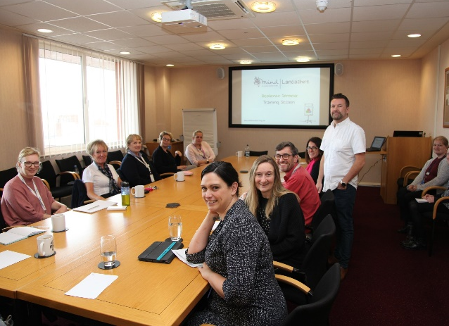
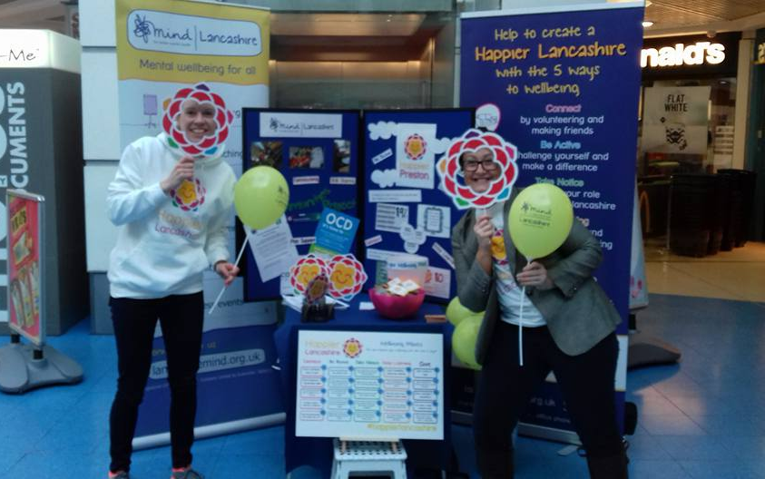
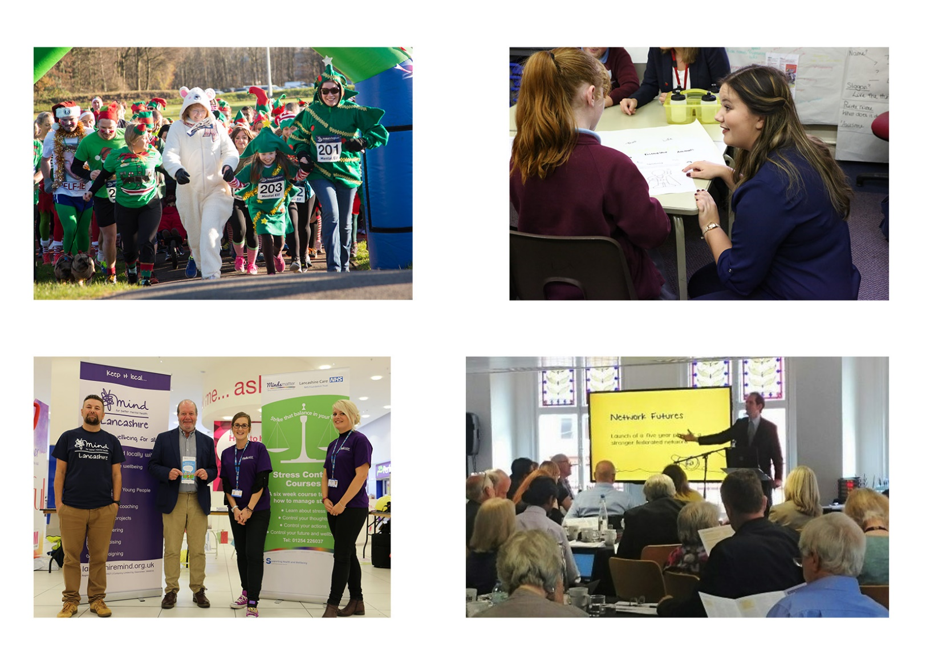
Recruitment Pack
Transformational Coach
September 2020
Thank you for your interest in working with Lancashire Mind
Who are we?
We are more than a mental health charity.
We’re a passionate movement leading the wellbeing revolution in Lancashire.

Our vision is mental wellbeing for all. Our work enables people in Lancashire to value and take care of their mental health. Our dedicated team challenge misconceptions about mental health, develop resilience in people from an early age and work with communities to build a happier Lancashire.
We work in partnership with others to provide support, raise awareness and campaign locally to make mental wellbeing a priority. We believe that prevention is the solution, that everyone can achieve mental wellbeing and that resilience is the key to sustaining it.
With 50% of mental health conditions developing before the age of 14, building resilience from an early age is central to the work we do. We have developed a range of resilience programme for children and young people of various ages.
Approximately 1 in 4 people in Lancashire are currently living with a mental health condition. The vast majority play an active role in society with a significant proportion in active employment. However, we know that too many still face barriers to good health, employment and wider well-being and we remain committed to ensuring that everyone experiencing a mental health condition is treated as an equal by society and can access the right support at the right time when they need it. We will not rest until we achieve mental wellbeing for all.
We invest in and work with others to innovate; developing and testing new ways of promoting mental well-being and better managing mental health conditions.
We work with people to manage and improve their mental wellbeing through our Tenancy Management and Wellbeing Coaching services, adopting a joined-up approach with other services.
We work with businesses across Lancashire to provide effective workforce training to improve resilience and mental wellbeing and to reduce the impact of stress and mental health conditions in the workplace.
Everyone who works for Lancashire Mind is fuelled by a passionate belief that achieving mental wellbeing will reduce the occurrence of mental health conditions and help those with conditions to manage them better and stay well for longer. We believe that, working together with others, we can make Lancashire the beacon county for mental wellbeing and ensure everyone experiencing a mental health condition is treated as an equal member of society.
The service
Wellbeing coaches work across Lancashire with children, young people and adults at risk of developing a mental health condition to enable them to develop coping strategies and take action to improve their wellbeing.
Wellbeing coaches across the county are working with different target populations informed by the varied needs and challenges across Lancashire. This ranges from working in primary care with people with long term health conditions to children and young people in schools.
Wellbeing coaches work to a core delivery model that is adapted to meet the needs of people who use the service.
The Project
The Age of Opportunity (Building Better Opportunities) project for Lancashire is funded by the European Social Fund and The National Lottery Community Fund. It is a multi-partner delivery model that aims to support those most at risk of exclusion from the labour market and identify, reduce and/or remove barriers to engagement and employment for people aged 50+.
The role
The Transformational Coach role sits within the Wellbeing Coach team. They provide intensive and sustained support to take the participant through each stage of the project with the aim of supporting the participant back into education, employment or training.

The Transformational Coach will be the single point of contact for the participant, maintain regular and consistent contact with them and be responsible for inspiring and motivating the participant to remain engaged.
The Transformational Coach is responsible for maintaining accurate records and paperwork to ensure effective tracking and monitoring; an essential part of the contract requirements of the project.
The successful candidate will have experience of working with individuals that services typically fail to reach.

What people enjoy about working with Lancashire Mind
- Challenging, varied, flexible and innovative work
- Shared passion for mental health and wellbeing
- Rewarding work - making a difference, seeing progression, a sense of achievement
- Feeling valued, listened to and supported by colleagues
- Working with people, the community, a wide range of organisations and meeting new people
- Responsibility, trust, openness and autonomy
- Opportunities to learn
- Feeling part of something revolutionary
Employee Benefits
- A 35-hour working week (full-time hours), with flexible start and finish times
- The annual holiday entitlement for full-time members of staff is 25 days, plus 8 bank holidays, with the potential for the days between Christmas and New Year to be gifted to staff based on organisation performance (pro rata for part-time staff)
- Lancashire Mind offer the opportunity for staff to save for their retirement by providing a workplace pension scheme
- Staff are eligible for a company sick pay scheme after completion of a six-month probation
- Emergency time off - we appreciate that there can be difficult times for you and your family; the organisation offers up to five days paid leave (pro-rata for part-time staff)
- All members of staff receive regular supervision, giving you protected time to reflect on and plan the work you do
- Lancashire Mind is committed to providing learning and development opportunities
- Workplace wellbeing scheme - provided by staff champions who provide wellbeing chats, organise wellbeing activities and plan social events to support people to maintain and improve their wellbeing
- We strive to be a green organisation and take practical steps to reduce our ecological footprint
- We reimburse the cost of standard eye tests and annual flu jabs.
Job description
Job title: Transformational Coach (x2)
Hours: 35 hours per week (Fixed term contract until 31 December 2021)
Salary: NJC point 14 (£22,462) to 19 (£24,799)
Responsible to: Wellbeing Coach Lead
Location: Office base is nominally Chorley, extensive travel across Lancashire working in the community (focus on delivering in Pendle and Preston)

Overview
The Transformational Coach is part of our Wellbeing Coach team. Wellbeing Coaches run 1:1 sessions, delivering low intensity interventions to help people build resilience, develop healthy coping strategies, and improve their wellbeing and quality of life. Transformational Coaches focus on supporting people furthest from the labour market, age 50+, back into education, employment and training as part of the Age Of Opportunity project.
The Transformational Coach is largely based within the community; there is a significant element of lone working to this role, so the successful candidate needs to be comfortable with this structure.
Main duties and responsibilities
- Coordinating the Age of Opportunity project for Lancashire Mind. This involves being the first point of contact for both participants and the funder, monitoring and evaluating impact and ensuring all required paperwork is completed
- Proactively generating referrals for the project by working alongside agencies such as; primary care, Job Centre Plus, voluntary and community sector organisations and other partners on the project
- Identifying opportunities for promoting the project at community venues and events
- Delivering 1:1 coaching sessions and support participants to recognise barriers to education, employment and training and work collaboratively to overcome those barriers
- Reporting the project outcomes and qualitative data such as case studies
- Promoting the project to partners, stakeholders and organisations across Lancashire
- Maintaining accurate, detailed records and paperwork to ensure effective tracking and monitoring. Provide timely, accurate data for monthly, quarterly and annual reporting
- Working with Wellbeing Coach Lead and Head of Services to review, implement and adapt the wellbeing coach offer to meet the needs of our beneficiaries
- Communicate effectively with the wellbeing coach team, colleagues across Lancashire Mind and agencies throughout Lancashire to ensure a collaborative approach and clear understanding of the project
- Working alongside the Empowerment volunteer where appropriate to help with delivery of support to individuals.
- Attending internal and external meetings and training, where necessary
- Undertake flexible working hours, including occasional weekends and evenings, and to travel across Lancashire
- Abide by Lancashire Mind’s policies and procedures
- Undertake other duties as and when deemed necessary by your line manager or head of team.
Please note: this post is subject to an enhanced Disclosure and Barring Service (DBS) check and the applicant will need to be able to travel across the county

Person specification
We only consider inviting to interview people who show that they possess the following qualifications, skills, experiences and personal attributes. When you fill in your application form, use examples from your professional and personal life to illustrate how you fulfil all the criteria required at application stage.

 | Criteria | Assessed at application (A) or interview (I)
Qualifications | - Qualified to degree level in related area of study e.g. Psychology, Sociology; or at least 2 years equivalent relevant experience | A
 | - Relevant experience or training in coaching, health & wellbeing or a related subject (e.g. motivational interviewing, behaviour change interventions, etc.) | A
Knowledge and experience | - Direct experience of providing health, wellbeing or social care information to individuals on a one-to-one basis | A and I
 | - Experience of motivating people to seek, gain and sustain employment, training or education | A and I
 | - Experience of working with and supporting people aged 50+ | A and I
 | - Experience of using comprehensive assessment tools, identifying barriers and developing action plans using behaviour change techniques. | A and I
 | - Experience of coordinating all aspects of a project and implementing service models with individuals (eg. Project promotion, generating referrals, building professional relationships to meet project aims) | A and I
 | - Knowledge and experience of professional boundaries, lone working, confidentiality and data protection | A
 | - Experience of working with stakeholders, volunteers and community groups using a community asset-based approach | A
 | - Knowledge and experience of relevant policy, procedure and legislation, such as safeguarding and mental capacity | A and I
Skills, abilities and competencies | - Excellent numeracy, literacy and report writing skills with the ability to maintain accurate records | A
 | - Communicate effectively and build successful partnerships | I
 | - Motivate and inspire others, including colleagues and people who use Lancashire Mind services | A
 | - Handle multiple tasks and a complex caseload simultaneously in a fast-paced environment, set priorities, work independently and in a team | I
 | - Excellent office IT skills (MS Office including Excel) and the ability to learn new software packages | Test at interview
 | - Work flexible hours, including evenings and weekends and travel across Lancashire as required | A
Personal attributes | - Committed to promoting positive mental health | I
 | - A demonstrable personal commitment to equal opportunities | A and I
 | - Positive, enthusiastic and friendly attitude | I

To apply
Applications must be submitted using a Lancashire Mind job application form, which can be downloaded from our website – www.lancashiremind.org.uk/recruitment. We do not, under any circumstances, accept CV’s.
The deadline for applications is 9:00am on 25th September 2020. Email your completed application form to admin@lancashiremind.org.uk – please do not convert your form to a PDF, otherwise it is not possible for us to remove the identifying information before sending your application to the recruitment panel.
Late applications will not be accepted. Those who do not adequately illustrate how they fulfil all criteria within the person specification, that are required at application stage, will not be considered for shortlisting.
Lancashire Mind is an equal opportunities employer and welcomes applications from all sections of the community, particularly candidates with a lived experience of mental health conditions who fulfil all the criteria within the person specification.
Interviews for this post are scheduled to take place on 6th October 2020. Please reserve this date in your diary because alternative dates cannot be offered.
If you have not heard from us by two weeks after the deadline, please assume that you have not been shortlisted on this occasion. The organisation regrets that it cannot provide feedback to unsuccessful applicants at the shortlisting stage.
Lancashire Mind
80-82 Devonshire Road
Chorley
Lancashire
PR7 2DR

01257 231660
admin@lancashiremind.org.uk
www.lancashiremind.org.uk

Registered Charity Number 1081427
Registered Company Number 3888655

