Ambulance report
09.01.2022
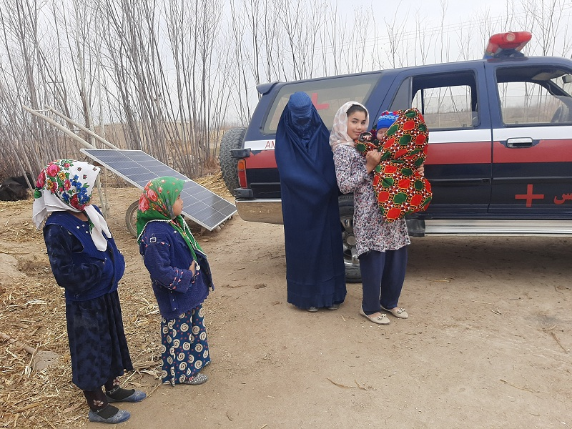
A 37 year old woman from Joy Jadid village was pregnant for the 4th time. Her husband had recently been admitted to as a jail for for people with addiction problems by the Taliban.
With the help of our SMG during her labor she was transferred to the health center without any preparation. A midwife assisted her delivery and using our clean birth kit. Once delivered, the baby was covered well and took one of our baby blankets safely home.
Many of our cases are similar to this one; providing emergency care, to women whose health, safety and that of their baby is at risk without intervention. The ambulance service is doing a great job despite these difficult situations.
Some photos are attached.

