ANC Report
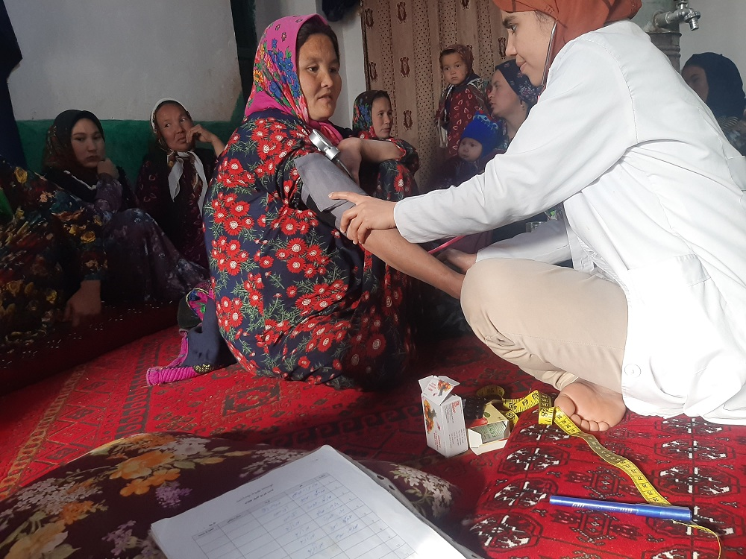
December 2021
The midwife has visited around 350 pregnant women in Kaldar.
Unfortunately, the recent situation created lots of psychological and physical problems in each village, particularly due to the deprivation experienced by women and children.
Many men in Kaldar are facing narcotic addiction issues. The Taliban arrested all these men and admitted them in a facility in Mazar. In each village around 30 men were arrested, and were punished with cold water daily. Two young boys died from this type of punishment. Out of these 30, around 15 of them had pregnant partners. This situation is causing lots of issues for the pregnant women too.
Though they are working very hard to feeding their children, their income is the same as before the takeover, or before their partners were arrested for narcotic addiction. The salary that many of the women earn from weaving carpet is not enough considering recent inflation; food prices have tripled in the past few months. WFP will help with the distribution of food, but only 10 percent of the Kaldar population can be fed through these means.
Child mortality is increasing due to cold weather. Narcotics are being used to keep them warm and sleepy. A lot of medication is not even accessible in health centers due to a national shortage due to importation issues. Hunger and lack of childcare is worsening child mortality by the day; most mothers are keeping busy for earning money to find food for them.
Our facilities which provide Anti natal case visits will likewise distributegood quality of medication in this difficult time, but the national issues are far from being resolved, and the situation is likely to worsen. 