Routledge Studies in the Histories of Children and Youth

This book series hosts new and dynamic scholarship on the global histories of children and youth in the modern era (c. 1750 to present). Encompassing all historical settings in which children and youth were located, it explores lived experiences, cultural representations, material and memorial cultures. Studies showcasing methodological innovation and youthful perspectives are especially encouraged, and the series is also interested in approaches that position the histories of young people and the analytical category of age within broader historiographical narratives and debates.

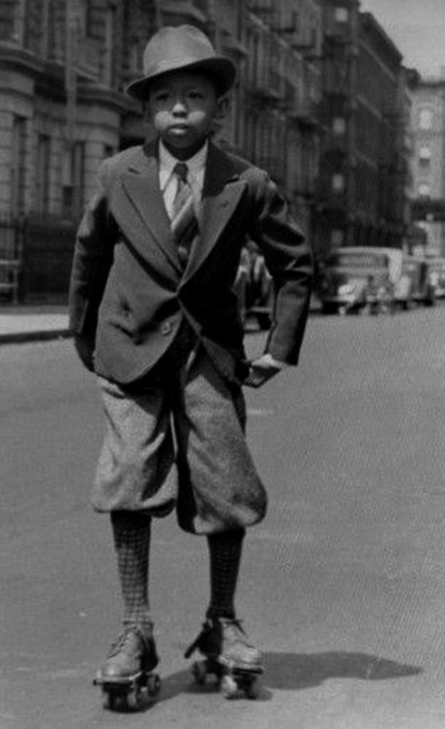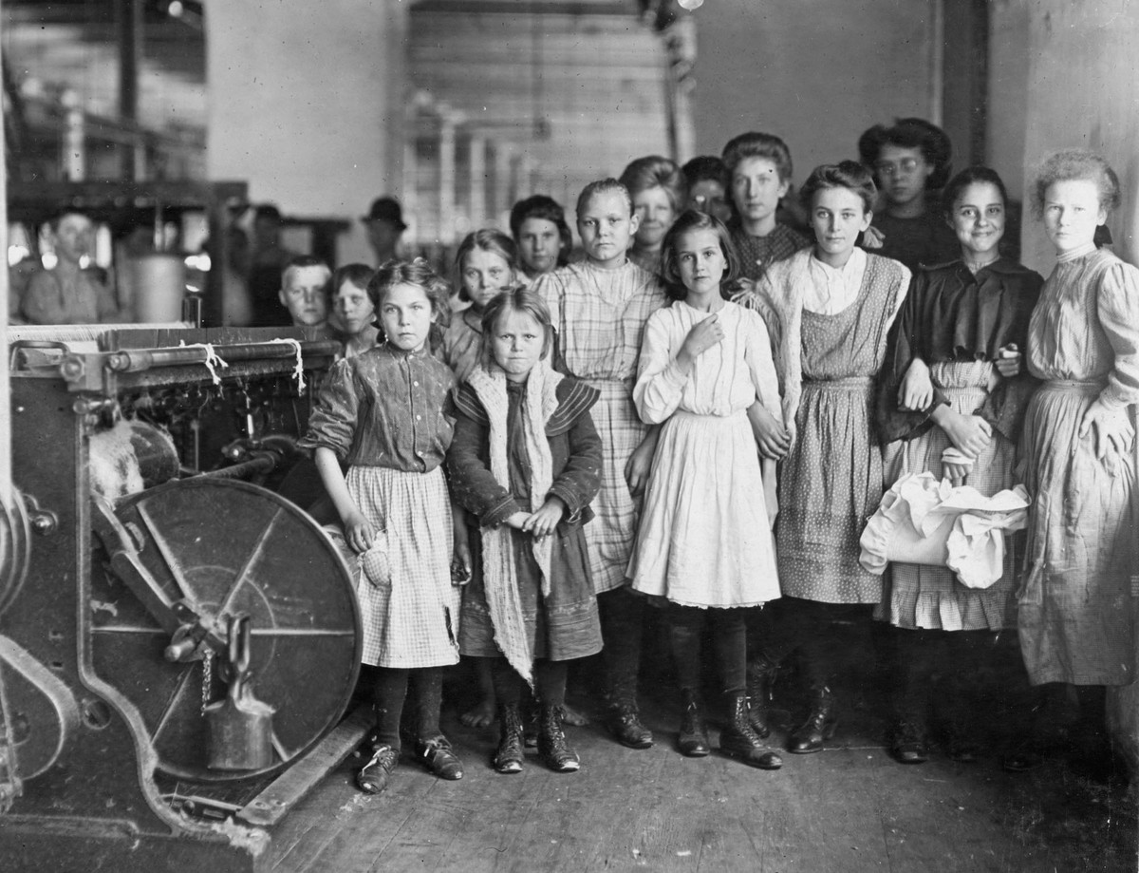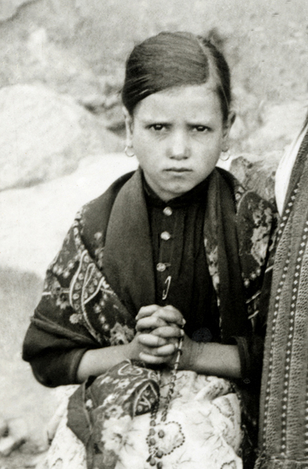

Proposals
Submissions are welcome from emergent and established scholars. We make prompt editorial decisions. Our titles are published in print and electronic format, and subject to peer review by recognised experts in the field. The series features monographs, edited collections, and textbooks or handbooks designed for university teaching. For further information prior to making a submission please contact max.novick@taylorandfrancis.com, copying in both simon.sleight@kcl.ac.uk and kristine.alexander@uleth.ca

Series Editors
Simon Sleight, King’s College London
Kristine Alexander, University of Lethbridge

Editorial Board
David Ambaras, North Carolina State University
Swapna Banerjee, Brooklyn College, CUNY
Dylan Baun, University of Alabama, Huntsville
Chris Brickell, University of Otago
Sarah-Anne Buckley, NUI Galway
Corrie Decker, University of California, Davis
Érika Melek Delgado, King’s College London
Sarah E. Duff, Colby College
Crystal Fraser, University of Alberta
Mona Gleason, University of British Columbia
Abosede George, Barnard College, New York
Mischa Honeck, Universität Kassel
Catriona Kelly, University of Oxford
Valeria Manzano, Universidad Nacional de San Martin
Gary McCulloch, UCL/Institute of Education
Mary Clare Martin, University of Greenwich
Nara Milanich, Barnard College, New York
Susan Miller, Rutgers University
Aaron Moore, University of Edinburgh
Heidi Morrison, University of Wisconsin, La Crosse
Hugh Morrison, University of Otago
Nell Musgrove, Australian Catholic University
Tamara Myers, University of British Columbia
Stephanie Olsen, Tampere University
Ishita Pande, Queen’s University, Ontario
Carla Pascoe Leahy, University of Melbourne
David Pomfret, University of Hong Kong
Shirleene Robinson, National Library of Australia
Yorick Smaal, Griffith University
Allyson Stevenson, University of Regina
Nicholas Syrett, University of Kansas
Melanie Tebbutt, Manchester Metropolitan University
Karen Vallgårda, University of Copenhagen
Susan Whitney, Carleton University
Christina Wu, La Sorbonne



    

