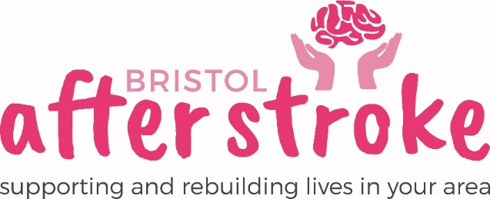

Longwell Green Aphasia Group
Volunteer Role Description

Role Title: | Longwell Green Aphasia Group - Volunteer
Responsible to: | Speech and Language Therapist
Time commitment: | Tuesdays 1.15pm – 3.15pm (2nd & 4th Tuesday of the month)
Location: | Longwell Green Community Centre  Shellards Road  Longwell Green  Bristol  BS30 9DU
Why we need your help:
Bristol After Stroke is facilitating an existing communication group in Longwell Green for people with “aphasia” (communication difficulties after a stroke). The Aphasia Group provides an environment for people with aphasia to practice conversation skills and share communication skills and tips.
The established group – which consists of around 8 people currently need a volunteer to support the sessions and create an encouraging supportive environment.
Role Summary: | - To support the Speech and Language Therapist to run a group for people with Aphasia.  - Support people with varying levels of aphasia in a group setting.  - Encourage all group members to take part in conversations, using a range of communication methods.  - Support activities in the group setting by using visual resources to be used at the group.  - Promote a supportive atmosphere that contributes to a sense of wellbeing for all group members.
Skills and Experience: | - Excellent communication skills, including excellent listening skills.  - Good Interpersonal skills.  - Be patient, understanding and have a responsible attitude.  - Know about or be willing to learn about communication difficulties.  - Know about or be willing to learn about stroke and its impact on people.  - Be comfortable working as part of a team.  - Recognise the importance of confidentiality and show this in practice.

What we can offer you:
- An induction, support and supervision in the role.
- Training on how to support communication for people with aphasia.
- You will be supported in your role by the Speech and Language Therapist as well as other appropriate members of staff as needed.
- Bristol After Stroke Newsletters; keeping you up to date on charity news and other volunteer opportunities.
- You will have the opportunity to meet with other Bristol After Stroke volunteers at Volunteer Training and at our annual Volunteer Day.

What we ask of you:
- To obtain 2 references from people who are not related to you.
- To keep to all the charity’s policies, values and guidelines.
- To complete an induction and any necessary training for the role.
- This post requires a DBS check. Bristol After Stroke follows the national DBS Code of Practice, this code is available on request.
- We will ask you to do a safeguarding course.

Bristol After Stoke
April 2022

