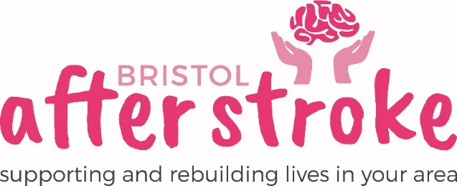

Volunteer Photographer

Role Title | Volunteer Photographer
Responsible to: | Volunteer Coordinator / Service Support Officer
Time Commitment: | Adhoc – This role is flexible and will involve going along to some of our courses and groups to take photos.
Location: | The role will take place at our groups / courses and events across Bristol and South Glos
Why we need your help:
Bristol After Stroke is an independent charity helping people in Bristol, South Gloucestershire and surrounding areas to rebuild their lives. We provide information, practical support, friendship and counselling in the months and years following a stroke.

We are looking for an enthusiastic and committed individual with an eye to detail who can help us through photography to highlight the importance of what Bristol After Stroke do. This unique role allows you to indulge your creative passions and skills and produce great quality images for us to use in leaflets, our website and on social media.

Role Summary: | - Taking photographs for use on our website, on our social media pages or in our flyers.  - You will work to a brief to deliver images in the format we can use.  - Photographing Service Users / Group Members, staff, volunteers and supporters at various courses / groups or events.  - Processing and editing photographs.  - Have access to a digital SLR or high spec Bridge camera.
Skills and Experience: | - Digital Photography skills to a high standard  - Keen eye for detail  - Lots of enthusiasm!  - Outgoing and pro-active.  - Good communication skills.  - The ability to follow a brief  - Be familiar with manual photographic techniques, including exposure, shutter speed, aperture and ISO settings.  - Possess an understanding of digital photo file formats, saving, handling and online transfer.

What we can offer you:
- An induction and support and supervision in the role.
- You will be supported in your role by the Volunteer Coordinator / Service Support Officer and other appropriate members of staff as needed.
- You will be reimbursed out of pocket expenses

What we ask of you:
- To sign an agreement regarding the photos you take.
- Adhere to Bristol After Stroke’s data protection and confidentiality policy.
- To be respectful and understanding of the people you take photos of.

Bristol After Stoke
Feb 2022

