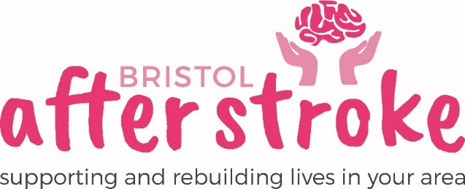

Marketing Volunteer
– Role Description

Role Title: | Marketing Volunteer
Responsible to: | Fundraiser
Time commitment: | 3 hours a week
Location: | Working from home
Why we need your help:

Bristol After Stroke is a vibrant independent charity helping people in Bristol, South Gloucestershire and surrounding areas to rebuild their lives after stroke. We provide information, practical support, friendship and counselling in the months and years following a stroke.

As a charity we want to raise our profile; we want more people to be aware of our services so if they need our support they know how to access it. We also want more people to think of us as a charity to support through fundraising.

This is an important and exciting role which could have a big impact on us as a charity.

Role Summary: | - Updating and editing Website content, including news.  - Producing a Social Media schedule and diary.  - Creating original content for social media posts – images or video.  - Posting social media content across platforms including Twitter, Facebook and Instagram, Youtube and Linked In.  - Search Engine Optimisation.
Skills and Experience: | - Able to communicate effectively, be articulate, with strong writing skills and the ability to feedback accurately.  - Social Media content research  - Good IT skills, including Microsoft Office – though training and support will be given with particular packages.  - Competent using CANVA or similar design and editing package.  - Basic video editing skills on iMovie or similar.  - Self-motivated and a pro-active approach to work.  - Experience of/ interest in social media and digital communications.  - Know about or be willing to learn about stroke and its impact on people.  - Recognise the importance of confidentiality and show this in practice.

What we can offer you:

- An induction, support and supervision in the role.
- You will be supported in your role by the Fundraiser as well as other appropriate members of staff as needed.
- Bristol After Stroke Newsletters; keeping you up to date on charity news and other volunteer opportunities.
- You will have the opportunity to meet with other Bristol After Stroke volunteers (virtually at present).

What we ask of you:
- To obtain 2 references from people who are not related to you.
- To keep to all the charity’s policies, values and guidelines.
- To complete an induction and any necessary training for the role.
- To have your own computer and a reliable internet connection.

Bristol After Stoke
Jan 2022

