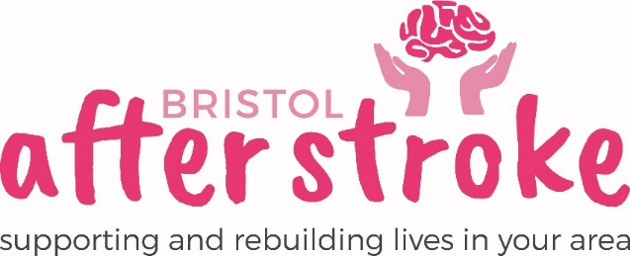

Activities and Group Volunteer - Portway

Role Title | Activities and Group Volunteer - Portway
Responsible to: | Group Leader
Time Commitment: | 3 hours weekly (Thursday - 12.30-3.30)  Minimum of 12 months.
Location: | Port of Bristol Social Club, Nibley Road, Shirehampton, BS11 9XY
Why we need your help:
- Bristol After Stroke is an independent charity helping people in Bristol, South Gloucestershire and surrounding areas to rebuild their lives. We provide information, practical support, friendship and counselling in the months and years following a stroke.
- Our Stroke Support Group Volunteers provide help and support to our Group Leaders and group members at our weekly stroke support groups.
- Our groups provide an opportunity for anyone who has been affected by stroke to meet others affected by stroke and make new friends, take part in stimulating and enjoyable activities which will support rehabilitation.

Role Summary: | - Provide support for group activities, exercises, and games.  - Support the Group Leader with the planning of Group Activities.  - Provide general support to Group Leader and Group Members when needed.  - Make and serve refreshments.  - Give added enthusiasm and encouragement to our members in taking part in any physical activities or exercises that may be offered during the session.  - Talk to group members, encourage them to get involved and generally help to promote a supportive, happy atmosphere that contributes to a sense of wellbeing.  - Help at the group for its full duration each week including setting up and clearing away of the room.
Skills and Experience: | - Be patient, understanding and have a responsible attitude.  - Know about or be willing to learn about undertaking risk assessments.  - Be comfortable working as part of a team.  - Know about or be willing to learn about stroke and its impact on people.  - Recognise the importance of confidentiality and show this in practice  - Be emotionally resilient

What we can offer you:
- An induction and support and supervision in the role.
- You will be supported in your role by the Group Leader and other appropriate members of staff as needed.
- Bristol After Stroke Newsletters; keeping you up to date on charity news and other volunteer opportunities.
- You will have the opportunity to meet with other Bristol After Stroke volunteers.

What we ask of you:
- To obtain 2 references from people who are not related to you.
- To keep to all the charity’s policies, values and guidelines.
- To complete an induction and any necessary training for the role.

Bristol After Stoke
Nov 2021

