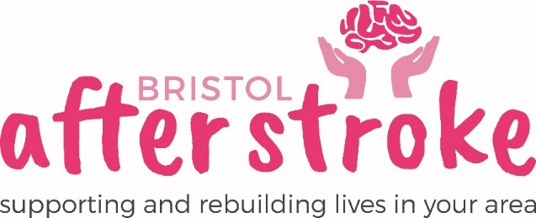

Activities and Group Volunteer – South Bristol

Role Title | Activities and Group Volunteer – South Bristol
Responsible to: | Group Organiser
Time Commitment: | 3 hours weekly (Thursday 10am – 1pm)  Minimum of 12 months.
Location: | The Conference Room, St Monica Wills House, Cromwell Road, Bedminster, BS3 3NH
Why we need your help:
- Bristol After Stroke is an independent charity helping people in Bristol, South Gloucestershire and surrounding areas to rebuild their lives. We provide information, practical support, friendship and counselling in the months and years following a stroke.
- Our Activities and Group Volunteers provide help and support to our Group Organisers and group members at our weekly stroke groups.
- Our groups provide an opportunity for anyone who has been affected by stroke to meet others affected by stroke and make new friends, take part in stimulating and enjoyable activities and have occasional trips out.

Role Summary: | - Help at the group for its full duration each week including setting up and clearing away of the room.  - Make and serve refreshments.  - Provide support for group activities, exercises and games.  - Provide general help and support to the Group Organiser and members as and when needed.  - Give added enthusiasm and encouragement to our members in taking part in any physical activities or exercises that may be offered during the session.  - Talk to group members, encourage them to get involved and generally help to promote a supportive, happy atmosphere that contributes to a sense of wellbeing.
Skills and Experience: | - Be patient, understanding and have a responsible attitude.  - Know about or be willing to learn about undertaking risk assessments.  - Be comfortable working as part of a team.  - Know about or be willing to learn about stroke and its impact on people.  - Recognise the importance of confidentiality and show this in practice

What we can offer you:
- An induction and support and supervision in the role.
- You will be supported in your role by the Group Organiser and other appropriate members of staff as needed.
- Bristol After Stroke Newsletters; keeping you up to date on charity news and other volunteer opportunities.
- You will have the opportunity to meet with other Bristol After Stroke volunteers.

What we ask of you:
- To obtain 2 references from people who are not related to you.
- To keep to all the charity’s policies, values and guidelines.
- To complete an induction and any necessary training for the role.

Bristol After Stoke
October 2019

