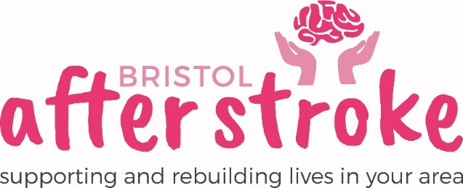

Conversation after Stroke – Volunteer – Role Description

Role Title | Conversation after Stroke - Volunteer
Responsible to: | Aphasia Group Lead Volunteer
Time Commitment: | 3 hours monthly 1st Monday of every month  (Monday – 1.30-4.30)  Minimum of 1 year
Location: | The Station, Silver Street, Bristol, BS1 2AG
Why we need your help:
Bristol After Stroke facilitates a peer-led drop-in group for people with aphasia (Communications difficulties after a stroke). It is led by Bristol After Stroke volunteers, many of whom have had, or still have similar difficulties themselves. The Conversation Cafe provides an environment where people who have had a stroke can practice speech and other forms of communication and share skills and tips. This group can be busy, so we are looking for another volunteer to help the 2 other volunteers who run the group.
Role Summary: | - You will be required to talk to cafe members, encourage them to get involved and generally help to promote a supportive, happy atmosphere that contributes to a sense of wellbeing.  - Provide support and added enthusiasm for group activities and exercises that may be offered during the session.  - Help at the group for its full duration each month; with set up and clear up times, this is likely to be up to three hours.  - Make and serve refreshments to group members.  - You may be asked to keep a register of attendees and take subs.  - Provide help and support to the café members and Aphasia Group Lead as and when needed.
Skills and Experience: | - Be patient, understanding and have a responsible attitude.  - Know about or be willing to learn about communication difficulties.  - Know about or be willing to learn about stroke and its impact on people.  - Be comfortable working as part of a team.  - Recognise the importance of confidentiality and show this in practice.

What we can offer you:
- An induction and support and supervision in the role.
- You will be supported in your role by the Aphasia Group Lead Volunteer as well as other appropriate members of staff as needed.
- Bristol After Stroke Newsletters; keeping you up to date on charity news and other volunteer opportunities.
- You will have the opportunity to meet with other Bristol After Stroke volunteers.

What we ask of you:
- To obtain 2 references from people who are not related to you.
- Complete an enhanced DBS disclosure form.
- To keep to all the charity’s policies, values and guidelines.
- To complete an induction and any necessary training for the role.

Bristol After Stoke
November 2019

