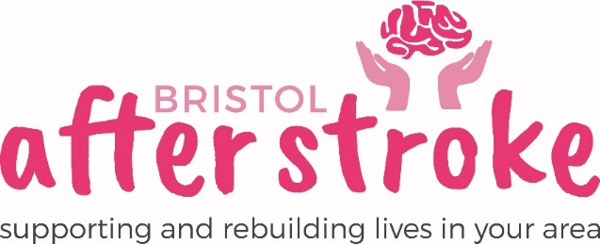

Volunteer Fundraising Committee Member

Role Title | Volunteer Fundraising Committee Member
Responsible to: | Fundraising Officer
Time Commitment: | Flexible:  The Committee will meet formally 3-4 times a year with some additional time and energy required to contribute to related tasks, events and activities.  Minimum commitment: 1 year
Location: | Community Based (must be able to attend meetings at Bristol After Stroke Office in Hartcliffe as well as attend events organised by committee.)
Why we need your help:
Bristol After Stroke is an independent charity helping people in Bristol, South Gloucestershire and surrounding areas to rebuild their lives. We provide information, practical support, friendship and counselling in the months and years following a stroke.
In order to provide our services, we need to raise funds from the local area, which is why we are setting up the Fundraising Committee.

Role Summary: | - Help to promote the work of the charity and encourage support from the local community.  - Help to organise collections, events and other fundraising activities for Bristol After Stroke.  - To attend and support fundraising events.  - Encourage others to fundraise or volunteer for us.  - Attend and participate in group meetings.  - Complete agreed action points following meeting.
Skills and Experience: | - Sincere interest and / or related experience with fundraising activity.  - Ability to work on own initiative  - Be comfortable working as part of a team.  - Commitment to work within fundraising guidelines and policies  - Honest, committed and reliable.  - Know about or be willing to learn about stroke and its impact on people.

What we can offer you:

- An opportunity to support fundraising in your area
- An induction and support and supervision in the role.
- Agreed reasonable out of pocket expenses
- You will be supported in your role by the Emma Collier.
- You will have the opportunity to meet with other Bristol after Stroke volunteers

What we ask of you:

- To obtain 2 references from people who are not related to you.
- To keep to all the charity’s policies and guidelines.
- To complete an induction and any necessary training for the role.

Bristol After Stoke
October 2018

