Forcefield Analysis template

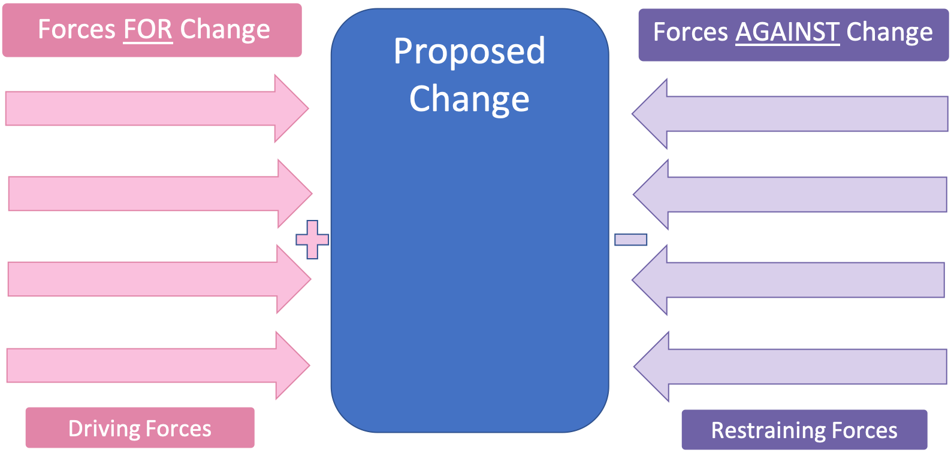

Fishbone Diagram template

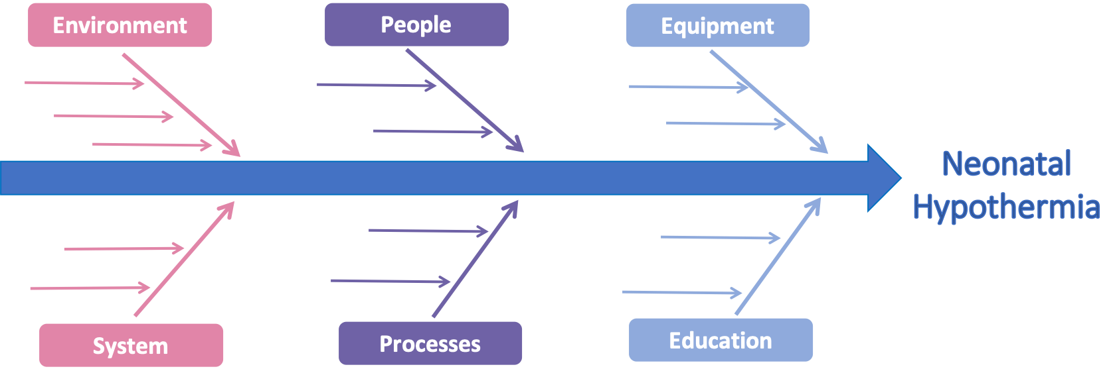

Driver Diagram template
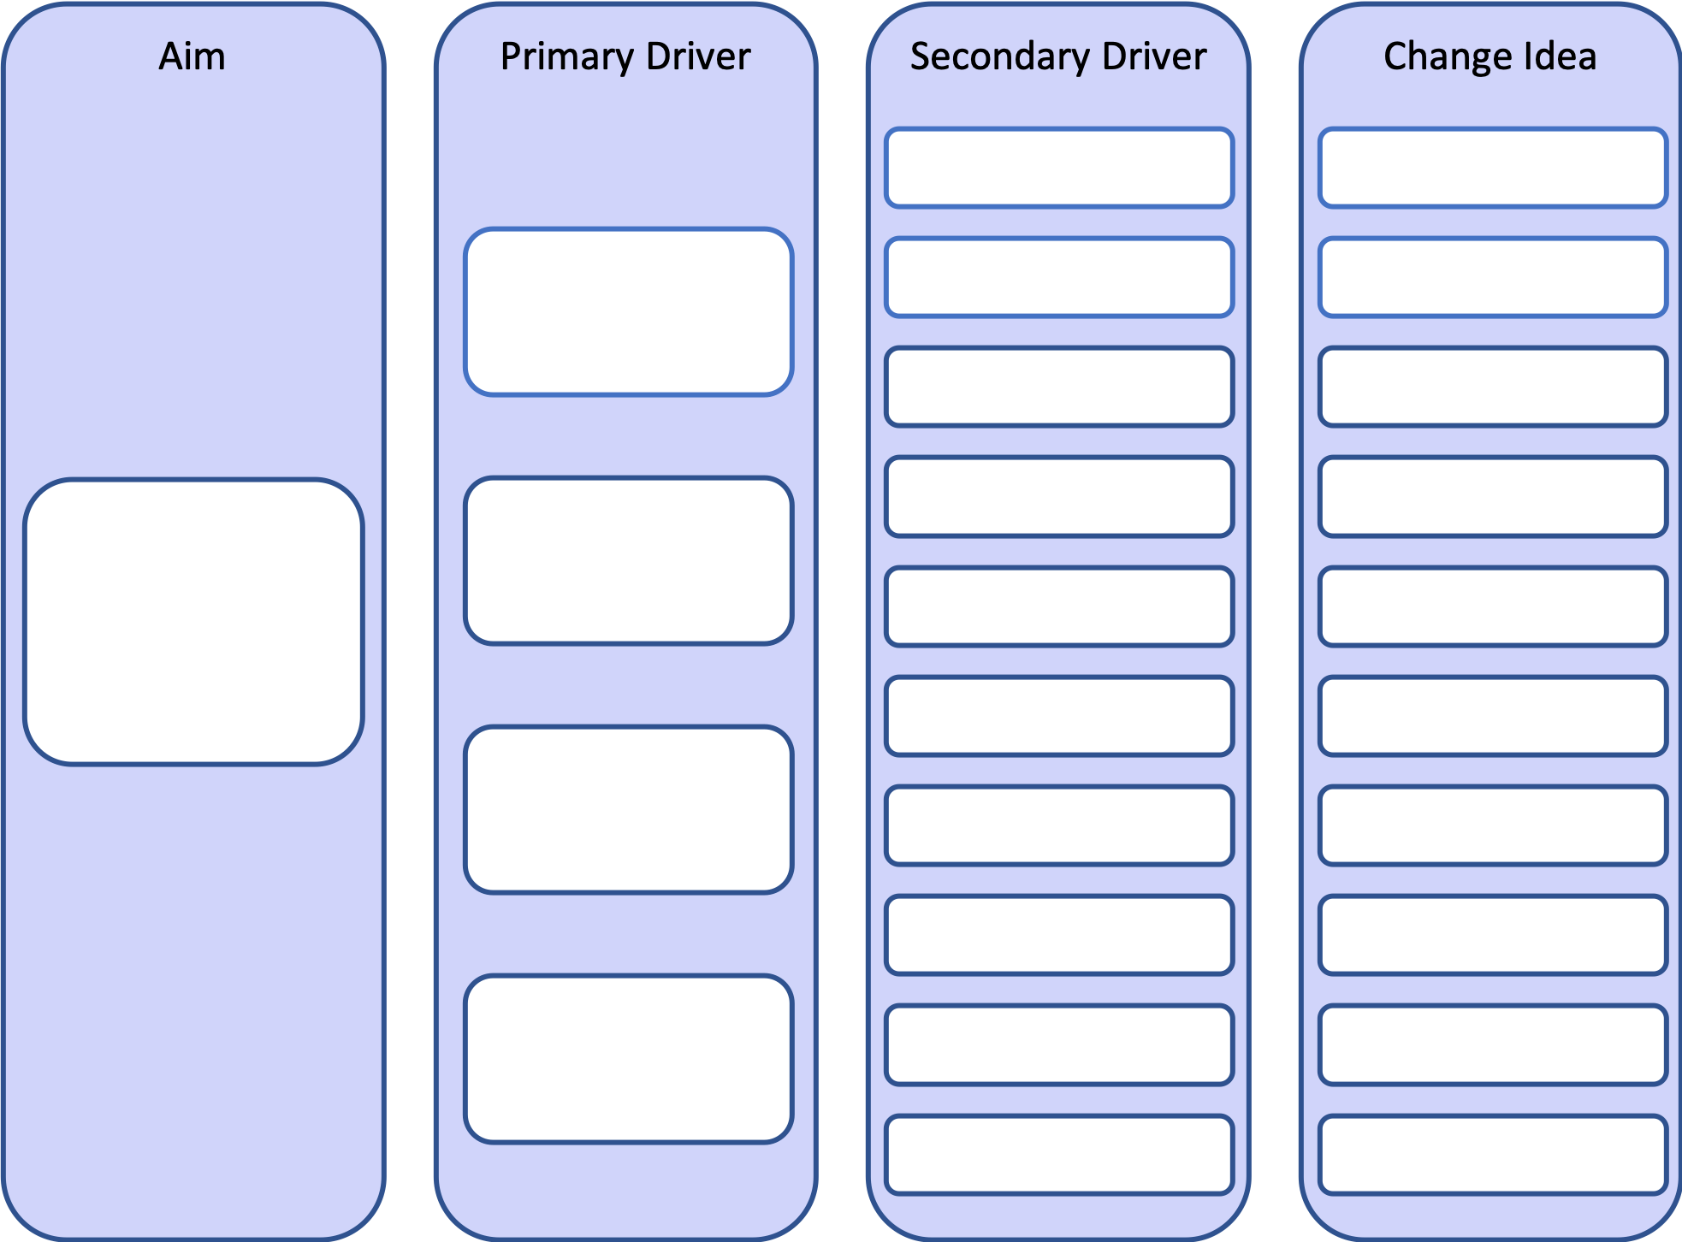
Example of Case Review or Exception Reporting Tool

Case Review Tool for Normothermia Noncompliance <36.5°C or >37.5°C

Hospital number:
Day of week and time of birth:
Gestation:
Birthweight:
Location of delivery:

First temperature recorded on admission to the neonatal unit:
Time the first temperature was recorded after admission:

At Stabilisation:
Was the paediatric/neonatal team present prior to delivery?
Number of staff present:
Highest senior member of staff present:
Neonatal nurse present:

Temperature of delivery room at the time of birth:
Was a radiant warmer delivering maximal heat prior to, and at time of, delivery?
Was delayed cord clamping undertaken?

Was a plastic bag used from the point of birth?
Were holes in bag kept to minimum to avoid “through drafts”?
Did bag remain closed around baby for whole process?
Was a hat applied?

Was a continuous temperature probe used?
Was radiant heat set to manual or servo?
Was a temperature recorded during stabilisation and how soon after birth?
What was the temperature recorded prior to leaving the delivery suite?
Did avoidable delay precede admission?
If baby met parents prior to admission, what thermal support was provided?

What manoeuvres were undertaken during stabilisation to maintain normothermia?

Learning:
Was hypothermia or elevated temperature avoidable?

What lessons can be learned?

What actions require to happen to improve process?

Example of Delivery Room checklist for Maintaining Normothermia
(this checklist can be incorporated into stabilisation and Golden Hour checklist)
Team preparation: Equipment:

Responsibility for thermal control allocated: Radiant heat
Required tasks described including: Plastic bag
- Environment warm/maximum radiant heat prior to birth Appropriately sized hat
- Thermal control during cord clamping Temperature probe
- Thermal control during meeting parents Power source for transfer
- Team in NNU notified to prepare for admission

Temperature | Significance | If T<36.5 | If T >37.5
T1 (temperature after probe stabilises on resuscitaire) | Measures efficacy of thermal care from birth till ABC are stabilised | Consider increasing radiant heat .  Remove draughts, ensure plastic bag sealed around baby, ensure probe in correct position. | If using servo with the temperature set at 37C reduce it to 36.5C. If using manual control, decrease radiant heat provided.  If using Transwarmer with plastic bag remove the Transwarmer
T2 (temperature prior to transfer) | Measures efficacy of thermal care during the transport | Is a warm humidified incubator ready? If not leave the baby to warm under radiant heat before moving. Use warmed towels over baby on transport. | If using a Transwarmer remove it
T3 (temperature on admission) | Measures efficacy off thermal care while the baby is being admitted to the incubator | Delay procedures if appropriate.  Eliminate draughts. | If using a Transwarmer remove it  Consider removing plastic bag
T4 (temperature after first hour) | Measures any loss of heat due to procedures | Increase incubator temperature.  Check humidity and consider increasing | Remove plastic bag if still around baby  Reduce incubator temperature

