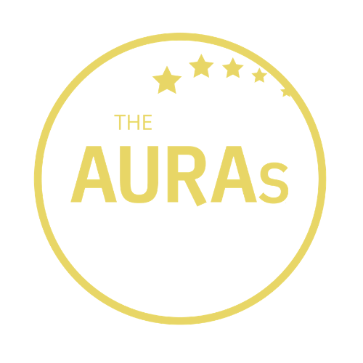

THE AURAs 2021:
AGENCY AWARDS NOMINATION FORM

Which award(s) are you entering?

Best Small Agency | [ ]
Commercial Acumen | [ ]
Communication | [ ]
Trusted Partner* | [ ]

Agency being nominated:

Contact at nominated agency:
Your name:

Your company:

Please tell us in at least 100 words why you think this agency is worthy of an AURA. Include a brief description of the work that was undertaken but focus mostly on the reasons you think their contribution went above and beyond the ordinary. If you are able to support your nomination with stakeholder quotes or evidence of impact, even better. You can use one form to nominate an agency in multiple categories or use a separate form for each category if you prefer

*If you are entering an Agency for the Trusted Partner Award, please include evidence/quotes from people within your organisation but outside the Insight/Research team

Please submit this form to awards@aura.org.uk by 1800hrs 28th May 2021

CONDITIONS OF ENTRY

Only people working for companies that were members of AURA at the time of the AURA Awards announcements on 19th July 2021 are eligible to enter

A nomination can be in respect of a body of work done by an agency or a single project

You may enter an agency for as many awards as you choose

Shortlisted agencies will be contacted by AURA the week commencing 7th June 2021. AURA will get in touch with the nominated contact shared in your submission.

AURA members will be invited to vote for shortlisted agencies from 7th June 2021. Voting closes at 2359hrs on 30th June 2021. Winners will be announced on 19th July 2021.

AWARDS CRITERIA

Commercial Acumen
This award recognises an agency which has stepped up and proactively helped our members drive commercial returns from their insights.

Communication
Putting the output of any research project in front of an internal audience can be a make or break moment. This award celebrates agencies whose communications are capable of creating ‘wow’ moments, ones clients are proud to put in front any internal audience

Trusted Partner
Strong relationships are at the heart of our business. This award is for agencies who have achieved Trusted Partner status – those who understands the business’s agenda and goes beyond the call of duty to help you deliver it

Best Small Agency (Fewer than 25 employees or <£1million turnover)
This award celebrates the contribution made by the many smaller hidden gem agencies our members have been working with

AURA’s Agency of the Year will be chosen from nominees from all these above categories

