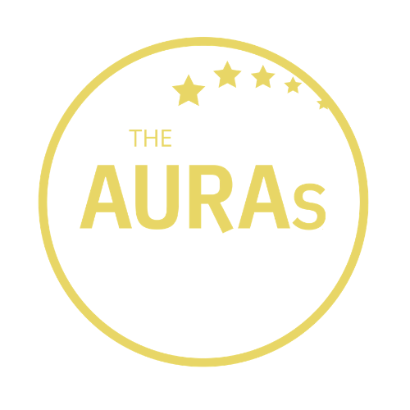

THE AURAs 2020:
BEST NEW INSIGHT TALENT NOMINATION FORM

This award recognises the best new talent in the research and insight industry. Nominees must have worked in research for no more than 5 years and must currently be working clientside. The winner of this award will be someone who has shown extraordinary passion and aptitude for what they do, as well as ability and impact way beyond their experience. Nominations are welcomed from agencies and AURA members and you are equally welcome to nominate yourself!

Your name:

Your company:

Name of the person you are nominating:

Nominee’s company:

Your contact email:

Nominee’s contact email:

Please tell us in a maximum 300 words why you or this person deserves to win this award. Wherever possible please use examples of outstanding performance to illustrate and help us understand what sets you/them apart. You may include up to three endorsements. These could be from within the nominee’s company (their research/insight team or stakeholders etc) and/or people who have worked closely with them in research agencies.

YOUR ENTRY

(max 300 words)

SUPPORTING ENDORSEMENT (optional)

Name and job title of first endorser (required)

First endorsement

Name and job title of 2nd endorser (optional)

2nd endorsement

Name and job title of 3rd endorser (optional)

3rd endorsement

Please submit this form to awards@aura.org.uk by 1800hrs on 17th July 2020

CONDITIONS OF ENTRY

- Entries are welcomed from people working for companies that were members of AURA at the time of the AURA Awards announcement on 10th September and research agencies who have worked with the nominee in the preceding 12-18 months.

- The nominee must have been working for an AURA member company at the time of nomination

- Each submission must not exceed 300 words (any additional wording will be discounted and not provided to the shortlisting panel)

- Nominees must have a maximum of 5 years’ experience at the time of nomination, and must currently be working clientside. However it is not essential their experience is exclusively clientside

- Submissions and all applicable information will be treated in confidence

KEY DATES

- Closing date for submissions is 1800hrs 17th July 2020. Any entries received after this date will not be considered

- Shortlisted entrants will be contacted by AURA on or before 31st July 2020 and publicly announced on 1st August 2020

- The winner will be announced at the AURA Awards online event, also on 10th September 2020

GOOD LUCK!

