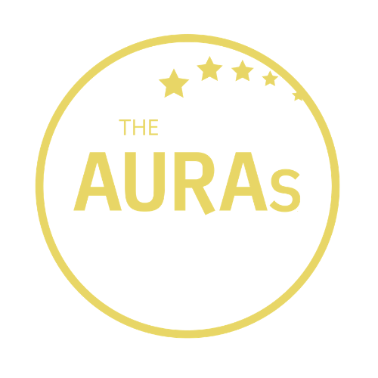

THE AURAs 2020:
AGENCY AWARDS NOMINATION FORM

Which award(s) are you entering?

Best New Agency | [ ]
Best Small Agency | [ ]
Commercial Acumen | [ ]
Communication | [ ]
Trusted Partner* | [ ]

Agency being nominated:

Contact at nominated agency:
Your name:

Your company:

Please tell us in up to 300 words why you think this agency is worthy of an AURA. Include a brief description of the work that was undertaken but focus mostly on the reasons you think their contribution went above and beyond the ordinary. If you are able to support your nomination with stakeholder quotes or evidence of impact, even better. You can use one form to nominate an agency in multiple categories or use a separate form for each category if you prefer

*If you are entering an Agency for the Trusted Partner Award, please include evidence/quotes from people within your organisation but outside the Insight/Research team

Please submit this form to awards@aura.org.uk by 1800hrs on 17th July 2020

CONDITIONS OF ENTRY

Only people working for companies that were members of AURA at the time of the AURA Awards announcements on 10th September are eligible to enter

A nomination can be in respect of a body of work done by an agency or a single project

You may enter an agency for as many awards as you choose

Shortlisted agencies will be contacted by AURA on or before 31st July 2020. AURA will get in touch with the nominated contact shared in your submission.

AURA members will be invited to vote for shortlisted agencies from 1st August 2020. Voting closes at 2359hrs on 4th September 2020. Winners will be announced on 10th September 2020.

AWARDS CRITERIA

Commercial Acumen
This award recognises an agency which has stepped up and proactively helped our members drive commercial returns from their insights.

Communication
Putting the output of any research project in front of an internal audience can be a make or break moment. This award celebrates agencies whose communications are capable of creating ‘wow’ moments, ones clients are proud to put in front any internal audience

Trusted Partner
Strong relationships are at the heart of our business. This award is for agencies who have achieved Trusted Partner status – those who understands the business’s agenda and goes beyond the call of duty to help you deliver it

Best Small Agency (Fewer than 25 employees or <£1million turnover)
This award celebrates the contribution made by the many smaller hidden gem agencies our members have been working with

Best New Agency (in business for 5 years or less)
All industries are enhanced by new entrants, innovators and disruptors. This award celebrates the contributions from new and emerging agencies

AURA’s Agency of the Year will be chosen from nominees from all these above categories.

