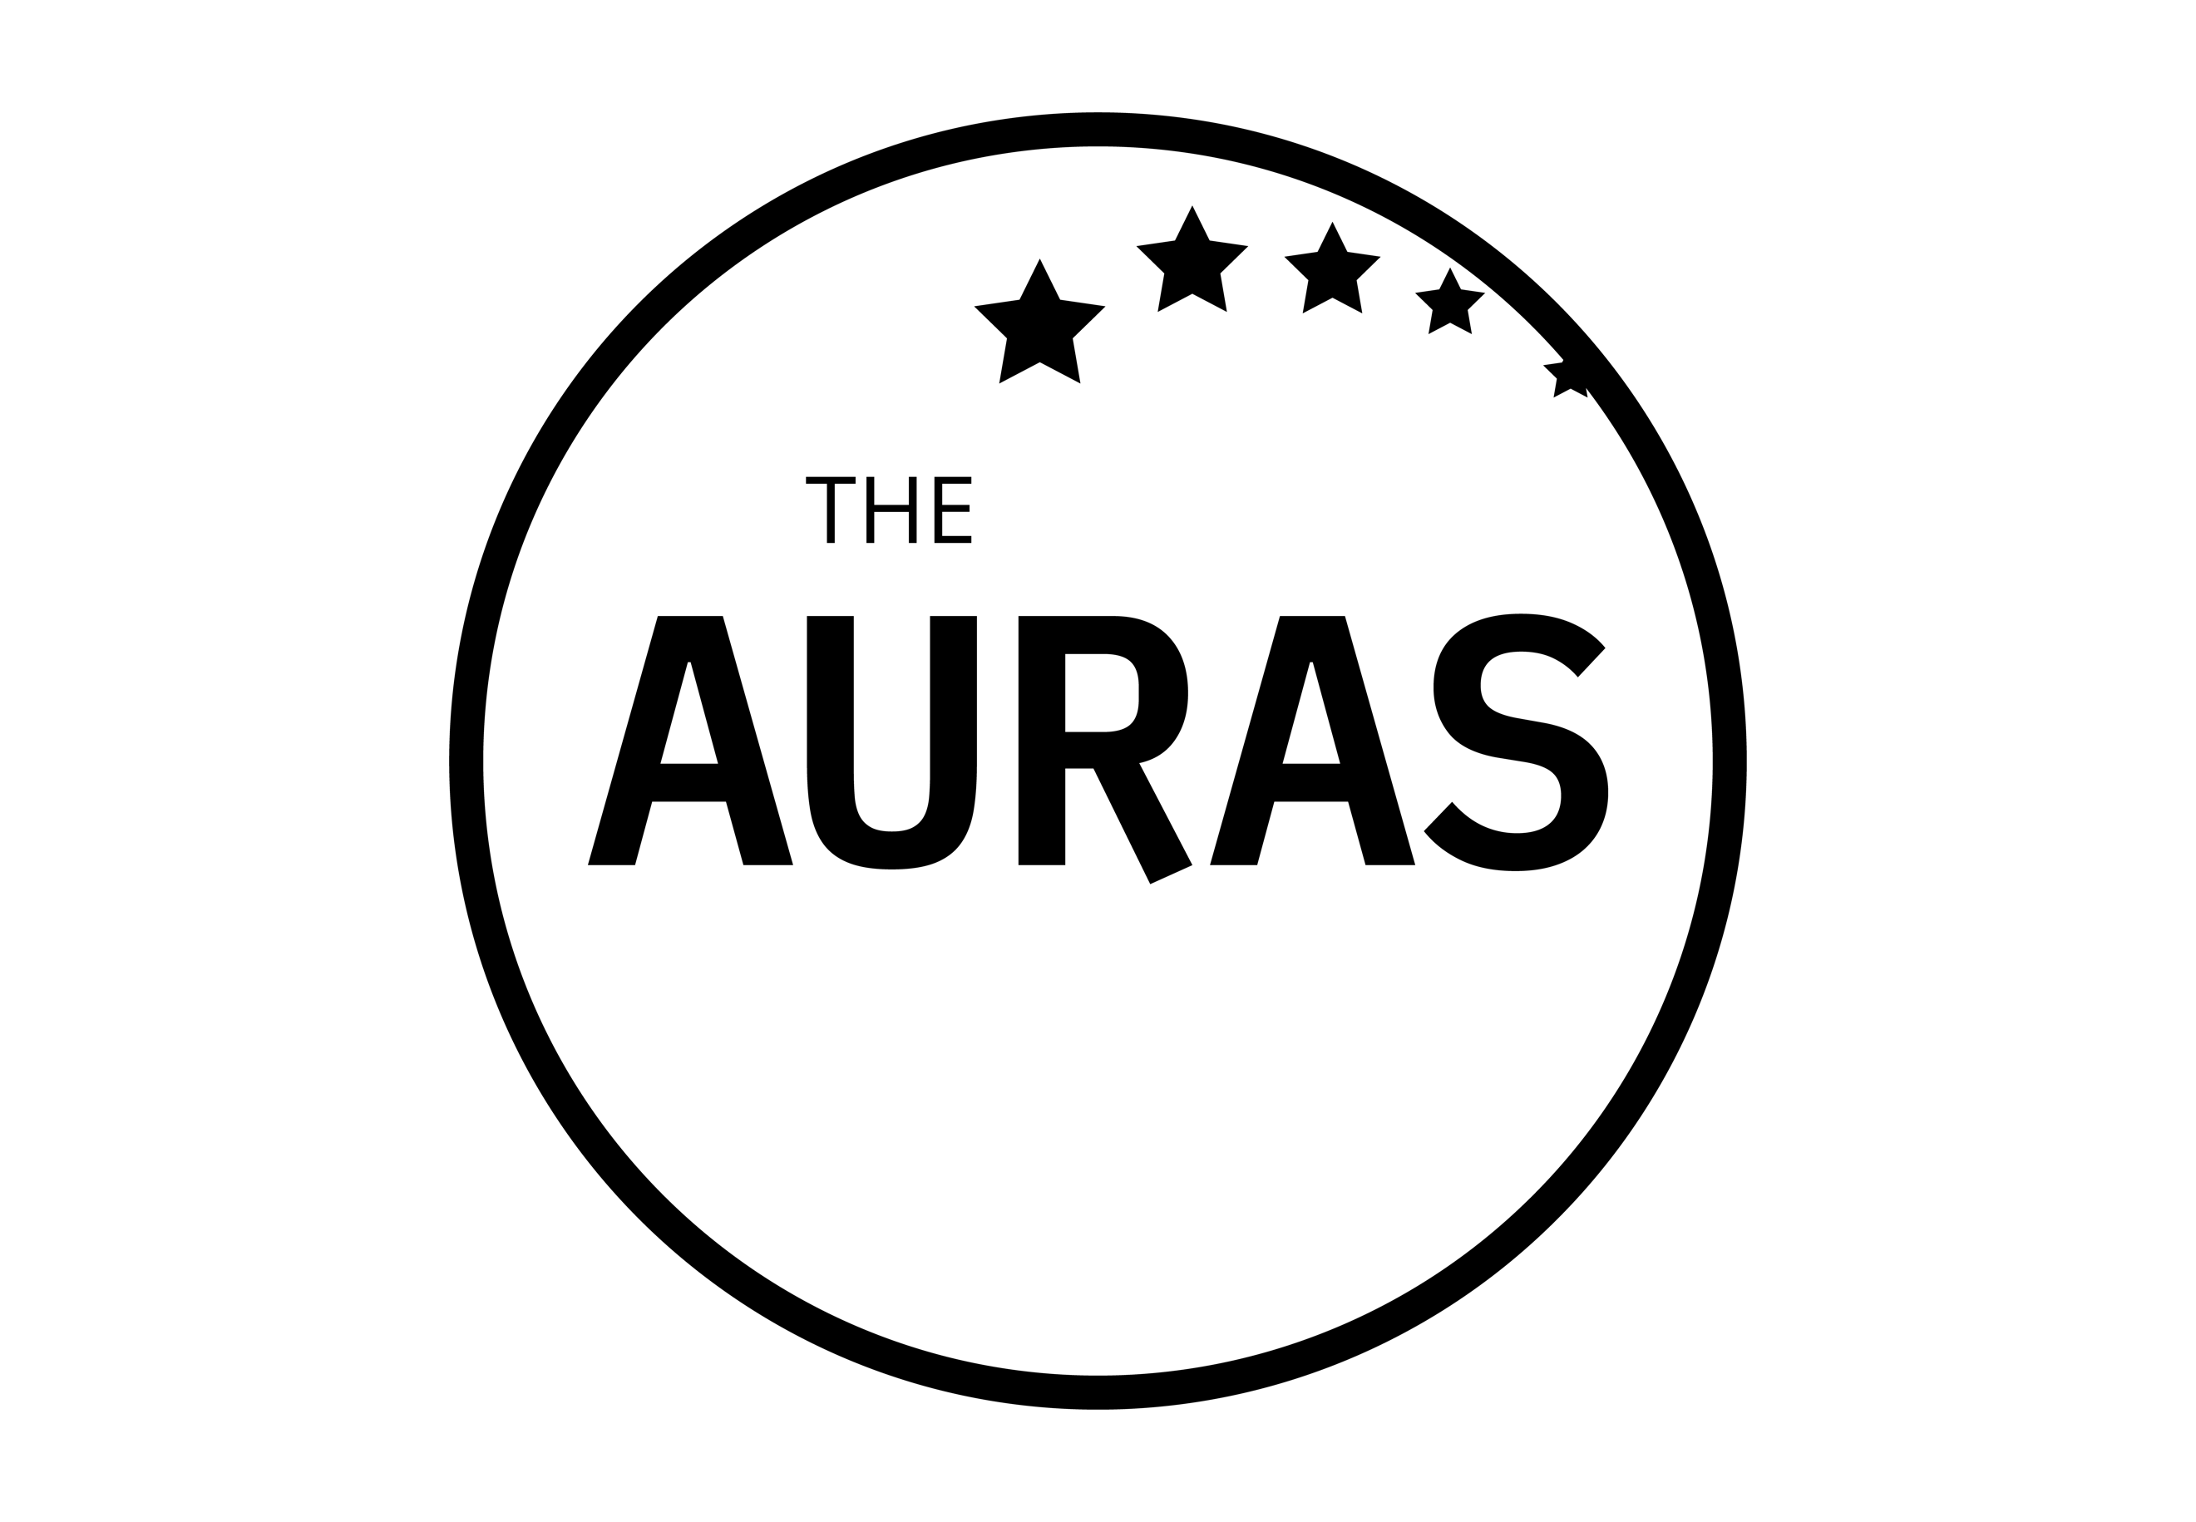

THE AURAs 2021: INSIGHT LEADERSHIP NOMINATION FORM

Management and leadership are never easy. Doing it at a time when your contact with your team is limited makes it particularly challenging. This award is to celebrate the best managers and leaders within your team. The people who have inspired or helped you to be a better researcher, have shaped the direction or your team, been there as a mentor and guide and/or have done something amazing for you or your team in the past year.

Nominees must work for an AURA member company, but entries are welcome from all levels of management – this doesn’t need to be just about the person at the top of the organisation chart.

Your name:

Your company:

Name of the person you are nominating:

Your contact email:

Nominee’s contact email:

Please tell us why you or this person deserves to win this award. Wherever possible please use examples to help us understand what sets you/them apart.

YOUR ENTRY

(max 300 words)

Please submit this form to awards@aura.org.uk by 1800hrs on 31st May 2021

CONDITIONS OF ENTRY

- Entries are welcomed from people working for companies that were members of AURA at the time of the AURA Awards announcement on 19th July 2021

- The nominee must have been working for an AURA member company at the time of nomination

- Each submission must not exceed 300 words

- Nominees must be leading/managing/supervising all or part of a team at any level within the organisation

- Submissions and all applicable information will be treated in confidence

KEY DATES

- Closing date for submissions is 1800hrs 31st May 2021. Any entries received after this date may not be considered

- Shortlisted entrants will be contacted by AURA publicly announced w/c 14th June 2021

- The shortlisted finalists and winner will be invited to the AURA Awards ceremony on 19th July where the winner will be announced

GOOD LUCK!

