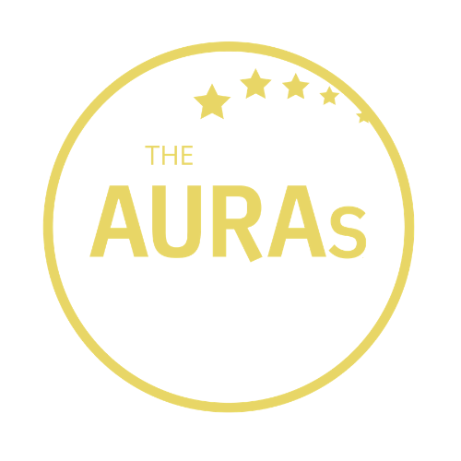

THE AURAs 2021
INSIGHT IMPACT ENTRY FORM

This award is given to the best case study from a client and/or client-agency collaboration for demonstrating the Impact of Insight on their business through:

- the bottom line improvements/successes; and/or
- engaging difficult to reach stakeholders; and/or
- changing the opinions of customers through effective and creative use of insight

Your name:

Your company:

Contact email:

You have up to 750 words for your entry. The shortlisted entries will be those case studies which best demonstrate the direct impact of their work: this may be financial, stakeholder influence, consumer behaviour or something else. For inspiration you can review previous’ award winners’ presentations on the AURA website here

Be sure your submission covers:

- The business issue you were tasked with
- How you went about tackling the question
- What you found out
- The impact the research had – your entry will be enhanced if you can provide supporting evidence in the form of data or endorsements

YOUR ENTRY

(max 750 words)

STAKEHOLDER ENDORSEMENT (Optional but it could you’re your submission get shortlisted!)

Name and job title of endorser

Endorsement

Please submit this form by email to awards@aura.org.uk by 1800hrs on 31st May 2021. Before submitting please check that you are available to present either in person in London or are available for a Zoom Q&A session on 19th July should your entry be shortlisted

CONDITIONS OF ENTRY

- Only people working for companies that were members of AURA at the time of the AURA Awards announcement on 19th July 2021 are eligible to enter
- Case studies can reflect a single project or a body of work
- A member may enter more than once. Each entry should be submitted on a separate form
- Joint submissions with agencies are permitted but the AURA member must make the submission
- Each submission including any testimonials must be in total a maximum of 750 words (any additional wording will be discounted and not provided to the shortlisting panel)
- Submissions and all applicable information will be treated in confidence

IF YOU ARE SHORTLISTED

- All finalists will be invited to present at the RAF Club in London on the 19th July 2021- times will be indicated once finalists have been notified.
- Members unable to be there in person will be allowed to pre-record their presentation and supply it to AURA by 12th July 2021. They should also be available for a live Q&A session by Zoom on 19th July
- Presentations must be a maximum of 25 minutes with an additional 15 minutes for audience questions
- Both the member(s) and the relevant research agency are permitted to take part in the finalist presentation.

KEY DATES

- Closing date for submissions is 1800hrs 31st May 2021. Any entries received after this date will not be considered
- Shortlisted finalists will be contacted by AURA on or before 14th June 2021
- Finalists will be invited to present their submission to AURA members at the RAF Club in London on 19th July 2021. Members unable to be there in person can pre-record their presentation but are asked to be available for a live Q&A session via Zoom on the 19th
- The winner will be announced at the AURA Awards Dinner on the evening of 19th July 2021

GOOD LUCK!

