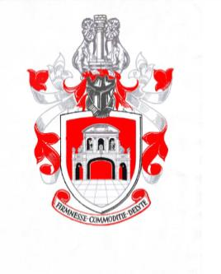
Newsletter of The Worshipful Company of Chartered Architects
Summer 2018

Message from the Master

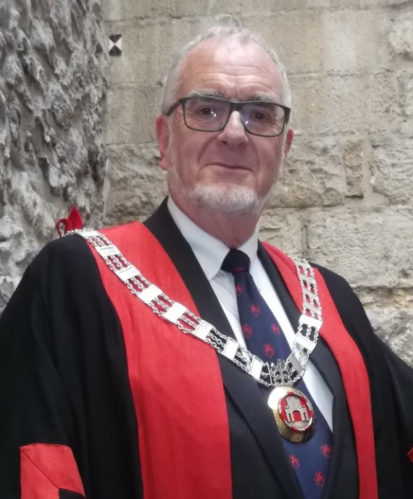
Since the spring newsletter no less than 71 more events representing the Company have come my way. I have been to St Paul’s Cathedral 3 times with the rest of the Livery to attend the United Guilds Service, the installation of 133rd Bishop of London and the Sons of the Clergy Service. The first in March is the Livery’s annual thanksgiving service, the second on 12th May saw Dame Sarah Mullally installed as London’s first Lady Bishop with much pomp and circumstance and the Sons of the Clergy Service is held annually to support distressed members of the clergy and their families.
Another (in effect) mandatory event was the Lord Mayor’s Big Curry Lunch on 11th April to raise money for the Armed Forces charities. Guildhall became the biggest curry house in the world for the day and 2,000 plus liverymen and friends feasted on curry, washed down with copious quantities of Tiger beer. During the event a silent auction of donated prizes was held in support of the charities and our contribution, one of the 3D printed models of Temple Bar that were carried as part of our float in last year’s Lord Mayor’s Show, suitably mounted on a varnished hardwood plinth, fetched no less than £150!.

Just one week later we all returned to Guildhall, this time to enjoy the Lord Mayor’s reception celebrating the 100th Anniversary of the founding of the Royal Air Force. I cannot remember the last time I saw so many neat haircuts and polished shoes in one place at the same time! To compliment the festivities indoors, outside in Guildhall Yard there was a stunning display of RAF aircraft past and present, from a Sopwith Camel and an SE5 from World War 1, a Spitfire and Hurricane from World War 2 to a Typhoon, the RAF’s current multi-role aircraft.
On 4th May the Lord Mayor unveiled our 2017 Building of the Year Plaque at No.8 Finsbury Circus and at the end of May 23 of us went on the Master’s overseas architectural tour to Lujbljana, capital of Slovenia. A full report of the trip is given later in this newsletter.
At the beginning of June Deirdre and I had the honour of attending a garden party at Buckingham Palace and at the end of the month we attended the annual prize giving at the City of London Freemen’s School at Ashtead. This is the third of the City’s schools that the WCCA supports, this time with a design prize for architectural draughtsmanship for pupils in the Senior School and the awards were given out on behalf of the Lord Mayor by Alderman Tim Hailes. Apart from the actual presentations ceremony in the sports hall the rest of the day was in fact another garden party with staff, parents, pupils and the Civic Party freely mingling and exploring the stunning grounds of the school.
On the 13th September 2018 this company will be 30 years old. Thanks to the efforts of our “Founding Fathers” over those 30 years we are now a respected and active member of the City Family with a popular annual lecture and much coveted buildings award. To mark our 30 year milestone the Company plans to give anniversary gift to the City in the form of our forthcoming book on the Livery Halls of the City, past and present This has received widespread support from all sides. To move forward into our next 30 years plans are being developed to take over our emblem – the Temple Bar itself as our base in the City. There is still much work to be done on this project but it has been received throughout the City and Livery with much interest and good will.
During the last 10 months Deirdre and I have been to some wonderful places on the Company’s behalf and met some outstanding people. Throughout all this time the goodwill of all the members of the WCCA has been a constant support and we thank you most sincerely.

Court News
Following the 150th meeting of the Court at Skinners’ Hall on 4th July the following Court officials were elected to serve from 20th September 2018 to 20th September 2019:-

Master Barry John Munday
Upper Warden Valerie Ellen Owen Le Vaillant OBE
Renter Warden Philip Leslie Cooper
Junior Warden Christopher Edward Dyson
Deputy Master Richard Graham Brindley
Almoner Dr Stuart Le Sage

New Court Members
Assistant Emeritus Richard Biggins

Retiring Court Members

Admission to the Freedom of the Company
Earle Peter Brent Arney by Redemption
Albena Atanassova by Servitude
Fiona Neil by Redemption
Stuart Nicholas Piercy by Redemption

Admission to the Livery of the Company
Geoffrey Philip Harris
Paul Velluet

The New Year Court on 14th February saw Tom Ball stand down as WCCA’s Almoner, after 21 years of service. In that role he personified the very best of the Livery’s values of Fellowship and Compassion. He represented the Company at joyful and sad occasions, kept the Court informed of of members who were suffering from ill health or in difficult circumstances and never missed sending out decennial cards to members who has achieved another decade. To mark his retirement the Court presented him with a crystal decanter and a set of goblets, accompanied by a bottle of rare malt whisky and an exclusive card designed by Past Master Jaki Howes and signed by members of the Court, past and present. Tom’s role as Almoner has been taken over by Court Assistant Dr Stuart Le Sage.

Reports from Committee Chairmen
Finance & Strategy – Stephen Wagstaffe – The Master

Communications – Barry Munday, Upper Warden
The committee has focussed throughout the year on improving the updating of the website, making sure it is relevant to members needs and presents a good face to the wider world. Great thanks are due to Webmaster Paul Weston for his tireless efforts. However, as he frequently reminds us, he relies on committee chairs, wardens and the membership in general feeding him with newsworthy material. Suggested further developments of the website include more information on how to join, encouraging practice links to the WCCA website and more CPD information.
We have also managed to produce regular newsletters such as this, spearheaded by our very busy Master. Our aim is to produce 3 newsletters per year.
Communications from the Clerk are now sent via Mail Chimp which he informs us is generally working well. The next and essential step to the expanding range of events is to introduce the Eventbrite booking system and electronic payments.
Along with all other organisations we have had to grapple with the implications of GDPR. After much deliberation and sometimes confusing advice the Clerk has opted for the “Legitimate Interest” route with our data protection policy being drawn to members’ attention. This has resulted in a relatively smooth transition into the new regulations.

Events – Valerie Owen Le Vaillent – Renter Warden
This year the committee has concentrated on ways to bring new and particularly young people into the Company. The conclusions were that events linked to the City and the Livery companies, visits to members’ architectural practices, building visits and CPD events would be the most effective. The monthly practice visits in particular have been notably successful in bringing along new and young members along. Attendances have been very good with the exception of the one to Space Syntax on 11th June. It was felt that poor follow-up publicity by the practice itself had contributed to this and Space Syntax have agreed to re-run the visit later in the year.
Reviewing past events the unveiling of the 2017 Building of the Year Plaque, judging of the 2018 Building of the Year Award and the Masters Overseas Study Tour are reviewed elsewhere in this newsletter, as are the forthcoming 30th Anniversary Livery Halls Book and the negotiations for the acquisition of the Temple Bar as the WCCA’s City of London base. Likewise the “Light Touch” 30th Anniversary Celebratory Activities are also introduced later in the newsletter.
Finally Past Master and Clerk Emeritus David Cole-Adams is commencing work on the production of a history of the Company from it’s inception as a Company in 1984, through the grant of Livery in 1988, to the present day.

Membership – Philip Cooper – Junior Warden
The Membership Committee has been concerned throughout the year to address the issues related to retention and expansion of the membership of the Company to be more inclusive and representational of the diversity of membership of the RIBA in terms of gender, ethnicity and age. Together with this aspiration the committee has been considering the fines charged to new and student members following representations from the Master of Students, John Assael.

This work is ongoing and will be presented in detail following a further round of committee meetings to the Installation Court in September. The current issues that would be attractive to a wider membership are being considered for Court approval and are summarised below:
- The City location of the Company is a prime resource to be exploited for the benefit of members.
- The tapping of this enormous resource to provide relevant professional development for members as well as creating networking opportunities within the City.
- Outreach events within offices of others within the City.
- There should be a recognition on our website and elsewhere that the Company members represent many of the leading practices within the City, nationally and internationally.
- Membership of the Company should indicate high standards of professionalism and the Company should be a resource both for our members and for clients or potential clients.
- Consideration of new membership levels such as “Friend”.
- The name of the Company should be streamlined and simplified in all normal communication.
- Consideration of the implications of the Royal Charter in communications.
- Instigation of a system of “buddying” for new members.
- Embracing and advertising the opportunities of the RIBA apprenticeship scheme to both practices and students.
- Updating and dissemination of the membership data within the Company.
- Liaising with the Master of Students as to how best to attract student members of the Company to become Liverymen by initially reducing the financial costs of membership.

Education – John Assael – Master of Students
The past three months have been very rewarding for those of us engaged in judging and making awards. My thanks to the Deputy Master of Students, John Bushell, for leading on much of this.
The Lawrence King Memorial Award 2018, Ardingly College
There were five excellent entries for this award and it was really quite a challenge to make an award as they were all so different, ranging from an adaptable desk to a serious piece of sculpture. However, we awarded the prize to an exceptional portfolio of drawings by Thomas Burke.
The Stuart Murphy Travel Prize
This very generous prize has been awarded to Daniel Krajnik who will be travelling to MIT in the USA to conduct research in a series of investigations into the potential off complex systems and machine learning in architectural design.
The Jonathan and Victoria Drawing Prize
We had fifteen outstanding entries this year including some that were digital. The judges decided to award a prize at Part 1 to Jack Barnett and two joint winners at Part 2 to Elin Soderberg and Sarah Smith for their extraordinary drawings.
Apprenticeships
The Renter Warden, Valerie Owen Le Valliant, and the Master of Students are engaged with the RIBA in promoting and supporting apprenticeships for architectural students. A number of meetings have been held with the President of the RIBA, Ben Derbyshire, and others to confirm our commitment to this exciting new way for students of architecture to “earn and learn” whilst studying. The WCCA will be attending an RIBA launch event in conjunction with the Stephen Lawrence Trust sometime later in the year.

Election Court Dinner:
On the (very) warm summer evening of 4th July 106 people comprising WCCA members, friends, family, visiting Livery Company Masters and the President of the RIBA gathered at Skinners’ Hall for the 30th Annual Election Court Dinner. After enjoying a relaxed reception on the Hall’s delightful roof terrace and a three course dinner with wines in the 17th century Livery Hall the elected Company Officers for the year 2018-19 were announced and the Company’s annual awards were presented. These were the 2018 Building of the Year Award, the presentation of a cheque to the ABS charity, the awarding of the ABS Plate for the most significant money raising effort on behalf of the ABS, the Jonathan and Victoria Ball Drawing Prize and the Stuart Murphy Student Travel Award.
Following the Loyal and Civic toasts the Master introduced the visiting Livery Masters from the Tylers & Bricklayers, Management Consultants, Tax Advisors, Fuellers, Constructors, Builders Merchants, Joiners & Ceilers and the Parish Clerks Companies, together with the President of the RIBA, WCCA Liveryman Ben Derbyshire. In proposing the toast to the Company’s guests the Master referred to the WCCA’s commitment to developing close cooperation with the RIBA in the development of apprenticeships in architectural education and invited the President to describe the RIBA’s plans with regard to this work. In his address Ben Derbyshire outlined steps already take, future moves in planning and expressed his enthusiasm for and appreciation of the WCCA’s commitment to this scheme. The evening ended with Ben proposing on behalf of the guests a toast to the Worshipful Company of Chartered Architects, together with the Master.

Overseas Study Tour:
On Thursday 24th May a group of 23 of us, comprising Company members, partners and friends checked in to the Union Grand Hotel in Ljubljana, the capital city of Slovenia, in preparation for 4 days of touring, lectures, dining and sightseeing in this delightful part of the world. Formerly part of Communist Yugoslavia and before that the Austro-Hungarian Empire, the country is now a very progressive part of the EU.

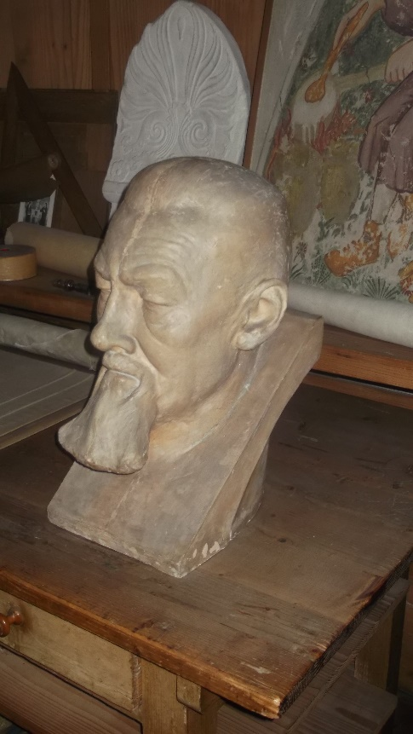
The city of Ljubljana itself has Stone Age roots, was a major Ancient Roman trading centre and is a fascinating blend of medieval, Gothic, Baroque, Art Decor, Communist and Post Modern architecture. It was virtually destroyed by an earthquake in 1895 and subsequently rebuilt in reinforced concrete as a protection from subsequent tectonic disturbances. At the time it was the first use of that material in the whole of the Balkans but it’s resistance to earthquakes has never been tested as there hasn’t been a ‘quake since! The focus of the tour was to see the work of Slovenia’s 19th/20th century architectural genius Joze Plecnik and to see if there was any cross-over of his work with that of Sir Edwin Lutyens, a direct contemporary.

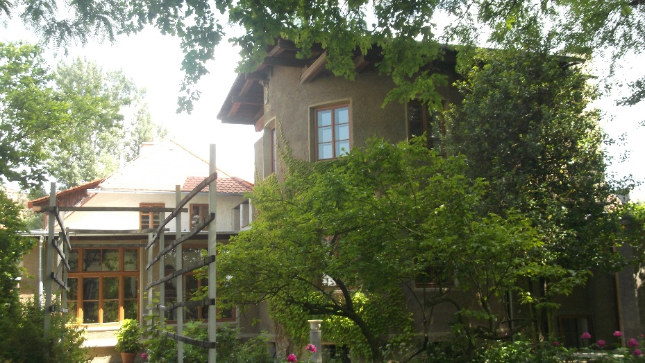

Joze Plecnik
Plecnik House

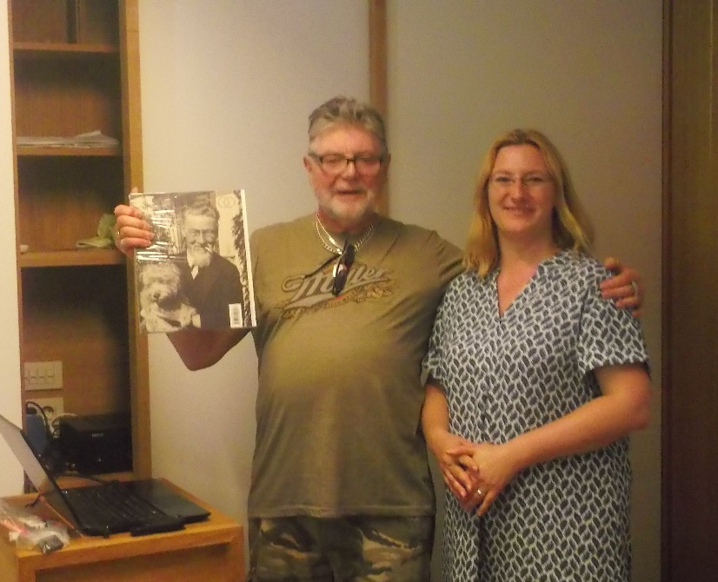
The first full day on Friday began with a tour of the Old City, clustered around the medieval castle on the south side of the River Ljubljanica, led by a very competent guide provided by the very helpful Tourist Information Centre. After lunch we walked to the suburb of Trnovo to visit the Plecnick Museum and Study Centre, built around Plecnick’s own house. After guided tours of the house and museum Past Master Mervyn Miller gave a lecture on his research into the possible links between Plecnik’s and Lutyens’ work. The visit concluded with a drinks reception at which we met staff from the Study Centre and the British Embassy. Our Ambassador, Sophie Honey, has an active interest in architecture, having previously sponsored two young Slovenian architects to attend the AA in London and was helpful setting up the tour. Sadly she was not able to attend the reception having ironically ben recalled to London for a briefing during the weekend of our trip!

Mervyn with Museum Curator Ana Porok

At dinner that evening the group was introduced to Robin Walker, a locally based New Zealand architect who had been the Master’s local contact researching and setting up the tour. He had been introduced to Stephen by Mervyn Miller with whom he had previously collaborated on a project. Is there anywhere in the World that Mervyn doesn’t know someone?!

Day three commenced with a free morning for sightseeing and shopping and was followed by an afternoon tour of the Modern City, led by Professor Aleksander Ostan from the Slovenian Architects’ Congress (their RIBA). We saw soaring apartment blocks, symphonies of adventurous brickwork, the very first skyscraper to be built in the Balkans and the very totalitarian Square of the Republic but the high point was without doubt Plecnik’s National and University Library. This stunning building, built between 1936 and 1941 features a dramatic black marble staircase leading upward from a very low-key street entrance towards the ”Light of Learning” on the first floor, which is actually the doorway to the glorious Reading Room. This vast dramatic chamber occupies the entire south side of the building and is a feast of delightful detailing. Access to this area is strictly restricted so we were very privileged to be allowed in, thanks to the Professor.

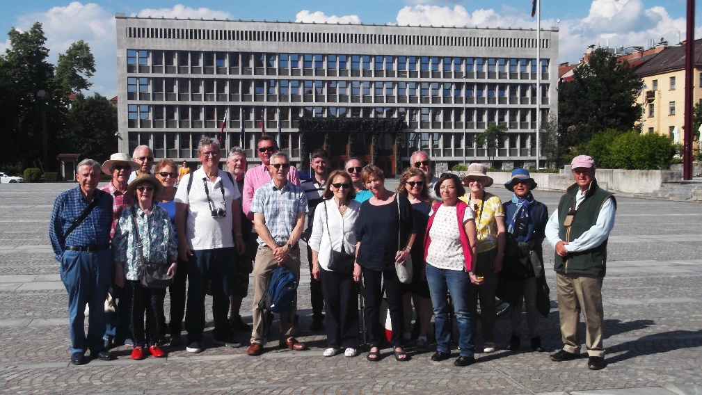
The Square of the Republic in front of the Parliament Building

Sunday was our last day and after checking out from the hotel we boarded a coach to spend the day with Robin as our guide touring the outskirts of the City and surrounding countryside visiting more of Plecnik’s work and that of his pupils.

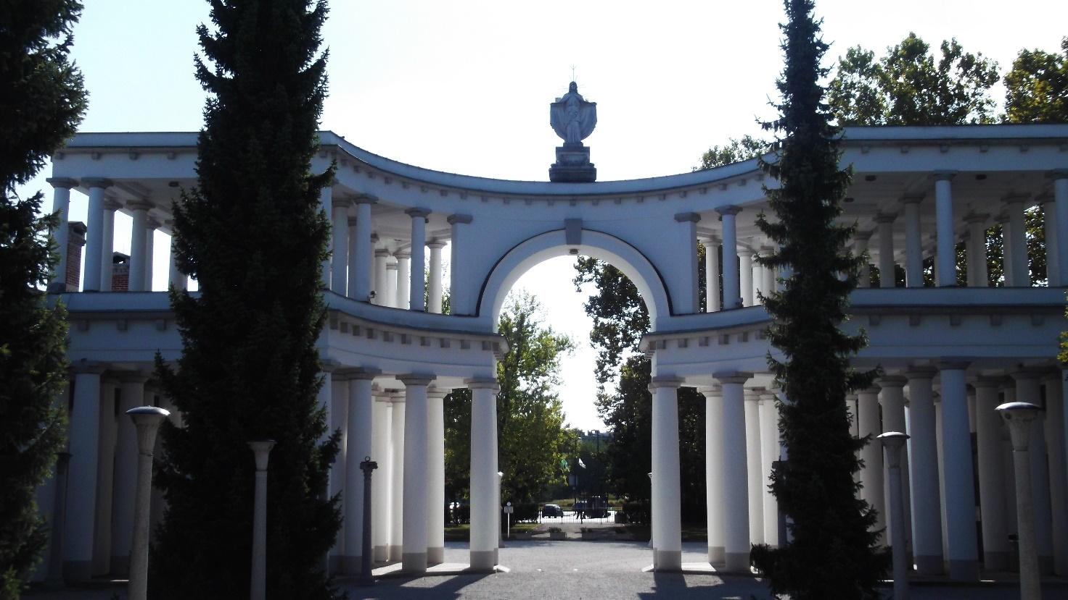

Entrance to the Zale Cemetery

These included the neo-classical Zale Cemetery and the delightful rural church of St Michael on the Marsh. This had been built by the locals themselves with help from Plecnik, using humble items such as twelve concrete drain pipes to form the interior columns holding the roof up. When we arrived a first communion was being celebrated so our visit was enlivened by the presence of a church full of local worshippers all dressed in their Sunday-best and the Master even ended up chatting to the Abbott who had conducted the service.

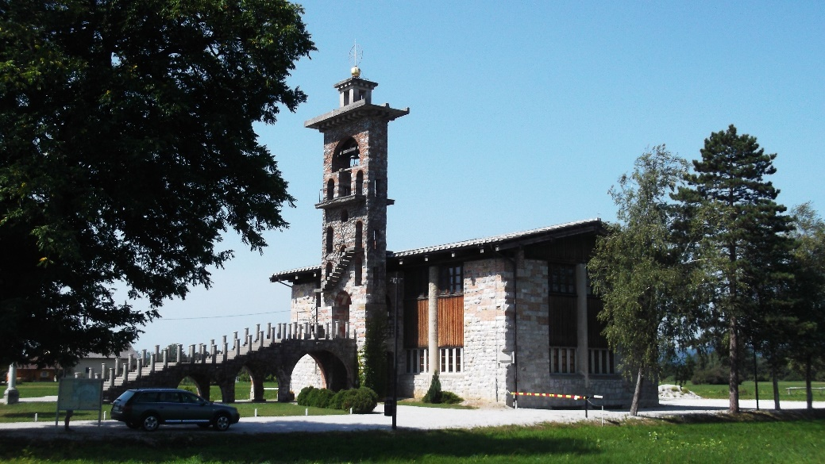
St. Michael on the Marsh

Before returning to the airport the tour finished with a stop for coffee and ice creams at the picturesque village of Skofja Loka, clinging precariously to both sides of a dramatic river gorge. It was just as well that the group was in a relaxed mood on arrival at the airport as it turned out that all flights were substantially delayed due to the thunderstorms over central Europe that had delayed Thursday’s flight out from the UK still being around. The return flight to Stansted was over 2 hours late taking off and it was a very late night home for some.

Livery Halls Book:
Barry Munday, Upper Warden

After 18 months of hard work the Livery Halls book has been completed in electronic form and will soon be winging its way to China where it will be printed and delivered back to the UK in time for an October launch.
This has been a remarkable venture which has depended upon the support and collaboration of many people and organisations. We raised the very substantial funds required to cover the cost of original research, writing and photography. Roughly half of that came from our own members and their practices with the remainder coming from a range of City institutions including the City of London Corporation, Brookfield and other Livery Companies.
The writers, Anya Lucas and Henry Russell, along with photographer Andreas von Einsiedel have been a pleasure to work with and have willingly accommodated the standards of historic accuracy rightly expected by the Livery Halls The Merrell team, responsible for the editing and design of the book, have proven to be tireless in their quest for quality. I am therefore confident that the book will be the definitive work on this unique collection of buildings and will be a fitting contribution to the City’s recorded history to mark our 30th year.
There is still time for WCCA members to order the book at a special pre-publication price and reminders will be sent out shortly.

Orpington Sea Cadet Unit:
It is the duty of every Livery Company in the City of London to support units of Her Majesty’s armed forces and this is now the sixth year of our association with the Orpington Sea Cadets or T.S. Whirlwind as they are officially known. A member of the WCCA is invited to join the Unit Management Committee (UMC) and to date that role has been filled by Past Master Michael Wilkey, Master Stephen Wagstaffe and currently by Liveryman Tim Godsmark. The Company helps with the maintenance of the Unit’s H/Q and makes an annual grant to the unit which enables the cadets to attend as many of the various courses provided by Sea Cadets UK. In return the unit provides a Carpet Guard at all our official functions and invites members of the Company to attend the Unit’s social functions as well as the cadets’ courses. For example during his time on the UMC the Master has spent a day getting very wet manning the safety boat during a sailing course in the Tilbury Docks and joined the Unit on a visit to No.10 Downing Street. The souvenir postcard signed by then PM David Cameron is a treasured possession!
In our six year partnership with Orpington SC the unit has gone from strength to strength culminating in the year 2017-18 when Senior Cadet Kyle Gatt received the County Deputy Lieutenant’s Annual Award for Excellence, C/O Petty Officer Andy Lawson was declared London Region Unit Commanding Officer of the Year and former C/O Lieutenant Sue Catterall, now the Unit’s principal fund raiser, received an MBE in the Queen’s Birthday Honours for 40 years continuous service to the Sea Cadet Movement and the Royal British Legion.
The Unit’s current priority project is the replacement of their temporary toilet and classroom annex with a permanent structure. Michael Wilkey prepared the initial feasibility study drawings and Tim Godsmark has been assisting with the various permissions that are required. However pressure of work has meant that Tim will have to stand down as the WCCA’s UMC member and a replacement from the Company is required. If there is anyone in the Company who is willing to take on the role and lives in the SE London/NW Kent area could they please let the Clerk know as soon as possible. Experience of working with youth organisations would be valuable but is not essential.

London Open House Weekend:
London Open House Weekend was co-founded by our own late Past Master Stuart Murphy in the late 1990’s and ever since then the WCCA has taken on the duty of managing the opening of the City Churches to the public during that weekend. This year the event falls on the weekend of 22nd and 23rd September. Most of the 43 churches within the City are able to provide their own stewards but a number of them still require volunteers to help out and it is this Company’s duty to provide them. Members of the Friends of the City Churches and Liverymen from other companies fill some of the gaps but help is always needed from members of this company. The sessions are from 10.00am to 1.00pm and 1.00pm to 5.00pm each day and volunteers can do as many or as few of them as they wish. If you are interested and are willing to help out could you please contact our co-ordinator Liveryman Patricia Stefanowicz on stefanowiczpkc@hotmail.com.

WCCA Monthly Practice Visits 2018:
Those remaining will be as follows:
10th September Allies & Morrisson
8th October Publica Associates

City Talks:
The programme is now completed.

City Walks:
That remaining is as follows:-
26th July – The Great Fire Livery Halls – start time 6.00pm

In Memoriam:
Jane Lamb
Sherban Cantacuzino
Peter Crouch

The Worshipful Company of Chartered Architects
Any queries, please contact the Clerk Jonathan Soar clerk@architectscompany.org

