Autumn 2017 Newsletter of The Worshipful Company of Chartered Architects

Message from the Master

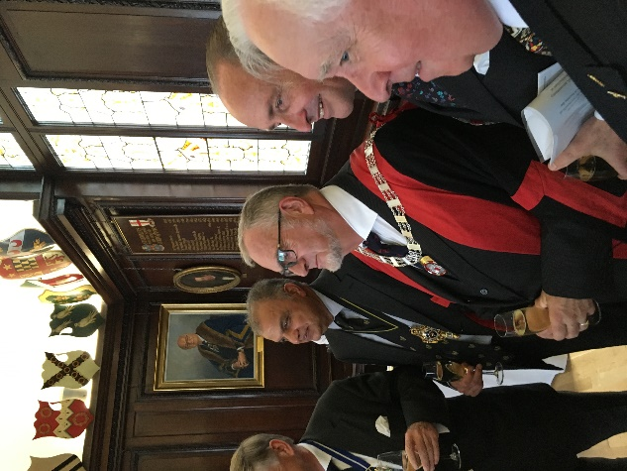
My installation as the 30th Master of the Worshipful Company of Chartered Architects on 20th September 2017 took place exactly 17 years to the day after my election to the Livery at the first Court meeting of our then Master, Lady Patricia Stewart – a very special moment for me.

Following the Installation Ceremony and Service, conducted by our Honorary Chaplain, the Reverend Canon David Parrott, at St Lawrence Jewry church, 94 of us sat down to lunch in Stationers’ Hall. Joining our Company were the Master Mason, the Prime Warden Blacksmith and the Master Plaisterer. Our Principal Guest was Alderman Charles Bowman, who, as Senior Alderman below the Chair, was elected at Common Hall on 29th September 2017 to be the 690th Lord Mayor of the City of London.

The theme for my year is to explore
‘The relationship between the Court of Aldermen, the Lord Mayor, the Sheriffs and the Livery’.

Thanks to the efforts of my immediate predecessors as Master, our Company is beginning to pull its weight in the life of the modern City, as you will have seen from our annual review. We have enrolled nearly 100 new Liverymen and Freemen, plus 30 students in the last 2 years, completely reversing the Company’s membership dynamic from 70% being 60+ in age to now less than 40%. However, we are also part of an ancient and historic city whose customs and traditions in some cases go back nearly 2,000 years. There are many things going on in the Square Mile that puzzle not only tourists but many of the 400,000 who commute in to work each day. Why do we “Swan Up” and beat the bounds? What do the City’s Cash, the Bridge House Trust and the Court of Common Council actually do? What is the Sons of the Clergy Service all about? How did Livery Companies come into being and what is the significance of the Lord Mayor’s Show? By means of talks from people who know about the civic side of the City’s life and guided walks around the Square Mile, I hope to be able to answer these and many other questions. You will by now have received the detailed programme of events for the coming twelve months and I look forward to meeting as many of you as possible over that time.

Court News

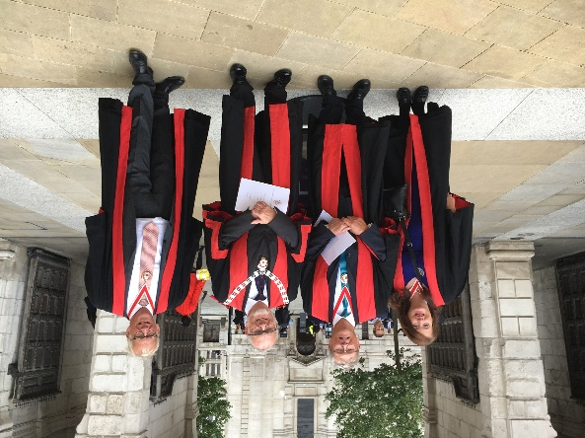
At the Installation ceremony on 20th September Barry Munday was installed as Upper Warden, Valerie Owen Le Vaillant steps up to become Renter Warden and Philip Cooper comes in as Junior Warden. Mike Stiff is the new Court Assistant, Stephen Blundell joins the Livery and Jonathan Clark became a Freeman. Three members stood down at the end of their terms on Court. They were Past Master Nigel Thomson after 25 years’ service, Howard Copping after 14 years and Richard Biggins after 7. Unanimous thanks were expressed in appreciation of their service to the Company.

The New Master
Stephen Wagstaffe RIBA, MRSH

Stephen was born in Sheffield but was brought up in Ilford, Essex after his father’s work brought the family south. He was educated at Beal Grammar School and studied architecture at the South West Essex Technical College & School of Art (a fellow alumni was Ian Drury of The Blockheads fame) which during his time there became firstly the North East London Polytechnic and finally the University of East London. He now lives in Buckhurst Hill with Deirdre, to whom he has been married for 46 years. They have four grown up daughters and two grandchildren.

After holiday jobs at the Architects Department of the London Borough of Redbridge his career proper commenced in private practice with first Edward D Mills and Partners and then with the Tooley and Foster Partnership doing military, educational and commercial work. He moved to the Greater London Council in 1971 where he spent 14 years in the Schools Division designing, building and maintaining schools and colleges all over Greater London.

When the GLC closed he moved to the Department of the Environment where, as a project architect in the Property Services Agency he was involved with a number of major projects including the Clore Gallery extension to Tate Britain on Millbank, the Tate Gallery North in Liverpool, the Department of Energy HQ in Victoria and the Old Admiralty Building in Whitehall. The most important posts held whilst at the PSA were as Superintending Officer for Phase 2 of the re-building of Hampton Court Palace after the fire in the King’s Apartments at Easter 1986 and the redevelopment of the East Wing of the Royal Courts of Justice in the Strand for the Court of Appeal.

When the PSA in its turn closed down in 1995, Stephen set up his own practice doing small scale domestic and commercial work until 2005 and then planning consultancy work until finally retiring in 2009.

At the same time as running his own practice, he became a tour guide specialising in the City of London, church architecture and World Wars 1 & 2. In the last 3 years he has taken groups to Colditz Castle, Auschwitz, the German-fortified sites in Jersey, the U Boat pens in Brittany, the Maginot Line and the Normandy D-Day beaches.

His interest in all things historical and particularly the Square Mile led to involvement in the ceremonial life of the City, first joining the Bridge Ward Club and then the WCCA. In 2001 he joined the Company team managing the involvement of the 43 remaining City churches in the annual Open House event, only stepping down from this role last year in preparation for becoming Master Chartered Architect.

Away from the Company and the City he is a trustee and former Chairman of the North Weald Airfield Museum and has been a volunteer community bus driver for 12 years. His hobbies include walking, swimming, collecting and making models, choral singing and watching motor sport.

The Assael Architectural Award for Tenacity

At the Installation Court Lunch on 20th September 2017 the first Assael Architectural Award for Tenacity was presented. This is a new charity award sponsored by WCCA Master of Students John Assael. It is designed to recognise tenacity and is to be given to a student of the Company who has pursued a successful course of architectural study in spite of hardships and obstacles, including poverty, physical handicap, mental health issues, family tragedy, personal difficulties or any other reason that the judges feel is valid and that shows remarkable resilience. Training to become an architect is a long and arduous career path – hard enough in good health and a secure environment - but for some the dedication and effort required to pursue their studies are the least of the problems they have to face. Since becoming Master of Students John has become particularly aware of this and chose to instigate the award. There were a significant number of applications for the inaugural award and these were judged by Stephen Wagstaffe as (then) Master-Elect, Alan Downing, Clerk to the Trustees, and John Assael himself.

Three applicants made it to the short list. Two candidates, India Wills and Alice Theodorou both suffered major interruptions to their careers, India through serious illness and Alice due to a truly horrible accident. Both have received excellent medical care and loving family support to aid recovery but this would all have counted for nothing without their own determination to overcome illness and injury. The judges were unanimous that they should both be rewarded with second place and that they should each receive £500.

The winner was Simon Banfield and his problems started with his mother becoming seriously ill when she was expecting him. He lost his father when he was only 3 years old and due to his mother’s periodic spells of ill-health from a very early age had to become not only her carer but family bread-winner as well, and all this while attending school and later college. The judges felt that he was a truly remarkable young man and agreed that he should be the first winner of the award. He received a cheque for £1,500 from the Master and John Assael.

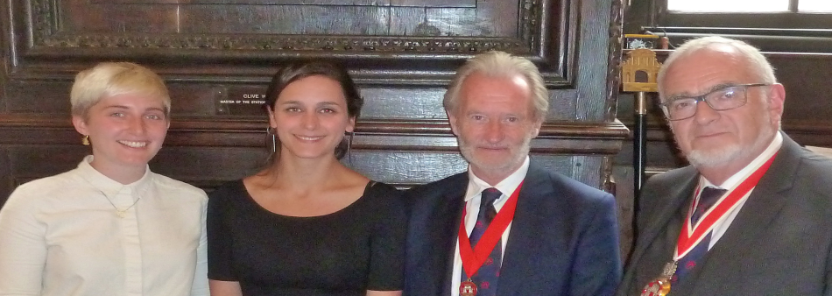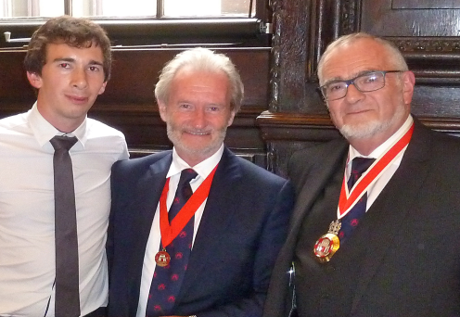

London Open House

On 16th and 17th September 2017 the Company once again took on responsibility for arranging for as many of the City’s 43 churches as possible to be open to the public over the annual two-day event, always held over the third weekend of September. Apart from producing an overall churches opening schedule that is distributed to the public from the City Information Centre at St Paul’s, the Company’s major task is to assemble a team of volunteers who take turns over the weekend manning those churches that are not able to provide their own stewards. From as many as 30 churches that needed help ten years ago the number has steadily dropped and this year, of the 34 churches that were open for all or part of the weekend, only 11 requested help. This still required 50 volunteers to provide the cover needed and despite emails and numerous phone calls, Liveryman Patricia Stefanowicz, who managed this year’s event, was only able to recruit 34 people, just 9 of whom were members of this Company. Considering that the late Stuart Murphy was co-founder of the event when he was our Company Master 1992 this is felt to be a very poor effort on the Company’s part. Each day of the event is divided into two halves – a morning session from 10.00am to 1.00pm and an afternoon session from 1.00pm to 5.00pm. Volunteers are only asked to do one half day on the Saturday or Sunday but should they be willing to do more during those 2 days this would be welcomed. The search for volunteers usually begins in earnest around Easter time but if you would like to add your name to the volunteers database now in preparation for next year’s event, please contact Patricia Stefanowicz: 020 7286 4505 or 07968 888 754 or stefanowiczpkc@hotmail.com .

Lord Mayor’s Show

Saturday, 11th November 2017, will be a momentous day for the Company when for the first time it enters its very own independent float in the Lord Mayor’s Show. Encouraged by the new Lord Mayor, who obtained a degree in architecture at Bristol University before becoming a chartered accountant, a float has been designed to celebrate the City’s rich architectural history. Led by the Master, Company members in costume will walk through the City streets paying tribute to architects from the past such as Wren, Hawksmoor, Dance, Soane and Lutyens, and celebrating its modern face with banners featuring contemporary buildings, many of which have been recipients of the Company’s annual architectural award over the years. If you don’t already have a place booked from which to witness the show why not make your way to Gresham Street close to St Lawrence Jewry Church by 10.30am to cheer on our float as it makes its way to the start of the parade at Bank junction.

Livery Halls Walk

On 14th September, the Master and Upper Warden took part in the annual inter-Livery Halls walk, visiting all of the Halls within the Square Mile – a distance of some 9 miles. Thank you to everyone who sponsored them, helping to raise money for the Company’s Charity.

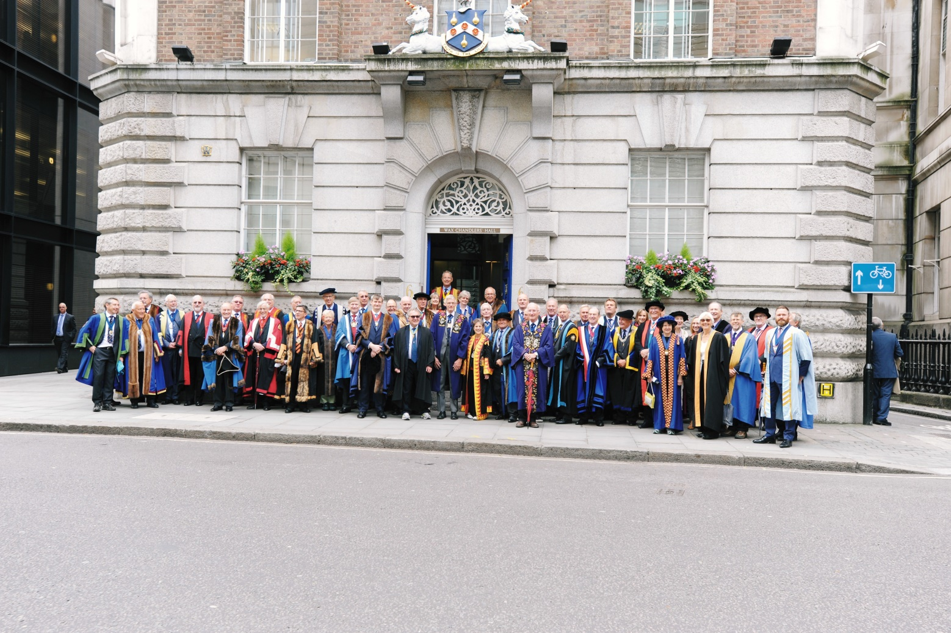

Proposed book on the Livery Halls of the City of London

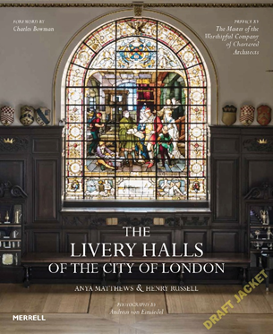

On 13th September 2018, WCCA will reach the 30th anniversary of receiving full Livery status. The idea emerged of celebrating this significant event by publishing a book relating to the architecture of the City.

Many aspects of the City are well covered by other publications, however, there is a surprising omission. A unique collection of buildings, the Livery Halls are one of the City’s major architectural and historic assets, yet there is no recent, comprehensive book on the subject. The last known book was first published in 1904 and reprinted in 1981 and contained charming pencil drawings by Richard Howard Penton, father of our own Past Master, John Howard Penton. This book is no longer in print and does not cover all of the 40 existing Livery Halls. The Worshipful Company of Chartered Architects wishes to bring things up to date with a beautiful and instructive new publication, which will be the definitive work for the next 30 years.

The WCCA has teamed up with Merrell Publishers, a London-based company renowned for its award-winning books on art and architecture. Our aim is to produce a publication that will appeal not only to the Livery Companies and those interested in the history of the City, but also to a wider readership. The book will include a chapter on Livery Halls that, for various reasons, have been lost over the centuries. This is being researched and written up by historian Anya Matthews who wrote her PhD at the Courtauld Institute on the subject of 17th Century Livery Halls. Social historian Henry Russell will be writing up the architectural and historical details of each of the extant Halls. We also plan to include specially commissioned photography so that each Hall will be presented to a consistently high standard.

Alderman Charles Bowman, Lord Mayor Elect, has enthusiastically agreed to write a preface setting the subject within the context of the City and the Livery. We have also obtained the support of the City of London Corporation who have provided us with a grant of £5000.

To produce such a high quality book is expensive. We are very fortunate to have been supported by a number of high-profile practices and we have already raised £22,500. But we do need further funding to reach our target. We are in the process of inviting all Company members to subscribe to the publication. All subscribers will be listed in the book and will have an opportunity to purchase at a special pre-publication price.

I do hope that you will support this important initiative and take the opportunity to play a part in recording these unique buildings for posterity.
Barry Munday, Upper Warden

Notices

The Company sponsors the annual International Building Press (IBP) Journalism Awards, which will be held this year at a Presentation Dinner at the Four Seasons Hotel on Thursday, 30th November. We have a table of ten available to us at this highly prestigious event, which attracts the very best of architects and architectural journalists. Places are available at £200 each on a strictly first-come, first-served basis via the Clerk. The Master will be at the table.

We are delighted to hear the news that Liveryman Professor James Stevens Curl (University of Ulster) has been awarded the 2017 President's Medal from the British Academy for his contribution to the study of the History of Architecture in Britain and Ireland.

You (and your guests) are cordially invited to join the York Guild of Building for their Annual Dinner at Merchant Taylors’ Hall, York on Thursday, 16th November. Tickets are £45 each, which excludes drinks (there will be a cash bar). Please contact the Clerk if you are interested.

The Corporation of London holds regular City Briefings, which are mainly aimed at new Liverymen and Freemen. Full details can be found at liverycommitteecourses.org/city-briefings.php where you can book online. These are highly recommended.

Specifically for Liverymen, the Livery Committee also publishes bi-monthly newsletters, which can be found at liverycompanies.info/library/livery-briefing/. This contains the latest edition as well as an archive of earlier publications.

Autumn 2017 Newsletter of the Worshipful Company of Chartered Architects

For all enquiries, please contact the Clerk, Jonathan Soar, clerk@architectscompany.org

www.architectscompany.org

